REKOGNISI

NO | NAMA KEGIATAN | TAHUN KEGIATAN | URL/ADDRESS | COPY SERTIFIKAT | DOKUMENTASI
1. | OKKBK | 2018 | instagram.com/himad3kkim_its |  | (terlampir)
2. | SPLASH | 2018 | instagram.com/himad3kkim_its |  | (terlampir)
3. | BMS (Basic Media Schooling) | 2018 | instagram.com/himad3kkim_its |  | (terlampir)
4. | LKMW-TD | 2018 | instagram.com/himad3kkim_its |  | (terlampir)
5. | PKTI-TD | 2018 | instagram.com/himad3kkim_its |  | (terlampir)
6. | LKMM-PRA TD | 2018 | instagram.com/himad3kkim_its |  | (terlampir)
7. | Asia Youth International Model United Nations | 2018 | modelunitednation.org | (terlampir) | (terlampir)
8. | LKMM-TD | 2019 | instagram.com/himad3kkim_its |  | (terlampir)
9. | Company Visit | 2019 | instagram.com/himad3kkim_its |  | (terlampir)
10. | NIPRO | 2019 | instagram.com/himad3kkim_its |  | (terlampir)
11. | D3XPLORE | 2019 | instagram.com/himad3kkim_its |  | (terlampir)

Lampiran:
- OKKBK
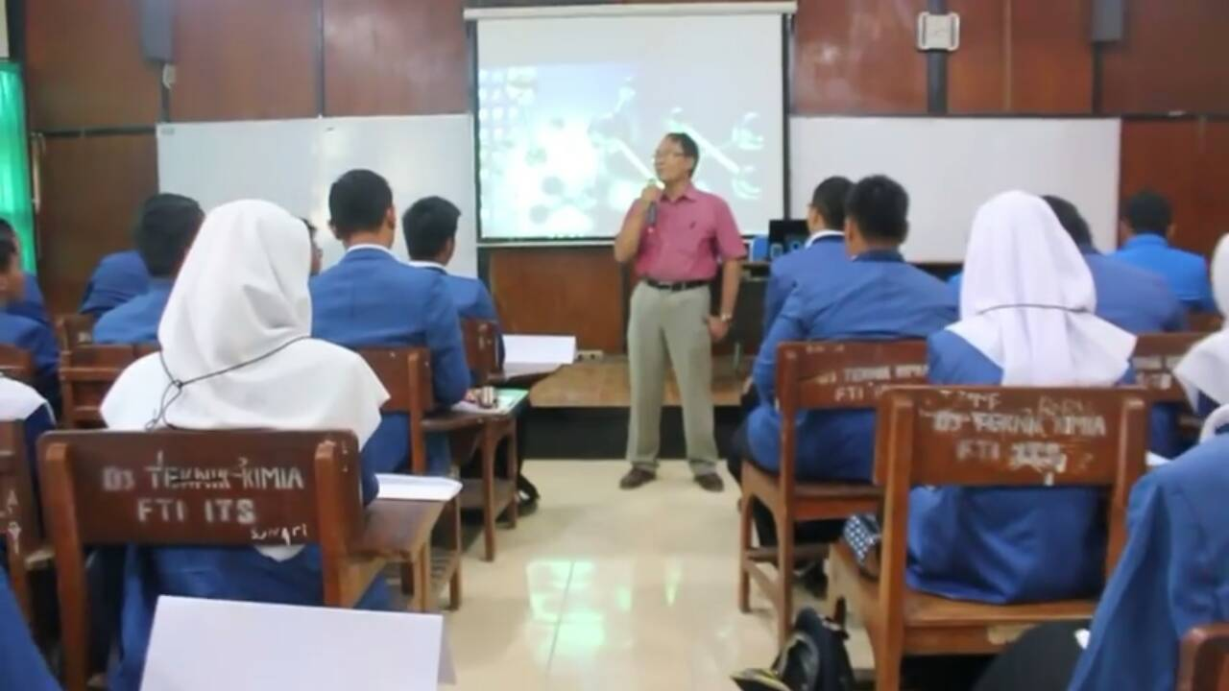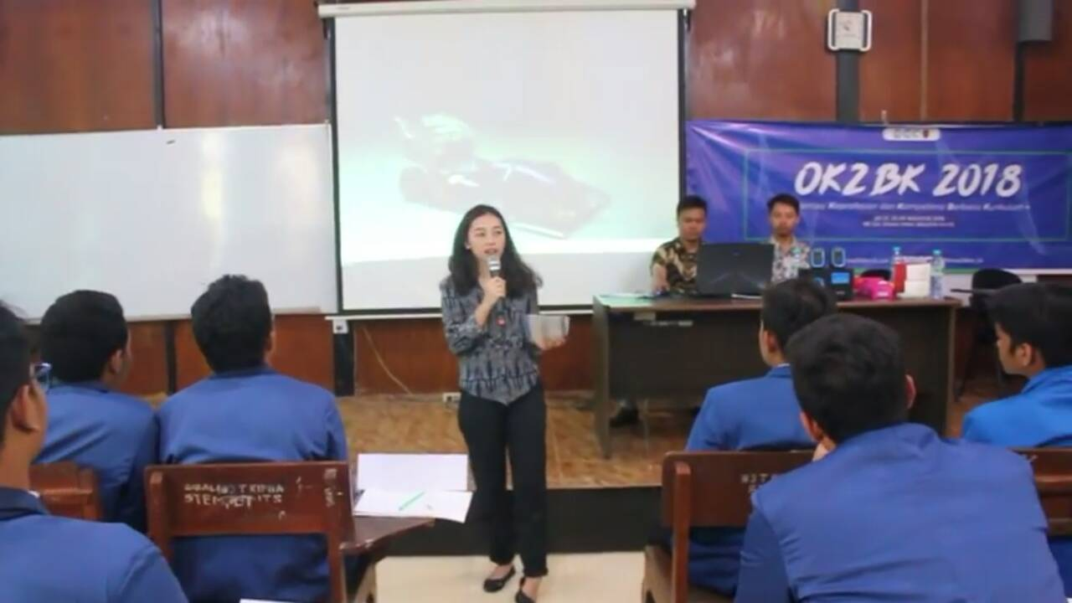

- BMS
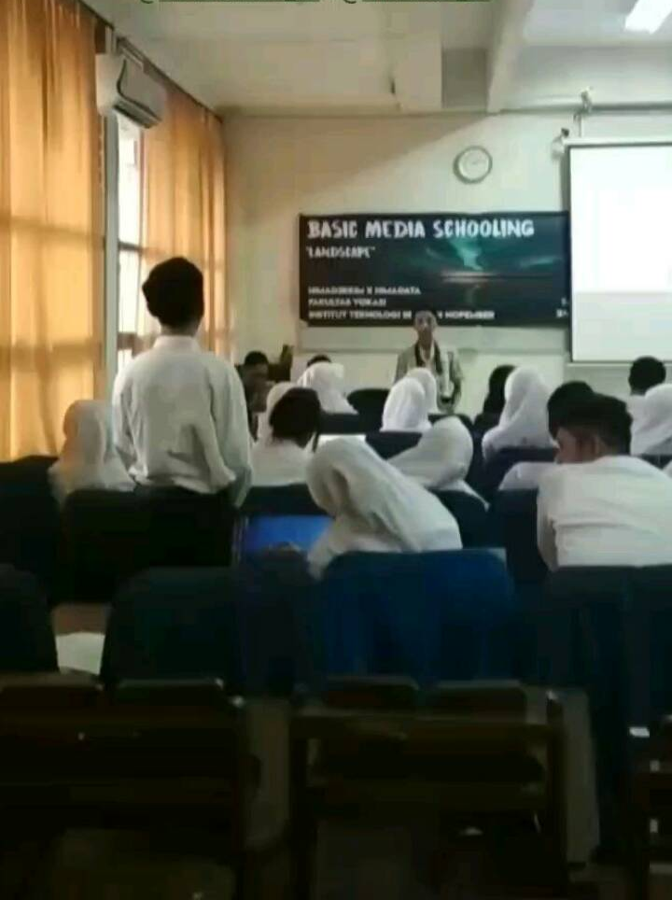
- SPLASH
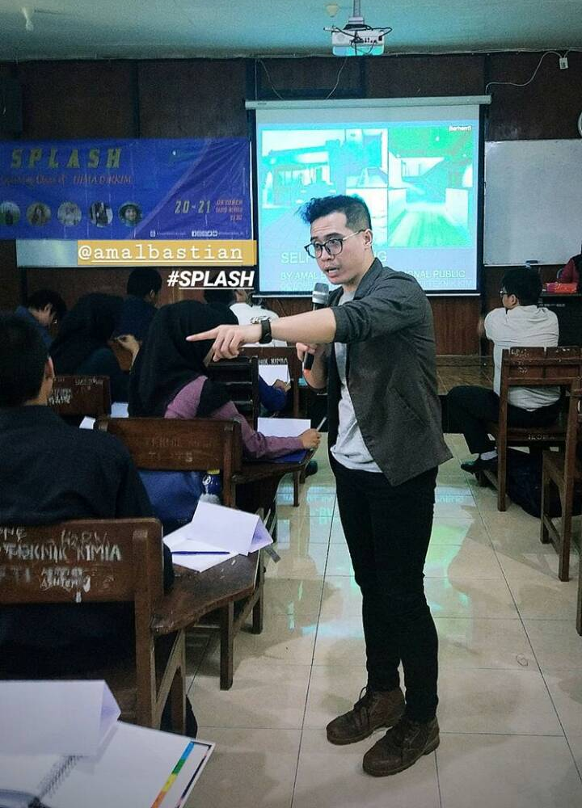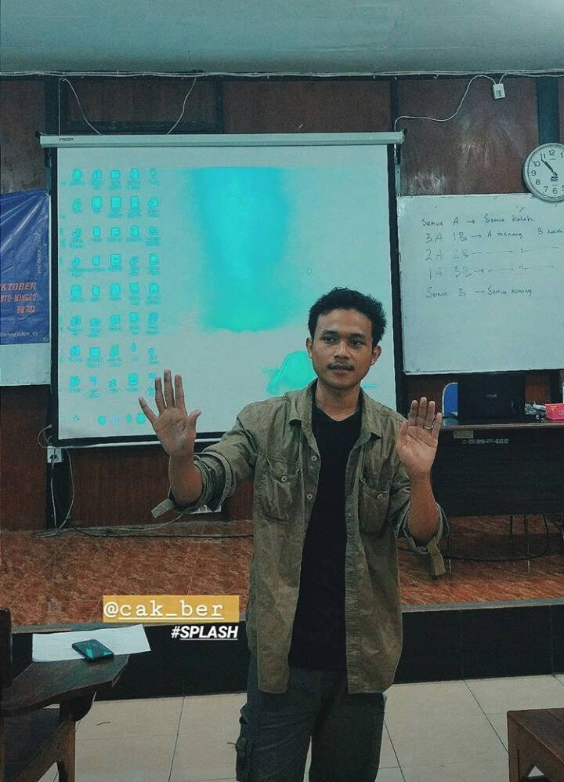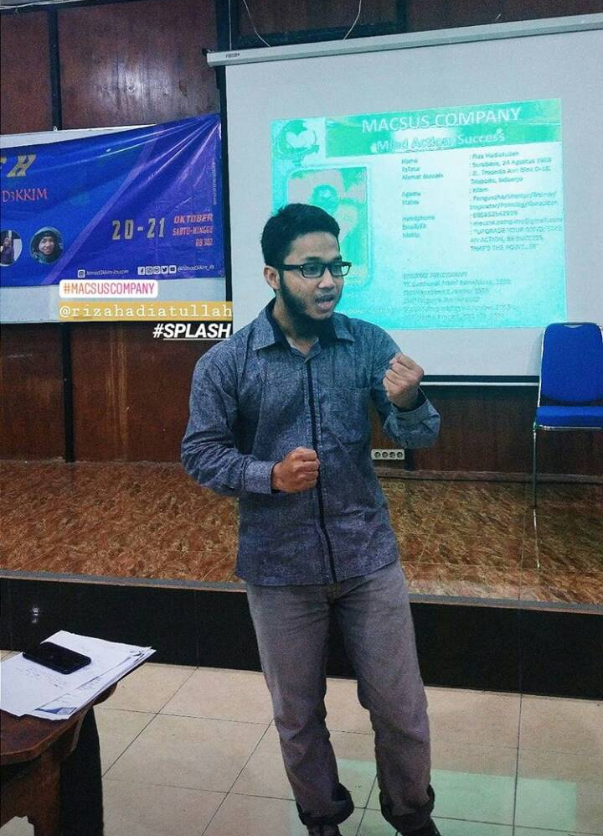

- PKTI-TD
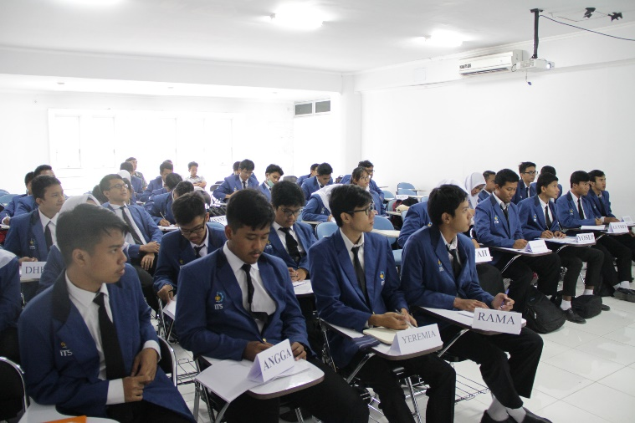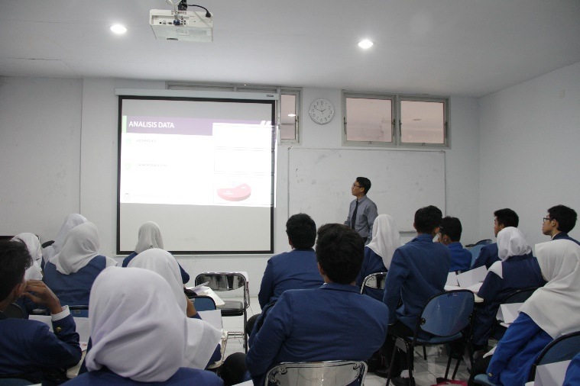
- Asia Youth International Model United Nations
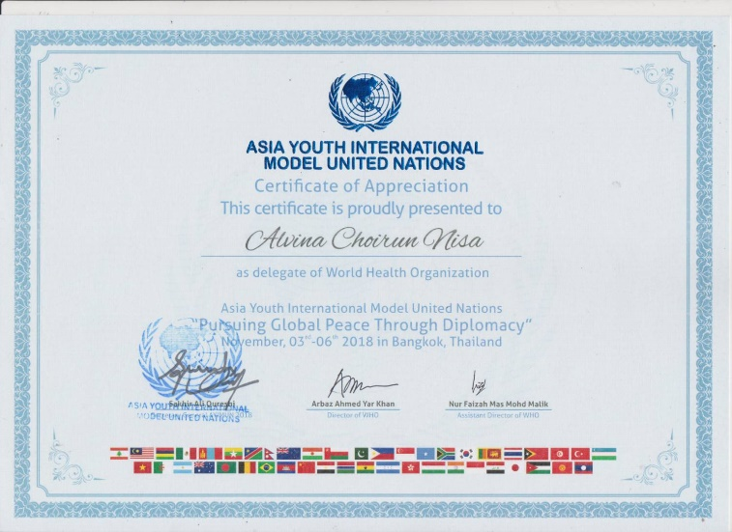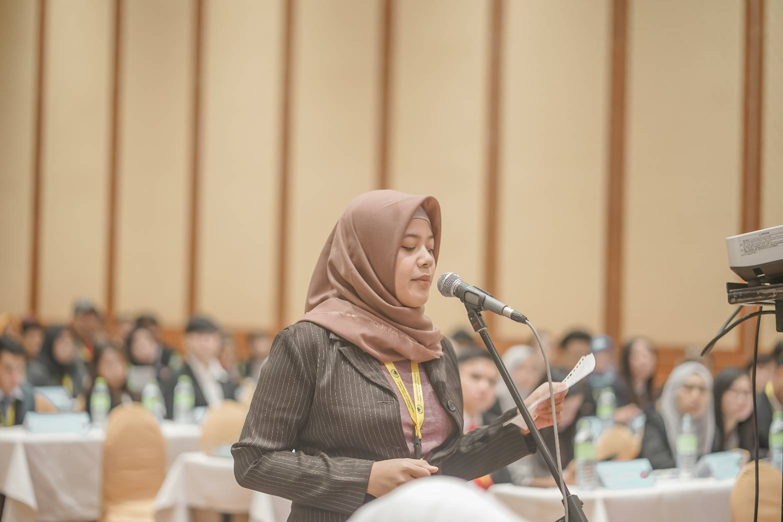

- LKMM-TD

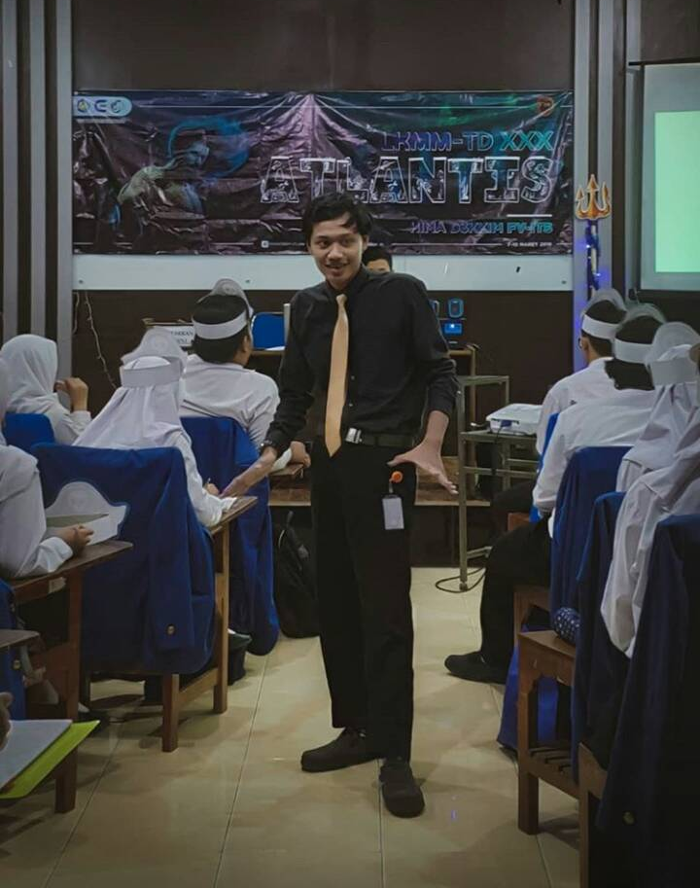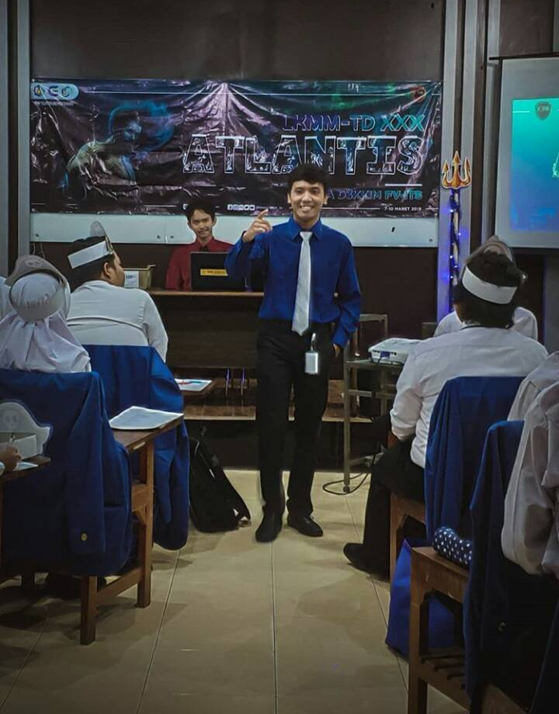

- Company Visit
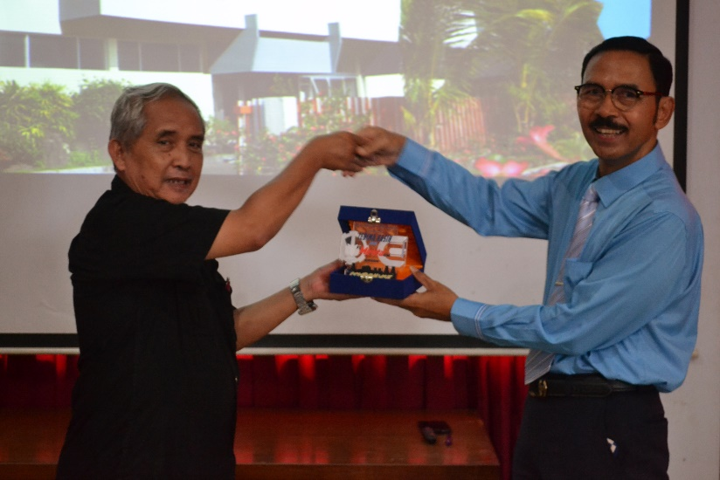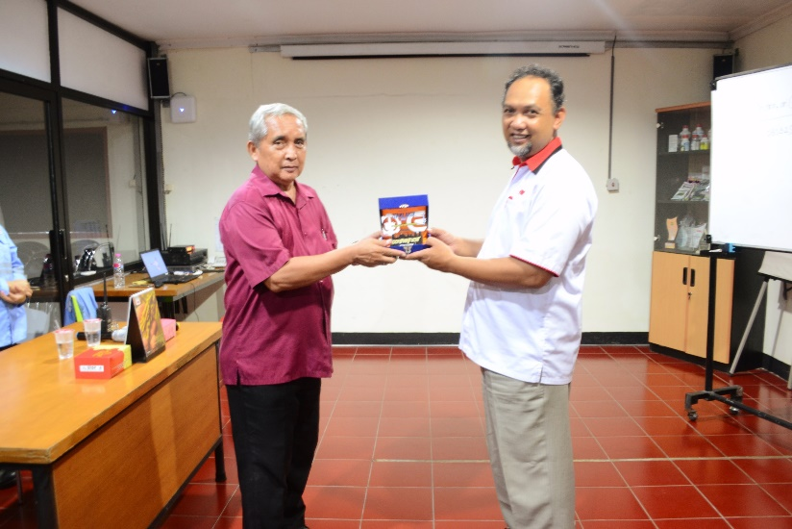

- NIPRO
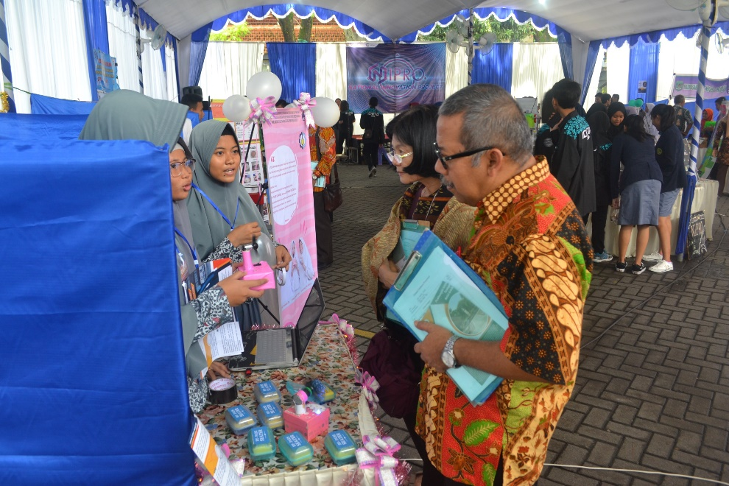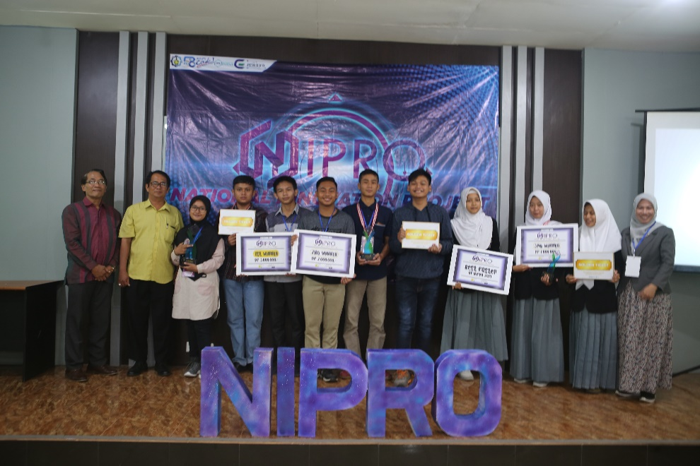

- D3XPLORE
