NAMA KEGIATAN | TINGKAT | TEMPAT | TANGGAL | NAMA ANGGOTA
LKTIN IDEA CHALLENGE ECO PROJECT 2019 | NASIONAL | INSTITUT TEKNOLOGI BANDUNG | 25-27 JANUARI 2019 | INTAN FEBRIANTI
 |  |  |  | DEWI RAHMITA AULIA
CHEMICATION 2018 | NASIONAL | UPN VETERAN JATIM | 05 November 2018 | WIRAWAN AZIZ
 |  |  |  | ADIK RONI SETIAWAN
 |  |  |  | FINDI KUSUMA WARDANI
AIRLANGGA CHEMISTRY ON WEEKEND 3.0 | NASIONAL | UNIVERSITAS AIRLANGGA | 21 OKTOBER 2018 | SELVI AMELIA VIRDA
 |  |  |  | INTI ROHMANIA
 |  |  |  | INTAN FEBRIANTI
NATIONAL SCIENTIFIC COMPETITION | NASIONAL | UNIVERSITAS INTERNASIONAL SEMEN INDONESIA | 4-7 FEBUARI 2019 | KHAFID DWI PRADANA
 |  |  |  | FIRMAN MAULANA
 |  |  |  | INTI ROHMANIA
 |  |  |  | ABIDAH LIFIANA
 |  |  |  | IRFIANI NURUL MAWADDAH
COME AND INNOVATE IN CHEMICAL ENGINEERING PHENOMENAL COMPETITION | NASIONAL | UNIVERSITAS KATOLIK PARAHYANGAN | 29-30 MARET 2019 | FIRMAN MAULANA
 |  |  |  | INTI ROHMANIA
 |  |  |  | MAUDINA ALFIRA ADZANI
MAHASISWA BERPRESTASI | INSTITUT | INSTITUT TEKNOLOGI SEPULUH NOPEMBER | 01 April 2019 | KHAFID DWI PRADANA
AIRLANGGA CHEMISTRY ON WEEKEND 3.0 | NASIONAL | UNIVERSITAS AIRLANGGA | 21 OKTOBER 2018 | WIRAWAN AZIZ
 |  |  |  | ADIK RONI SETIAWAN
 |  |  |  | FINDI KUSUMA WARDANI
THE 5TH INTERNATIONAL YOUNG INVENTOR AWARD | INTERNASIONAL | NUSA DUA, BALI | 19-22 SEPTEMBER 2018 | RAKHMAD ROFIANSYAH
 |  |  |  | SELVI AMELIA VIRDA
 |  |  |  | NANDA TISYA AL ADHA
 |  |  |  | ADIK RONI SETIAWAN
 |  |  |  | SURYA KURNIA
 |  |  |  | LINNANIYATUL
 |  |  |  | ZELA MARNI SAFITRI
 |  |  |  | ALVINA CHOIRUNNISA
 |  |  |  | NI WAYAN ARISTYA DEWI
 |  |  |  | ANGGHISNA RICHARD
 |  |  |  | FINDI KUSUMA WARDANI
 |  |  |  | M YOSI KURNIAWAN
 |  |  |  | ANANDA MAULIDHA

Lampiran:
- LKTIN IDEA CHALLENGE ECO PROJECT 2019
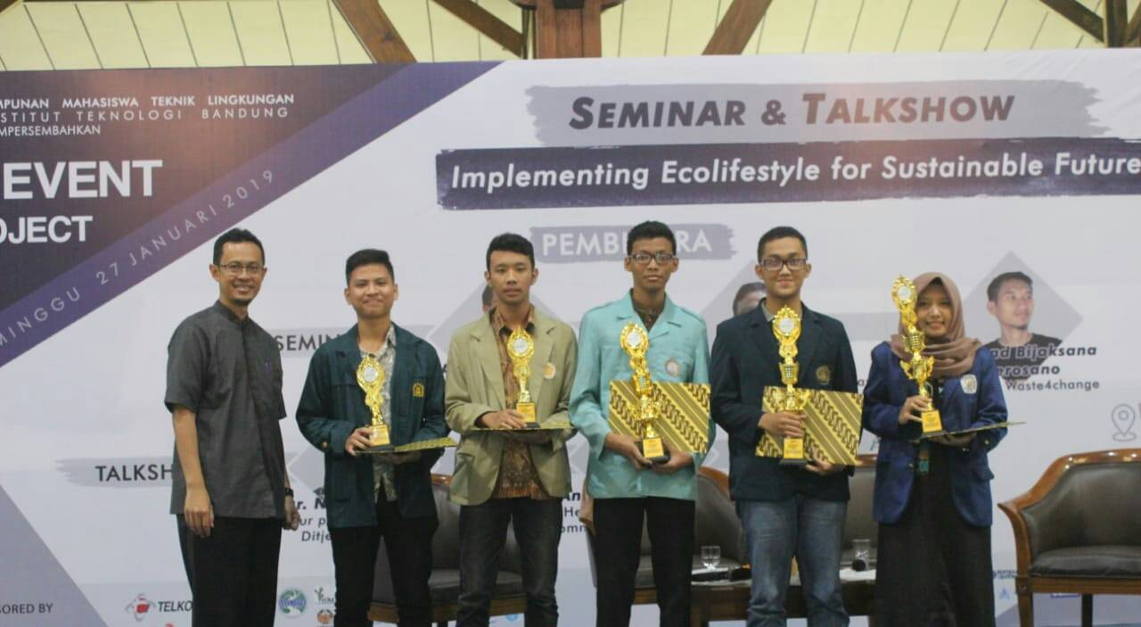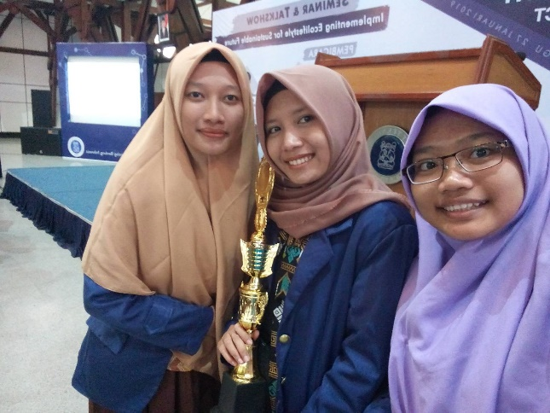

- AIRLANGGA CHEMISTRY ON WEEKEND 3.0
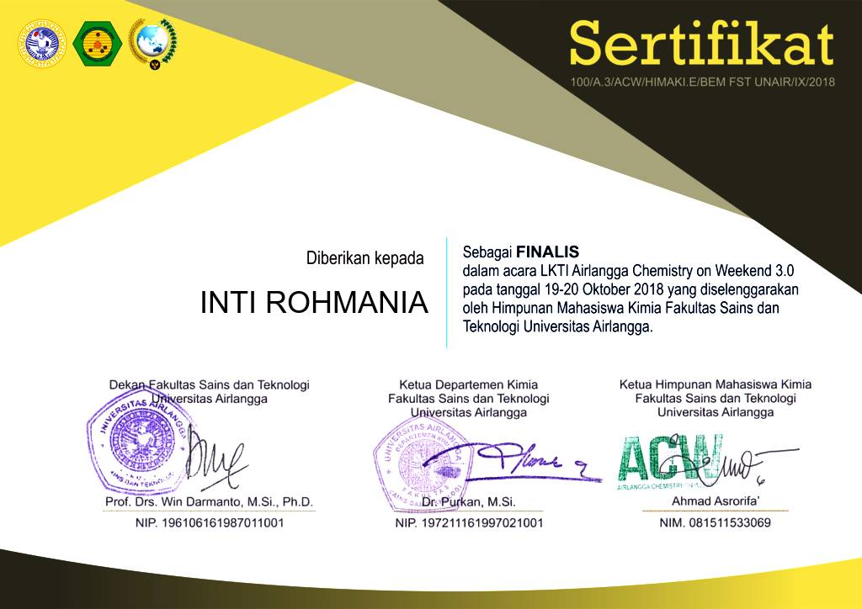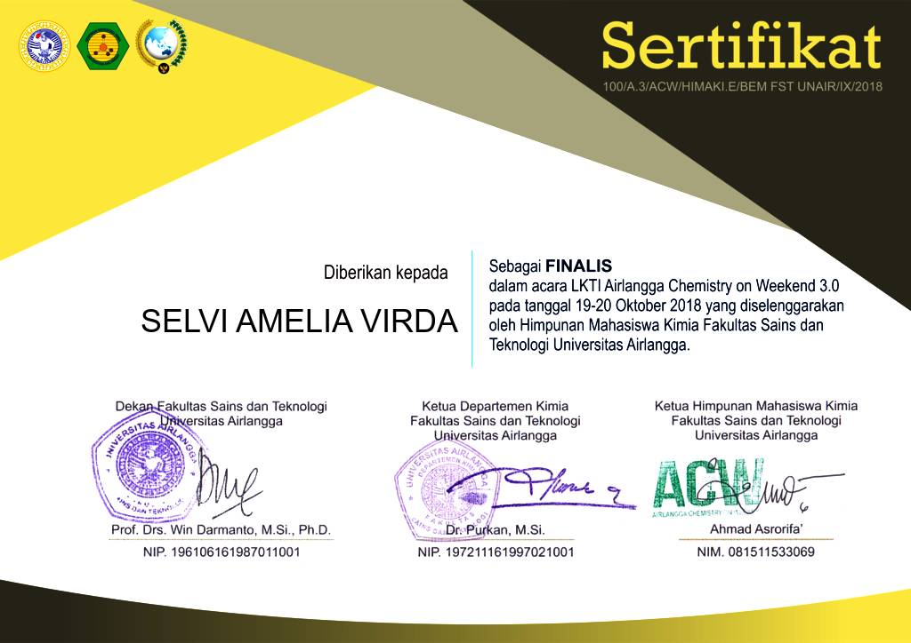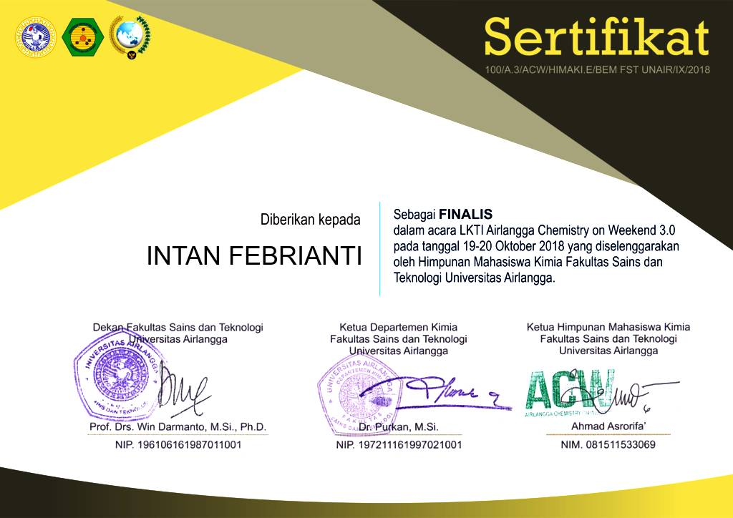
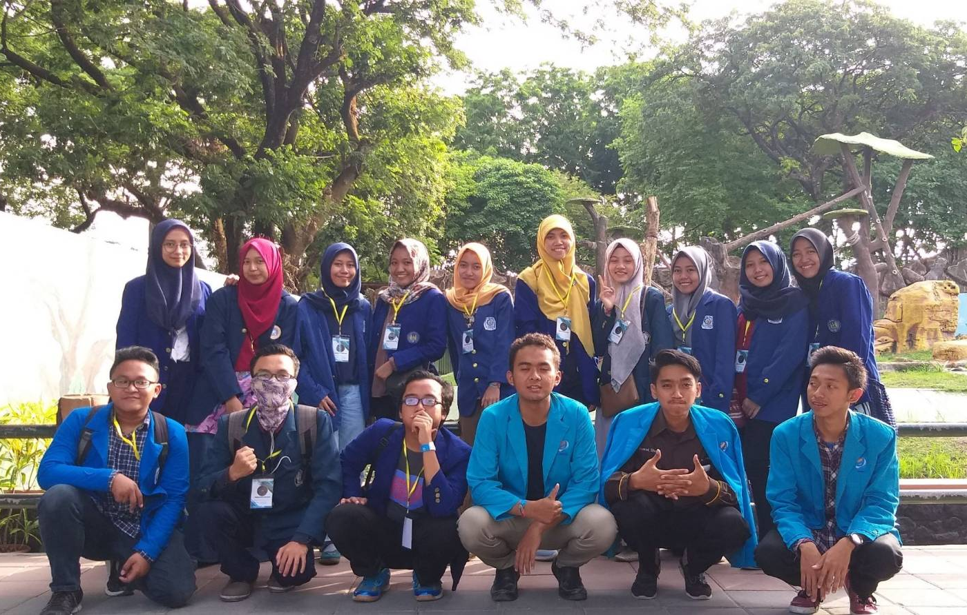

- COME AND INNOVATE IN CHEMICAL ENGINEERING PHENOMENAL COMPETITION
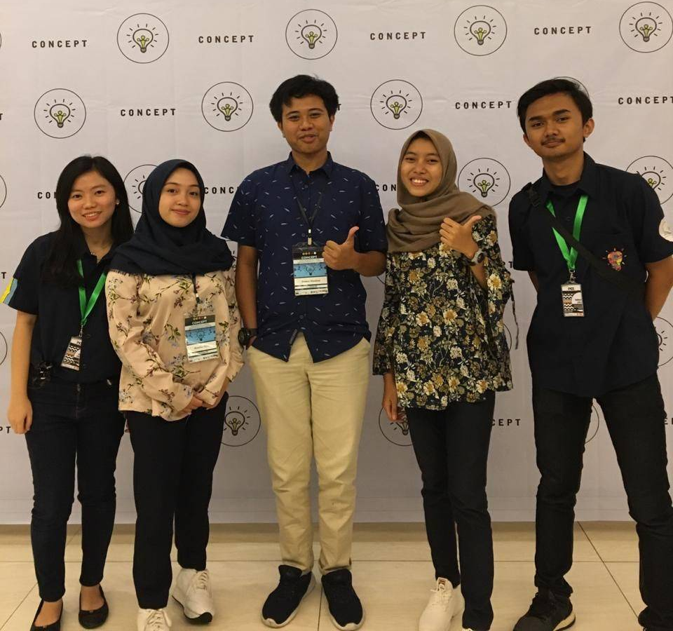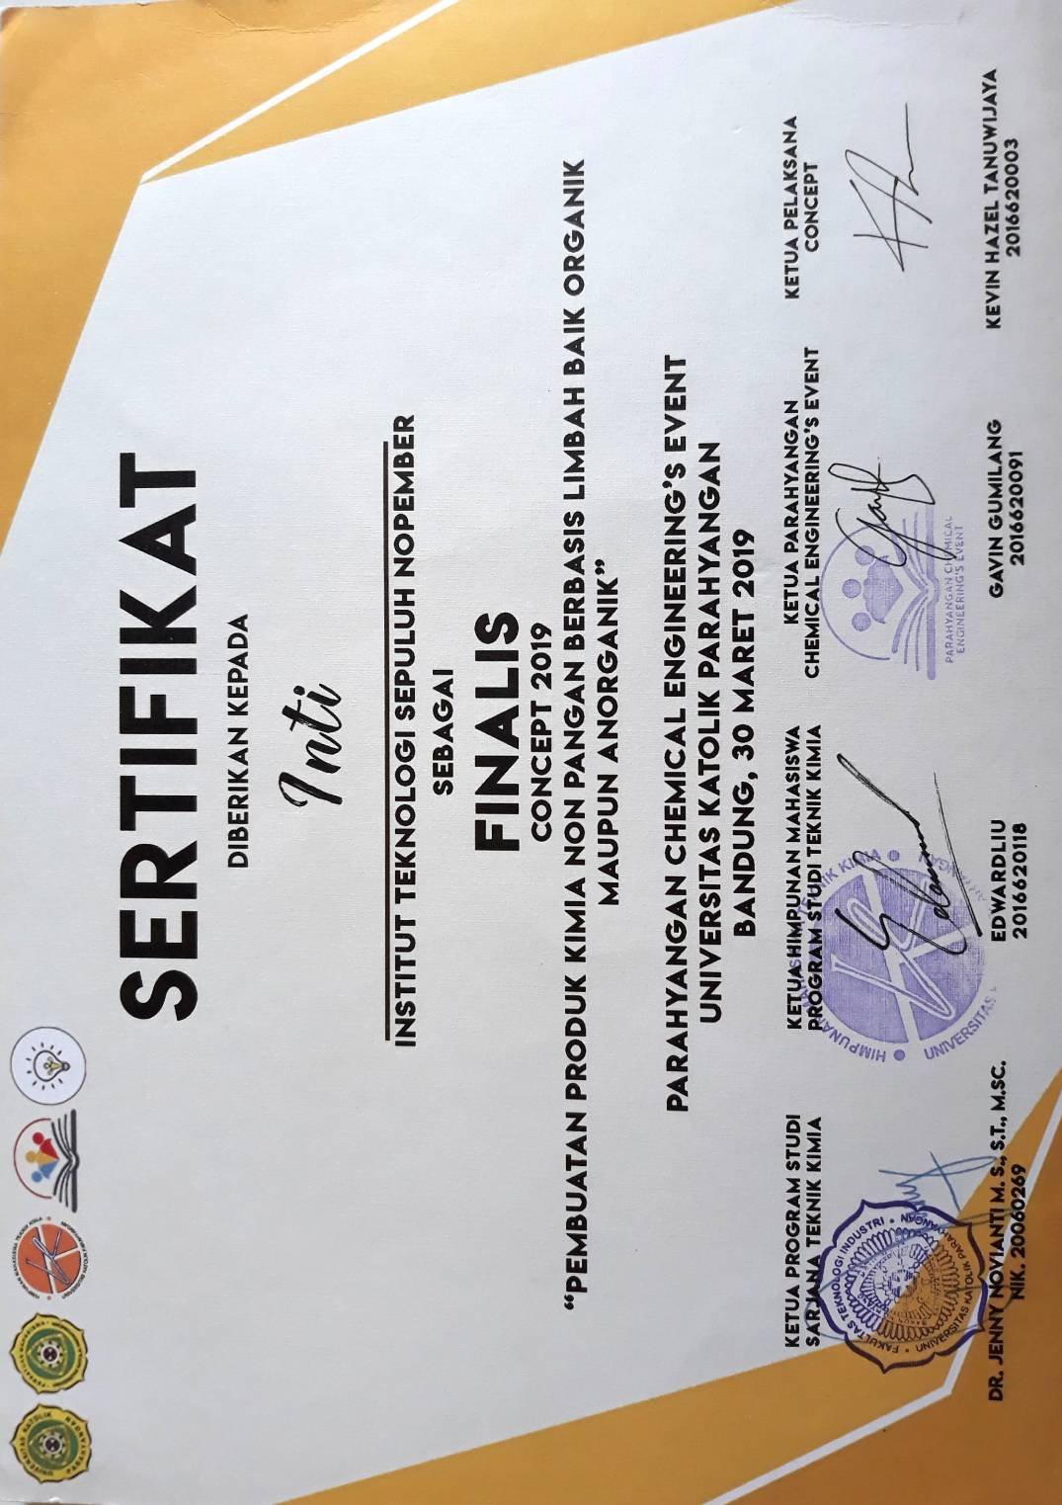
- MAHASISWA BERPRESTASI
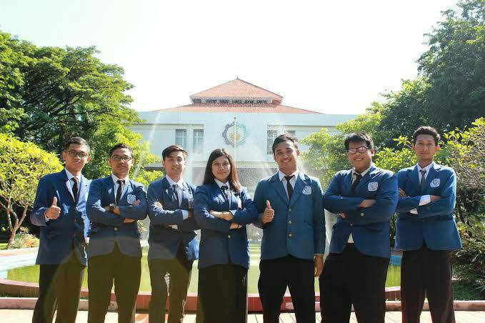

- AIRLANGGA CHEMISTRY ON WEEKEND 3.0
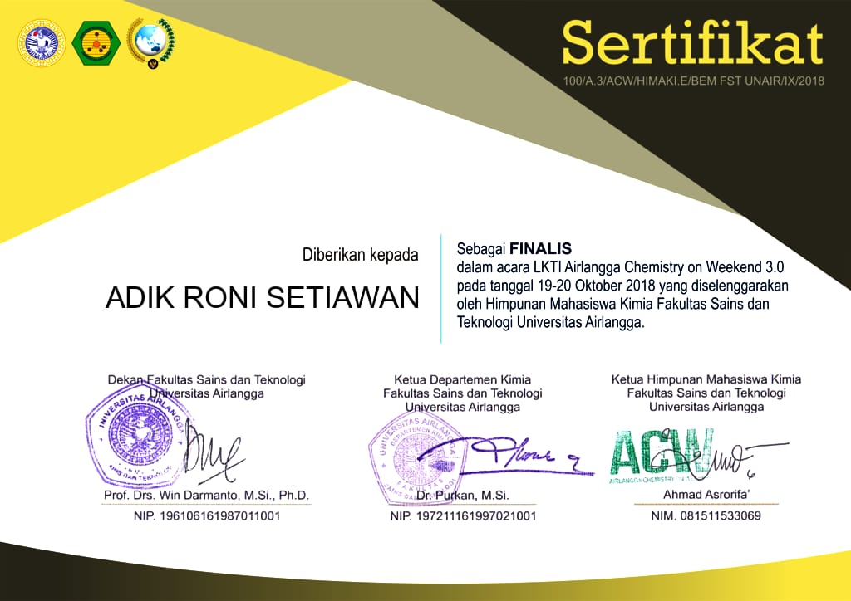

- THE 5TH INTERNATIONAL YOUNG INVENTOR AWARD
