**Tenaga Administrasi**

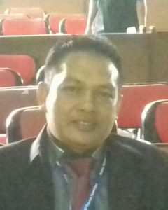

Muzammil

**Kasubbag Tata Usaha**

Heri Kusmayadi

[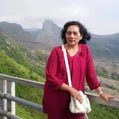](http://ichem-tech.its.ac.id/index.php/tenaga-administrasi/img-20170915-wa0008-2/?customize_changeset_uuid=d0fa327a-1d18-403c-b0e3-ef7f36c150b9&customize_messenger_channel=preview-2)

Anik Septiowardani

[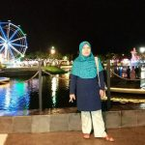](http://ichem-tech.its.ac.id/index.php/tenaga-administrasi/img-20170915-wa0004/?customize_changeset_uuid=d0fa327a-1d18-403c-b0e3-ef7f36c150b9&customize_messenger_channel=preview-2)

Heny Poernamawati

[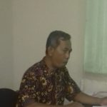](http://ichem-tech.its.ac.id/index.php/tenaga-administrasi/sri-aji-oye/?customize_changeset_uuid=d0fa327a-1d18-403c-b0e3-ef7f36c150b9&customize_messenger_channel=preview-2)

Sri Aji

[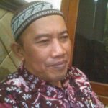](http://ichem-tech.its.ac.id/index.php/tenaga-administrasi/photo/?customize_changeset_uuid=d0fa327a-1d18-403c-b0e3-ef7f36c150b9&customize_messenger_channel=preview-2)

Sugeng Priono

[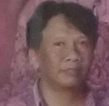](http://ichem-tech.its.ac.id/index.php/tenaga-administrasi/slamet/?customize_changeset_uuid=d0fa327a-1d18-403c-b0e3-ef7f36c150b9&customize_messenger_channel=preview-2)

Slamet Hariono

[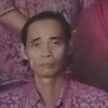](http://ichem-tech.its.ac.id/index.php/tenaga-administrasi/20170926_101447-3/?customize_changeset_uuid=d0fa327a-1d18-403c-b0e3-ef7f36c150b9&customize_messenger_channel=preview-2)

M. Efendi

[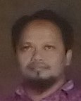](http://ichem-tech.its.ac.id/index.php/tenaga-akademik/wawan-2/?customize_changeset_uuid=d0fa327a-1d18-403c-b0e3-ef7f36c150b9&customize_messenger_channel=preview-2)

Wawan Prawono

[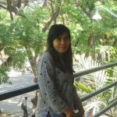](http://ichem-tech.its.ac.id/index.php/tenaga-administrasi/img-20170915-wa0005/?customize_changeset_uuid=d0fa327a-1d18-403c-b0e3-ef7f36c150b9&customize_messenger_channel=preview-2)

Ratri Randa Kirana, A.Md

[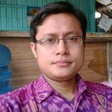](http://ichem-tech.its.ac.id/index.php/tenaga-administrasi/img-20170915-wa0007/?customize_changeset_uuid=d0fa327a-1d18-403c-b0e3-ef7f36c150b9&customize_messenger_channel=preview-2)

Purwodarmianto, A.Md

[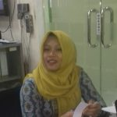](http://ichem-tech.its.ac.id/index.php/tenaga-administrasi/aprilia-oye/?customize_changeset_uuid=d0fa327a-1d18-403c-b0e3-ef7f36c150b9&customize_messenger_channel=preview-2)

Aprilia Dwi Nuryati

[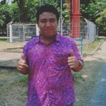](http://ichem-tech.its.ac.id/index.php/tenaga-administrasi/photo-2/?customize_changeset_uuid=d0fa327a-1d18-403c-b0e3-ef7f36c150b9&customize_messenger_channel=preview-2)

Fahmi Ramadhan