TUGAS AKHIR - TF 181801

PERANCANGAN FAULT TOLERANT CONTROL (FTC) PADA REGENERATIVE ANTI-LOCK BRAKING SYSTEM DENGAN MOTOR BLDC

NAMA SAYA
NRP. 023XXXXXXXXXXX

Dosen Pembimbing
Pembimbing 1
NIP XXXX
Pembimbing 2
NIP XXX

Program Studi S1 Teknik Fisika
Departemen Teknik Fisika
Fakultas Teknologi Industri dan Rekayasa Sistem
Institut Teknologi Sepuluh Nopember
Surabaya
20XX

Tugas Akhir - TF 181801

JUDUL TUGAS AKHIR

NAMA MAHASISWA
NRP 023XXXXXXXXXXX

Dosen Pembimbing
Nama Pembimbing 1
NIP XXX
Nama Pembimbing 2
NIP XXX

Program Studi S1 Teknik Fisika
Departemen Teknik Fisika
Fakultas Teknologi Industri dan Rekayasa Sistem
Institut Teknologi Sepuluh Nopember
Surabaya
20XX

Halaman ini sengaja dikosongkan
Halaman ini sengaja dikosongkan

COVER PAGE
FINAL PROJECT - TF 181801

FINAL PROJECT TITLE

STUDENT NAME
NRP 023XXXXXXXXXXX

Advisor
Advisor 1
NIP XXX
Advisor 2
NIP XXX

Study Program Bachelor of Engineering Physics
Department of Engineering Physics
Faculty of Industrial Technology and System Engineering
Institut Teknologi Sepuluh Nopember
Surabaya
2XXX

Halaman ini sengaja dikosongkan

PERNYATAAN ORISINALITAS

Yang bertanda tangan di bawah ini.

Nama Mahasiswa / NRP : Nama Saya
Departemen / Prodi : Teknik Fisika / S1 Teknik Fisika
Dosen Pembimbing / NIP : ….

dengan ini menyatakan bahwa Tugas Akhir dengan judul “JUDUL ANDA” adalah hasil karya saya sendiri, bersifat orisinal, dan ditulis dengan mengikuti kaidah penulisan ilmiah.
Bilamana di kemudian hari ditemukan ketidaksesuaian dengan pernyataan ini, maka saya bersedia menerima sanksi sesuai dengan ketentuan yang berlaku di Institut Teknologi Sepuluh Nopember.

Mengetahui  Dosen Pembimbing  (___________________________)  NIP. | Surabaya, XX Bulan 2XXX  Mahasiswa,  Materai  6000  (Nama Saya)  NRP. 023XXXXXXXXX

Halaman ini sengaja dikosongkan

STATEMENT OF ORIGINALITY

The undersigned below:

Name of student / NRP : ____________________________________
Department : Engineering Physics
Advisor / NIP : ____________________________________

hereby declare that the Final Project with the title of “_____________________________” is the result of my own work, is original, and is written by following the rules of scientific writing.
If in the future there is a discrepancy with this statement, then I am willing to accept sanctions in accordance with the provisions that apply at Institut Teknologi Sepuluh Nopember.

Surabaya, __________________
Acknowledged
Advisor Student

(___________________________) (___________________________)
NIP. NRP.

Halaman ini sengaja dikosongkan

LEMBAR PENGESAHAN

JUDUL TUGAS AKHIR DITULIS SINGKAT JELAS DAN MENGGAMBARKAN TEMA POKOK

TUGAS AKHIR
Diajukan untuk memenuhi salah satu syarat
memperoleh gelar Sarjana Teknik pada
Program Studi Sarjana Teknik Fisika
Departemen Teknik Fisika
Fakultas Teknologi Industri dan Rekayasa Sistem
Institut Teknologi Sepuluh Nopember

Oleh: Nama Saya
NRP. 023XXXXXXXXXX

Disetujui oleh Tim Penguji Tugas Akhir:

- Nama dan gelar pembimbing Pembimbing I
- Nama dan gelar pembimbing Ko-pembimbing
- Nama dan gelar penguji Penguji
- Nama dan gelar penguji Penguji
- Nama dan gelar penguji Penguji
SURABAYA
Bulan, Tahun
Halaman ini sengaja dikosongkan

APPROVAL SHEET

THE TITLE OF THE FINAL PROJECT IS WRITTEN BRIEFLY, CLEARLY AND DESCRIBING THE MAIN THEME

FINAL PROJECT
Submitted to fulfill one of the requirements
for obtaining a degree Bachelor of Engineering at
Undergraduate Study Program of Engineering Physics
Department of Engineering Physics
Faculty of Industrial Technology and Systems Engineering
Institut Teknologi Sepuluh Nopember

Oleh:

NAMA SAYA
NRP. 023XXXXXXXXXXX

Disetujui oleh Tim Penguji Tugas Akhir:

- Name of Advisor and academic title Advisor
- Name of Co-Advisor/Examiner and academic title Co-Advisor
- Name of Examiner and academic title Examiner
- Name of Examiner and academic title Examiner
- Name of Examiner and academic title Examiner
SURABAYA
Month, Year

Halaman ini sengaja dikosongkan

PERANCANGAN FAULT TOLERANT CONTROL (FTC) PADA REGENERATIVE ANTI-LOCK BRAKING SYSTEM DENGAN MOTOR BLDC UNTUK APLIKASI MOBIL LISTRIK DENGAN KESALAHAN PADA AKTUATOR

Nama Mahasiswa / NRP | : | Nama Saya
Departemen | : | Teknik Fisika FTIRS – ITS
Dosen Pembimbing | : | Pembimbing 1
 |  | Pembimbing 2

Abstrak
Lorem Ipsum is simply dummy text of the printing and typesetting industry. Lorem Ipsum has been the industry's standard dummy text ever since the 1500s, when an unknown printer took a galley of type and scrambled it to make a type specimen book. It has survived not only five centuries, but also the leap into electronic typesetting, remaining essentially unchanged. It was popularised in the 1960s with the release of Letraset sheets containing Lorem Ipsum passages, and more recently with desktop publishing software like Aldus PageMaker including versions of Lorem Ipsum. Lorem Ipsum is simply dummy text of the printing and typesetting industry. Lorem Ipsum has been the industry's standard dummy text ever since the 1500s, when an unknown printer took a galley of type and scrambled it to make a type specimen book. It has survived not only five centuries, but also the leap into electronic typesetting, remaining essentially unchanged. It was popularised in the 1960s

Kata Kunci: ABS, Fault Tolerant Control, inverter, motor BLDC

Halaman ini sengaja dikosongkan

FAULT TOLERANT CONTROL (FTC) DESIGN ON REGENERATIVE ANTI-LOCK BRAKING SYSTEM WITH BLDC FOR ELECTRIC CAR APPLICATION WITH FAULTS ON ACTUATOR

Student Name /NRP | : | My Name / 023xxx
Department | : | Engineering Physics FTIRS – ITS
Advisor | : | Name of advisor and academic title

Abstract
Lorem Ipsum is simply dummy text of the printing and typesetting industry. Lorem Ipsum has been the industry's standard dummy text ever since the 1500s, when an unknown printer took a galley of type and scrambled it to make a type specimen book. It has survived not only five centuries, but also the leap into electronic typesetting, remaining essentially unchanged. It was popularised in the 1960s with the release of Letraset sheets containing Lorem Ipsum passages, and more recently with desktop publishing software like Aldus PageMaker including versions of Lorem Ipsum. Lorem Ipsum is simply dummy text of the printing and typesetting industry. Lorem Ipsum has been the industry's standard dummy text ever since the 1500s, when an unknown printer took a galley of type and scrambled it to make a type specimen book. It has survived not only five centuries, but also the leap into electronic typesetting, remaining essentially unchanged. It was popularised in the 1960s

Keywords: ABS, Fault Tolerant Control, inverter, motor BLDC

Halaman ini sengaja dikosongkan

KATA PENGANTAR

Duis autem vel eum iriure dolor in hendrerit in vulputate velit esse molestie consequat, vel illum dolore eu feugiat nulla facilisis at vero eros et accumsan et iusto odio dignissim qui blandit praesent luptatum zzril delenit augue duis dolore te feugait nulla facilisi:
- Lorem ipsum dolor sit amet, consetetur sadipscing elitr
- Lorem ipsum dolor sit amet, consetetur sadipscing elitr
- Lorem ipsum dolor sit amet, consetetur sadipscing elitr
- Lorem ipsum dolor sit amet, consetetur sadipscing elitr
- Lorem ipsum dolor sit amet, consetetur sadipscing elitr
Serta pihak-pihak lain yang tidak dapat disebutkan satu-persatu. Semoga laporan tugas akhir ini dapat dipergunakan dengan sebaik-baiknya.

Surabaya, XX Bulan 2XXX
Penulis

Halaman ini sengaja dikosongkan

DAFTAR ISI

HALAMAN JUDUL………………………………………………………………..…………..i
PERNYATAAN ORISINALITAS v
LEMBAR PENGESAHAN ix
APPROVAL SHEET xi
Abstrak xiii
Abstract xv
KATA PENGANTAR xvii
DAFTAR ISI xix
DAFTAR GAMBAR xxi
DAFTAR TABEL xxii
BAB I PENDAHULUAN 1
1.1 Latar Belakang 1
1.2 Rumusan Masalah 2
1.3 Tujuan 2
1.4 Batasan Masalah 2
1.5 Sistematika Laporan 2
BAB II TINJAUAN PUSTAKA DAN DASAR TEORI 3
2.1 Sub Materi 1 3
2.2 Sub Materi 2 3
2.3 Sub Materi 3 4
BAB III METODOLOGI PENELITIAN 5
3.1 Sub Materi 1 5
3.2 Sub Materi 2 5
3.3 Sub Materi 3 6
3.4 Sub Materi 4 6
3.5 Sub Materi 5 7
BAB IV HASIL DAN PEMBAHASAN 9
4.1 Sub Materi 1 9
4.2 Sub Materi 2 9
4.3 Sub Materi 3 10
4.4 Sub Materi 4 10
BAB V KESIMPULAN DAN SARAN 13
5.1 Kesimpulan 13
5.2 Saran 13
DAFTAR PUSTAKA 14
LAMPIRAN 16
BIODATA PENULIS 18

DAFTAR GAMBAR

Gambar 2.1 Quarter car model 3
Gambar 2.2 Kurva hubungan slip ratio dengan friction coefficient mmmmmmm 3
Gambar 3.1 Rangkaian equivalen BLDC 7
Gambar 4.1 Respon slip ratio saat pengereman 9
Gambar 4.2 Perbandingan slip ratio dengan dan tanpa FTC pada kesalahan switch 5. Perbandingan slip ratio dengan dan tanpa FTC pada kesalahan Switch 1 dan 2 11
Gambar 4.3 Perbandingan penurunan kecepatan kesalahan switch 5. Perbandingan slip ratio dengan dan tanpa FTC pada kesalahan Switch 1 dan 11

Halaman ini sengaja dikosongkan

DAFTAR TABEL

Tabel 2.1 Urutan komutasi six-step inverter 4
Tabel 3.1 Variabel pada persamaan gaya 7
Tabel 3.2 Parameter kontroler slip ratio 8
Tabel 4.1 Performansi kontrol speed 13

Halaman ini sengaja dikosongkan

PENDAHULUAN

Latar Belakang
Latar belakang berisi alasan mengapa riset yang diambil perlu untuk diselesaikan. Kedua perlu diberikan penjelasan menyeluruh perkembangan riset untuk mengatasi masalah dalam riset yang diambil. Ketiga adalah alasan pemilihan metode dalam riset yang diambil dibandingkan dengan perkembangan pada point kedua. Keempat perlu diberikan penjelasan perkembangan riset kedepan atas diselesaikannya riset yang diambil.
Lorem ipsum dolor sit amet, consetetur sadipscing elitr (Westbrook, 2005). Lorem ipsum dolor sit amet, consetetur sadipscing elitr (Shiosansi, 2008), Lorem ipsum dolor sit amet, consetetur sadipscing elitr (Offer, 2010). Lorem ipsum dolor sit amet, consetetur sadipscing elitr (Tur, 2007).
Lorem ipsum dolor sit amet, consetetur sadipscing elitr (Tur, 2007). Lorem ipsum dolor sit amet, consetetur sadipscing elitr (Gao, 2001). Lorem ipsum dolor sit amet, consetetur sadipscing elitr (Murali, 2017), Lorem ipsum dolor sit amet, consetetur sadipscing elitr (Bai, 2011), Lorem ipsum dolor sit amet, consetetur sadipscing elitr (Gao, 2001).
Lorem ipsum dolor sit amet, consetetur sadipscing elitr (Errabelli, 2012). Lorem ipsum dolor sit amet, consetetur sadipscing elitr (Blanke, 1999). Lorem ipsum dolor sit amet, consetetur sadipscing elitr. Lorem ipsum dolor sit amet, consetetur sadipscing elitr. At vero eos et accusam et justo duo dolores et ea rebum. Stet clita kasd gubergren, no sea takimata sanctus est Lorem ipsum dolor sit amet. Lorem ipsum dolor sit amet, consetetur sadipscing elitr, sed diam nonumy eirmod tempor invidunt ut labore et dolore magna aliquyam erat, sed diam voluptua. At vero eos et accusam et justo duo dolores et ea rebum. Stet clita kasd gubergren, no sea takimata sanctus est Lorem ipsum dolor sit amet. Lorem ipsum dolor sit amet, consetetur sadipscing elitr. At vero eos et accusam et justo duo dolores et ea rebum. Stet clita kasd gubergren, no sea takimata sanctus est Lorem ipsum dolor sit amet. Lorem ipsum dolor sit amet, consetetur sadipscing elitr, sed diam nonumy eirmod

Rumusan Masalah
Rumusan masalah berisi runtutan masalah yang akan diselesaikan dalam riset yang diambil:
- Lorem ipsum dolor sit amet, consetetur sadipscing elitr?
- Lorem ipsum dolor sit amet, consetetur sadipscing elitr?

Tujuan
Tujuan dijelaskan untuk, minimal, menjawab rumusan masalah yang dibuat:
- Lorem ipsum dolor sit amet, consetetur sadipscing elitr
- Lorem ipsum dolor sit amet, consetetur sadipscing elitr

Batasan Masalah
Batasan masalah sesuatu yang harus diberikan pada riset yang diambil untuk menghilangkan generalisasi asumsi. Misalkan brand, ruang lingkup plant, tipe alat, dsb:
- Lorem ipsum dolor sit amet, consetetur sadipscing elitr
- Lorem ipsum dolor sit amet, consetetur sadipscing elitr
- Lorem ipsum dolor sit amet, consetetur sadipscing elitr

Sistematika Laporan
Sistematika laporan berisi gambaran singkat bagaimana struktur peenulisan laporan tugas akhir untuk memudahkan pembaca dalam mamahami alur laporan. Lorem ipsum dolor sit amet, consetetur sadipscing elitr. At vero eos et accusam et justo duo dolores et ea rebum. Stet clita kasd gubergren, no sea takimata sanctus est Lorem ipsum dolor sit amet. Lorem ipsum dolor sit amet, consetetur sadipscing elitr, sed diam nonumy eirmod tempor invidunt ut labore et dolore magna aliquyam erat, sed diam voluptua. At vero eos et accusam et justo duo dolores et ea rebum. Stet clita kasd gubergren, no sea takimata sanctus est Lorem ipsum dolor sit amet

TINJAUAN PUSTAKA DAN DASAR TEORI

Sub Materi 1
Teori penunjang berisi studi pustaka materi dalam riset yang diambil (Lubbers, 2014). Persamaan ditulis sesuai dengan format berikut, rata kiri dengan Cambria Math (Font size: 12) dan ukuran numbering (2.1) adalah 12. Sitasi harus selalu diberikan jika mengambil referensi dari sumber lain (Tur, 2007):

$$F_{x}= μ.m.g$$ | (2.1)
$$F_{a}= 0,5.c_{r}.δ.A_{f}.v^{2}$$ | (2.2)

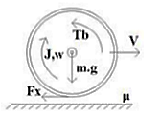
Gambar 2.1 Quarter car model

Sub Materi 2

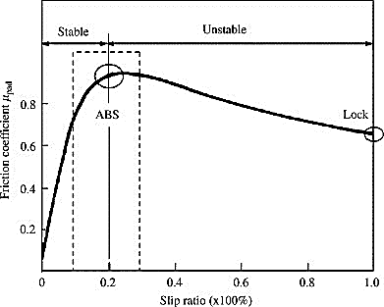
Gambar 2.2 Kurva hubungan slip ratio dengan friction coefficient mmmmmmmmm
$$F_{x}= μ.m.g$$ | (2.3)

At vero eos et accusam et justo duo dolores et ea rebum. Stet clita kasd gubergren, no sea takimata sanctus est Lorem ipsum dolor sit amet (Gao, 2001).

Sub Materi 3
Lorem ipsum dolor sit amet, consetetur sadipscing elitr, sed diam nonumy eirmod tempor invidunt ut labore et dolore magna aliquyam erat, sed diam voluptua (Murali, 2017).
Jika Panjang tabel tidak melebihi ukuran A4, maka tabel tidak diperkenankan terpotong dengan halaman lain sehingga harus dalam 1 halaman yang sama (Singh, 2012). Jika panjang tabel melebihi panjang A4, header tabel (baris merah dibawah) harus dimunculkan dalam halaman lanjutan

Tabel 2.1 Urutan komutasi six-step inverter hmhj mbmbm nmbmmm kkkkkk djduuud ddjj
Rotor Pos. (deg) | H1 | H2 | H3 | Switch tutup | Phase
 |  |  |  |  | A | B | C
0-60 | 1 | 0 | 0 | Q1 Q4 | + | - | Off
60-120 | 1 | 1 | 0 | Q1 Q6 | + | Off | -
120-180 | 0 | 1 | 0 | Q3 Q6 | Off | + | -
180-240 | 0 | 1 | 1 | Q3 Q2 | - | + | off
240-300 | 0 | 0 | 1 | Q5 Q2 | - | Off | +
300-360 | 1 | 0 | 1 | Q5 Q4 | off | - | +

METODOLOGI PENELITIAN

Metodologi penelitian diawali dengan flowchart detail tentang riset yang diambil. Gambar pada flowchart dapat terkuantifikasi dengan angka. Hal yang bersifat kualitatif dapat dijelaskan dengan detail pada sub materi setelah flowchart untuk lebih menjelaskan alur penelitian.
Catatan, jika data yang digunakan menyerupai materi pada BAB 2, maka sebaiknya melakukan rujukan pada persamaan, gambar, atau tabel yang telah ditulis pada BAB 2 sehingga tidak diperlukan penulisan kembali pada BAB 3.

Sub Materi 1
Lorem ipsum dolor sit amet, consectetur adipiscing elit, sed do eiusmod tempor incididunt ut labore et dolore magna aliqua. Ut enim ad minim veniam, quis nostrud exercitation ullamco laboris nisi ut aliquip ex ea commodo consequat. Duis aute irure dolor in reprehenderit in voluptate velit esse cillum dolore eu fugiat nulla pariatur. Excepteur sint occaecat cupidatat non proident, sunt in culpa qui officia deserunt mollit anim id est laborum.

Sub Materi 2

Sub Sub Materi 1
Lorem ipsum dolor sit amet, consectetur adipiscing elit, sed do eiusmod tempor incididunt ut labore et dolore magna aliqua. Ut enim ad minim veniam, quis nostrud exercitation ullamco laboris nisi ut aliquip ex ea commodo consequat. Duis aute irure dolor in reprehenderit in voluptate velit esse cillum dolore eu fugiat nulla pariatur. Excepteur sint occaecat cupidatat non proident, sunt in culpa qui officia deserunt mollit anim id est laborum.:

$$F_{x}= μ.m.g$$ | (3.1)
$$-4\left(F_{x}+F_{a}+F_{w}\right)=m\frac{dv}{dt}$$ | (3.2)
Lorem ipsum dolor sit amet, consectetur adipiscing elit, sed do eiusmod tempor incididunt ut labore et dolore magna aliqua. Ut enim ad minim veniam, quis nostrud exercitation ullamco laboris nisi ut aliquip ex ea commodo consequat, (2.1), (2.2), (2.3) (Tur, 2007):

Tabel 3.1 Variabel pada persamaan gaya
No. | Simbol | Variabel (satuan) | Nilai
1. | $$m$$ | Massa QCM (kg) | 425
2. | $$g$$ | Percepatan gravitasi (m/s²) | 9,8
3. | $$c_{r}$$ | Koefisien aerodinamik | 0,3
4. | $$δ$$ | Densitas udara (kg/m³) | 1,225
5. | $$A_{f}$$ | Luas permukaan frontal (m²) | 3,1
7. | $$c_{t}$$ | Koefisien resistansi putaran roda | 0,01
8. | $$α$$ | Sudut jalan qcm (rad) | 0

Sub Sub Materi 2
Lorem ipsum dolor sit amet, consectetur adipiscing elit, sed do eiusmod tempor incididunt ut labore et dolore magna aliqua. Ut enim ad minim veniam, quis nostrud exercitation ullamco laboris nisi ut aliquip ex ea commodo consequat (Murali, 2017)

$$μ\left(λ,v\right)=\left(c_{1}\left(1-e^{{-c}_{2}λ}\right)-c_{3}λ\right).e^{{-c}_{4}λv}$$ | (3.3)

Sub Materi 3
Lorem ipsum dolor sit amet, consectetur adipiscing elit, sed do eiusmod tempor incididunt ut labore et dolore magna aliqua. Ut enim ad minim veniam, quis nostrud exercitation ullamco laboris nisi ut aliquip ex ea commodo consequat. Duis aute irure dolor in reprehenderit in voluptate velit esse cillum dolore eu fugiat nulla pariatur. Excepteur sint occaecat cupidatat non proident, sunt in culpa qui officia deserunt mollit anim id est laborum:

Sub Materi 4
Duis aute irure dolor in reprehenderit in voluptate velit esse cillum dolore eu fugiat nulla pariatur. Excepteur sint occaecat cupidatat non proident, sunt in culpa qui officia deserunt mollit anim id est laborum (Tashakori, 2011)

Gambar 3.1 Rangkaian equivalen BLDC
$$V_{a}=Ri_{a}+L\frac{di_{a}}{dt}+e_{a}$$ | (3.4)
$$V_{b}=Ri_{b}+L\frac{di_{b}}{dt}+e_{b}$$ | (3.5)

Sub Materi 5
Duis aute irure dolor in reprehenderit in voluptate velit esse cillum dolore eu fugiat nulla pariatur. Excepteur sint occaecat cupidatat non proident, sunt in culpa qui officia deserunt mollit anim id est laborum.

Halaman ini sengaja dikosongkan

HASIL DAN PEMBAHASAN

BAB IV membahas secara detail hasil termuan terhadap riset yang diambil untuk menjaawab rumusan masalah.

Sub Materi 1
Lorem ipsum dolor sit amet, consectetur adipiscing elit, sed do eiusmod tempor incididunt ut labore et dolore magna aliqua. Ut enim ad minim veniam, quis nostrud exercitation ullamco laboris nisi ut aliquip ex ea commodo consequat.
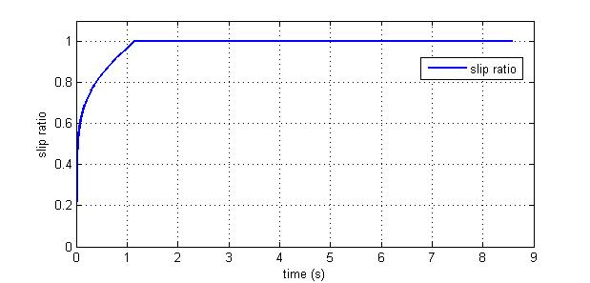
Gambar 4.1 Respon slip ratio saat pengereman
Lorem ipsum dolor sit amet, consectetur adipiscing elit, sed do eiusmod tempor incididunt ut labore et dolore magna aliqua. Ut enim ad minim veniam, quis nostrud exercitation ullamco laboris nisi ut aliquip ex ea commodo consequat. Duis aute irure dolor in reprehenderit in voluptate velit esse cillum dolore eu fugiat nulla pariatur. cepteur sint occaecat cupidatat non proident, sunt in culpa qui officia deserunt mollit anim id est laborum.

Sub Materi 2
Lorem ipsum dolor sit amet, consectetur adipiscing elit, sed do eiusmod tempor incididunt ut labore et dolore magna aliqua. Ut enim ad minim veniam, quis nostrud exercitation ullamco laboris nisi ut aliquip ex ea commodo consequat. Duis aute irure dolor in reprehenderit in voluptate velit esse cillum dolore eu fugiat nulla Lorem ipsum dolor sit amet, consectetur adipiscing elit, sed do eiusmod tempor incididunt ut labore et dolore magna aliqua. Ut enim ad minim veniam, quis nostrud exercitation ullamco laboris nisi ut aliquip ex ea commodo consequat. Duis aute irure dolor in reprehenderit in voluptate velit esse cillum dolore eu fugiat nulla pariatur.

Tabel 4.1 Performansi kontrol speed
Kriteria Performansi | Nilai
Rise time | 0,12 s
Settling Time | 0,18 s
Max. overshoot | 0%

Sub Materi 3
Lorem ipsum dolor sit amet, consectetur adipiscing elit, sed do eiusmod tempor incididunt ut labore et dolore magna aliqua. Ut enim ad minim veniam, quis nostrud exercitation ullamco laboris nisi ut aliquip ex ea commodo consequat. Duis aute irure dolor in reprehenderit in voluptate velit esse cillum dolore eu fugiat nulla pariatur.

Sub Materi 4
Lorem ipsum dolor sit amet, consectetur adipiscing elit, sed do eiusmod tempor incididunt ut labore et dolore magna aliqua. Ut enim ad minim veniam, quis nostrud exercitation ullamco laboris nisi ut aliquip ex ea commodo consequat. Duis aute irure dolor in reprehenderit in voluptate velit esse cillum dolore eu fugiat nulla pariatur.

Kesalahan pada Switch 1
Lorem ipsum dolor sit amet, consectetur adipiscing elit, sed do eiusmod tempor incididunt ut labore et dolore magna aliqua:

Kesalahan pada Switch 2
Lorem ipsum dolor sit amet, consectetur adipiscing elit, sed do eiusmod tempor incididunt ut labore et dolore magna aliqua. Ut enim ad minim veniam, quis nostrud exercitation ullamco laboris nisi ut aliquip ex ea commodo consequat. Duis aute irure dolor in reprehenderit in voluptate velit esse cillum dolore:

Kesalahan pada Switch 3
Lorem ipsum dolor sit amet, consectetur adipiscing elit, sed do eiusmod tempor incididunt ut labore et dolore magna aliqua:
- gkdfhdfhnzd
- khhf.hn.xhhhh
- jhlkxfjhlxjh
- jn,xmfhn.
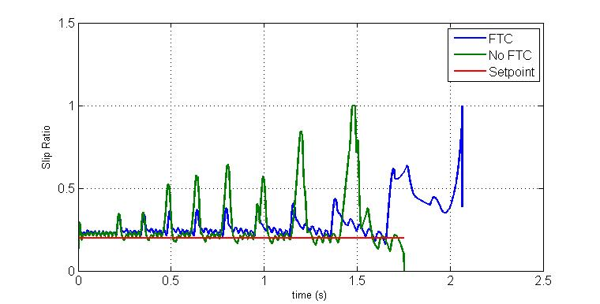
Gambar 4.2 Perbandingan slip ratio dengan dan tanpa FTC pada kesalahan switch 5. Perbandingan slip ratio dengan dan tanpa FTC pada kesalahan Switch 1 dan 2
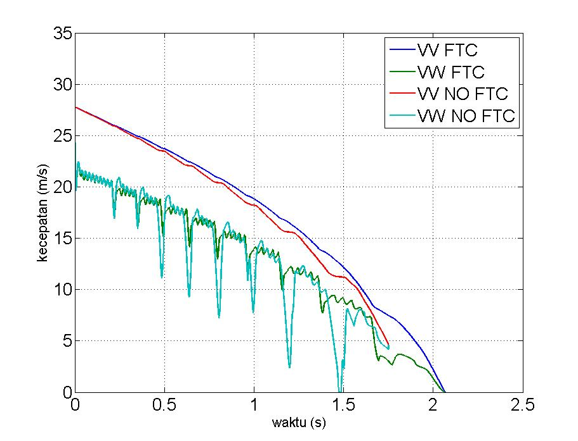
Gambar 4.3 Perbandingan penurunan kecepatan kesalahan switch 5 dengan dan tanpa FTC

Halaman ini sengaja dikosongkan

KESIMPULAN DAN SARAN

Kesimpulan
Kesimpulan menjawab permasalahan dengan penjelasan detail informasi yang telah dibahas pada BAB 4:
- Lorem ipsum dolor sit amet, consetetur sadipscing elitr.
- Lorem ipsum dolor sit amet, consetetur sadipscing elitr.
- Lorem ipsum dolor sit amet, consetetur sadipscing elitr

Saran
Saran berisi tentang kemungkinan penelitian lanjutan:
- Lorem ipsum dolor sit amet, consetetur sadipscing elitr.
- Lorem ipsum dolor sit amet, consetetur sadipscing elitr.
- Lorem ipsum dolor sit amet, consetetur sadipscing

Halaman ini sengaja dikosongkan

DAFTAR PUSTAKA

Bai, L. (2011). Electric Drive System with BLDC Motor. International Conference on Electric Information and Control Engineering (p. 254). Kuala Lumpur: Universiti Malaya.
Blanke, M. (1999). Fault Tolerant Control Systems. London: Adventure Workd Press.
Errabelli, R. (2012). Fault-Tolerant Voltage Source Inverter for Permanent Magnet Drives. IEEE Transactions on Power Electronics, 27.
Gao, Y. (2001). Electronic Braking System of EV and HEV--Integration of Regenerative Braking, Automatic Braking Force Control and ABS. 42 Volt Technology and Advanced Vehicle Electrical Systems.
Lubbers, K. (2014). Design and Analysis of a Model Based Low Level Slip Controller Based on a Hybrid Braking System. Science in Systems and Control Delft University.
Murali, T. (2017). Four Quadrant Operation and Control of Three Phase BLDC Motor. International Conference on Circuits Power and Computing Technology.
Offer, G. J. (2010). Comparative analysis of battery electric, hydrogen fuel cell, and hybrid vehicle in a future sustainable road transport system. energy policy, 38, 24-29.
Shiosansi, R. (2008). Emissions Impacts and Benefits of Plug-in Hybrid Electric Vehicles and Vehicle-to-Grid Services. Environmental Science Technology, 1199-1204.
Singh, C. P. (2012). State-space Based Simulink Modeling of BLDC Motor and its Speed Control Using Fuzzy PID Controller. International Journal of Advances in Engineering Science and Technology, 2, 359-369.
Tashakori, A. (2011). Modeling of BLDC Motor with Ideal Back-EMF for Automotive Applications. World Congress on Engineering. London.
Tur, O. (2007). An Introduction to Regenerative Braking of Electric Vehicles as Anti-Lock Braking System. Proceedings of 2007 IEEE Intelligent Vehicles Symposium, (pp. 13-15). Istanbul.
Westbrook, M. H. (2005). Development and future of battery, hybrid, and fuel-cell cars. London: The Institution of Electrical Engineers.

LAMPIRAN

- Sistem Pengereman Regenerative sebagai ABS
Zfhzdddh fhxxfh fhddjd hxfgx dngz nfgkdjghskldr gjdkfgsdlkr jgdkfdslk gjdlkfgdl fgsldkglsdg fljgsldj fgjdljs. Jdfgkhdkslgh zgbmbgd zbgglz ngzdkgdklg kjzfglz. jghzdkghz, gkdjhgk dghkdgh dkhfglkdg.

- Quarter Car Model
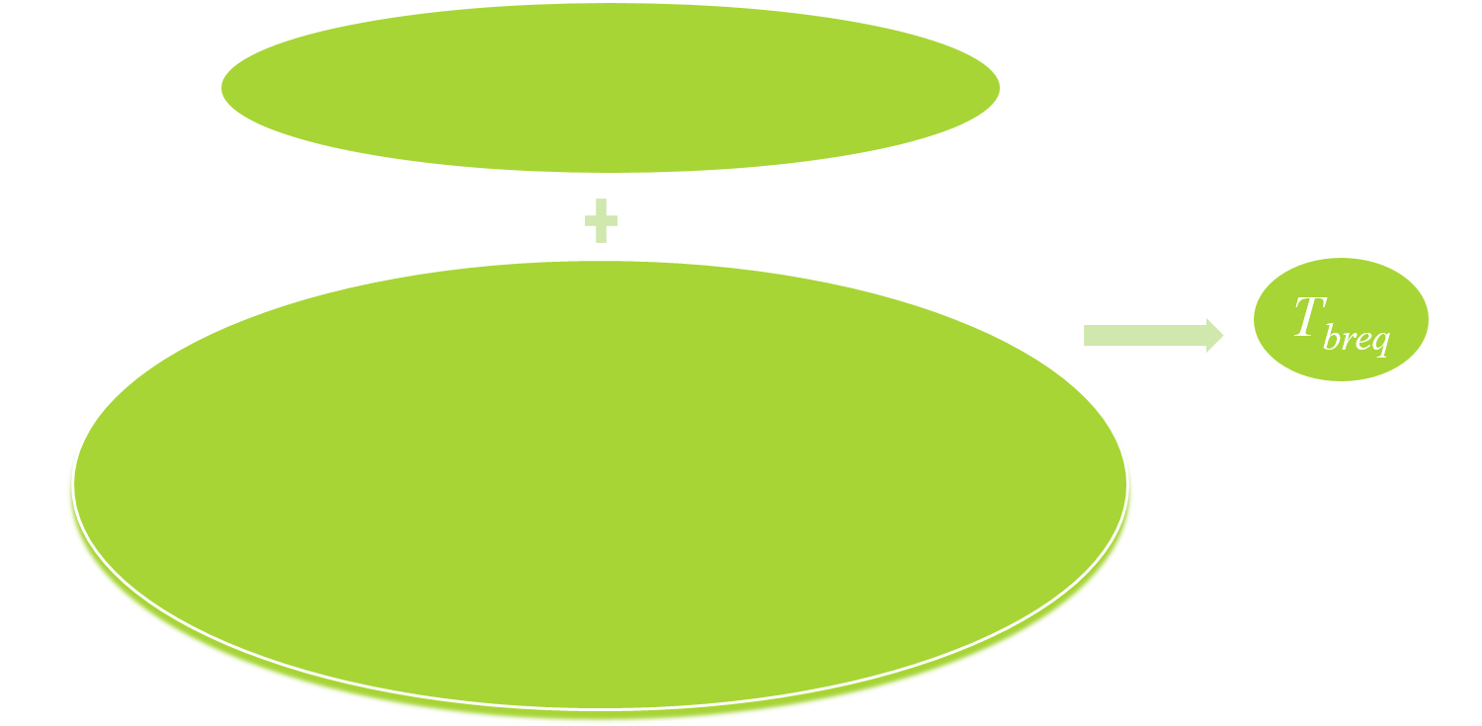
Gambar B.1 Diagram blok algoritma hfjsK

- Kode Matlab

clc;
%% parameter
m = 425;
r = 0.325;
Af = 3.1;
Cr = 0.3;
v0 = 27.778;
freq_max = 20000;
h = 0.01;
nb_p = 4;
Ts_vect = 50e-6;

Halaman ini sengaja dikosongkan

BIODATA PENULIS

Pas Foto
Nnnnnnnnnnnnnnnn nnnnnnnnnnn nnnnnnnn hvhhhhhhhh nnnnnnnnn nnnnnnnnnnnn nnnnnnnnn nnnnnnnnnnnn bvm. Mjgdgmdjfghdgh mjfhhhhhhhhhhhhhhhhhhh mfmffffffffm mggggggggggg gggggggggg mgjfhdjhjjjj hfghdgdhgdujd mfmfmfmfmff. Kmmmm mmmmm hdjghghjdghdjh dfshdsgh mmmmm mmmmmvnhbm bmmmmmmmmmm. Mmmm mmmmm mmmmm mmmmm mmmmmmm mmm bbbbbbb bbbbbbbbbb bbbbbbbbbbb nbzcbcxbccc. Msjfkjshflskzkl fsdhrgjseyrs dhfzsdgzsjgs.

