THE GUIDELINES
DESIGN IV / ENGINE ROOM LAYOUT
Machinery and Electrical System

Authors:
Ir. Hari Prastowo, M.Sc
Nurhadi Siswantoro, S.T., M.T.

DEPARTMENT OF MARINE ENGINEERING
FACULTY OF MARINE TECHNOLOGY - ITS
2019

Halaman ini sengaja dikosongkan
This page is intentionally left blank

SUBJECT : | DESIGN IV / ENGINE ROOM LAYOUT
DOCUMENT TITTLE : | THE GUIDELINES FOR DESIGN IV / ENGINE ROOM LAYOUT
DOCUMENT NO : | 01/D4-ERL/II/2019

DISCLAIMER

Manual desain ini hanya merupakan panduan untuk keperluan perkuliahan. Penulis tidak merekomendasikan panduan ini dipakai untuk keperluan industri dan komersial. Penulis tidak bertanggung-jawab bila terjadi kecelakaan yang diakibatkan oleh penggunaan manual ini untuk aplikasi industri dan komersial.

This design manual is a guidelines for educational purposes only. The authors do not recommend this guidelines for industrial and commercial purposes. The author is not liable in the event of any accident resulting from the use of this manual for industrial and commercial applications.

Halaman ini sengaja dikosongkan
This page is intentionally left blank

DAFTAR ISI

1. PENDAHULUAN / OVERVIEW 1
2. PROSEDUR / PROCEDURE 1
3. LAPORAN / REPORT 3
4. STANDAR DOKUMENTASI / STANDARD OF DOCUMENTATION 5
LAMPIRAN A – Format laporan 8
LAMPIRAN B – Business Process 30
LAMPIRAN C-1 - Design IV Machinery and Electrical System Form 34
LAMPIRAN C-2 – Engine Room Layout Form 41

Halaman ini sengaja dikosongkan
This page is intentionally left blank

PENDAHULUAN

Panduan ini bertujuan sebagai pedoman mata kuliah Desain IV (ME184730) dan Ship Machinery Plants/Engine Room Layout (ME184761). Pedoman ini terdiri dari 3 bagian utama:  - Prosedur  - Laporan  - Standar dokumentasi | The guidelines is intended as a guidelines for Design IV (ME184730) and Ship Machinery Plants/Engine Room Layout (ME184761). It consists of 3 main sections:  - Procedures  - Reports  - Standard of documentation

OVERVIEW

PROSEDUR

PROCEDURE
Prosedur dalam pengambilan mata kuliah Design IV (ME184730) dan Ship Machinery Plants/Engine Room Layout (ME184761) secara garis besar dapat dilihat pada Lampiran B.  - Mata Kuliah Pra-syarat  Mahasiswa harus mengambil mata kuliah pra-syarat berikut sebelum mengambil Desain IV (ME184730) dan Ship Machinery Plants/Engine Room Layout (ME184761). Berikut adalah mata kuliah pra-syarat:  - Design I  - Design II  - Design III  - Ship Resistance & Propulsion  - Marine Diesel & Propulsion Systems  - Marine Piping Systems  - HVAC  - Marine Electrical  - Marine Safety  - Pelaksanaan Pekerjaan  Dalam pengerjaan tugas Desain IV/Engine Room Layout mahasiswa mengikuti langkah-langkah berikut:  - Peserta  Tugas Desain IV / Engine Room Layout dikerjakan oleh mahasiswa secara individu  - Dosen Pembimbing  Dosen pembimbing terdiri dari Dosen Machinery dan Electrical  - Deliverable  Mahasiswa harus menyerahkan dokumen berupa:  - Laporan Machinery System  - Laporan Electrical System  catatan:  (termasuk: gambar, lampiran yang mana telah disetujui oleh dosen pembimbing) pada saat UTS dan UAS  - Monitoring  Selama proses pengerjaan 16 minggu, ada 3 kali monitoring progress.  - Progress I (Week 5)  - Progress II (Week 10 + UTS)  - Progress III (Week 16 + UAS)  Sudden death penalty:  Jika mahasiswa tidak mampu menyelasaikan target pada setiap monitoring, maka tidak diperkenankan untuk melanjutkan ke tahap berikutnya.  No Point of Return:  Bila ada mahasiswa yang melakukan “Drop” mata kuliah dan tidak menyelesaikan. Maka tidak akan diperkenankan untuk mengambil mata kuliah ini pada semester depannya.  - Bobot Penilaian  Bobot penilaian adalah sebagai berikut:  - Dospem (Machinery) = 24%  - Dospem (Electrical) = 16%  - UTS (Machinery) = 18%  - UTS (Electrical) = 12%  - UAS (Machinery) = 18%  - UAS (Electrical) = 12% | The procedures for Design IV (ME184730) and Ship Machinery Plants / Engine Room Layout (ME184761), generally can be seen in Appendix B.  - Pre-Requisite courses  Students shall take the following pre-requisite courses before taking Design IV (ME184730) and Ship Machinery Plants/Engine Room Layout (ME184761). Below listed are the pre-requisites courses:  - Design I  - Design II  - Design III  - Ship Resistance & Propulsion  - Marine Diesel & Propulsion Systems  - Marine Piping Systems  - HVAC  - Marine Electrical  - Marine Safety  - Project Execution  To complete the Design IV / Engine Room Layout students follow the steps below:  - Participant  Design IV / Engine Room Layout is done individually  - Supervisors  The supervisors consist of machinery and electrical supervisor.  - Deliverable  The student must deliver documents of:  - Report of Machinery System  - Report of Electrical System  Note:  (included: drawing, attachments which have been approved by the supervisor) at the Midterm and Final Examination  - Monitoring  There are 3 times progress monitoring for 16 weeks.  - Progress I (Week 5)  - Progress II (Week 10 + Mid Exam)  - Progress III (Week 16 + Final Exam)  Sudden death penalty:  If the student is not able to complete the target on each monitoring, student is not allowed to proceed to the next stage.  No Point of Return:  Once decided, this course shall be proceeded to full completion. Those who quit from this course will not be allowed to take in the next consecutive semester.  - Assessment Weight  Assessment weights are as follows:  - Supervisor (Machinery) = 24%  - Supervisor (Electrical) = 16%  - Midterm (Machinery) = 18%  - Midterm (Electrical) = 12%  - Final (Machinery) = 18%  - Final (Electrical) = 12%

LAPORAN

- REPORT
Struktur laporan Desain IV / Engine Room Layout terdiri dari 3 bagian utama, yaitu:  - Filosofi Desain  - Detail Perhitungan  - Lampiran (Spect, Drawing, dll)  - Filosofi Desain  Laporan machinery system terdiri dari 11 dokumen / filosofi desain, yaitu:  - List codes of Equipment  - Bilge System  - Oily-Water Bilge System  - Ballast System  - Fire Main System  - Fuel Oil System  - Lubricating Oil System  - Engine Cooling System  - Compressed Air System  - Domestic System  - Engine Room Air Ventilation System  Laporan electrical terdiri dari 4 dokumen / filosofi desain:  - Lightings and Electric Terminals  - Communication and Navigation Equipments  - Emergency Source of Electricity Power (ESEP)  - Generator & Shore Connection  Lihat Lampiran A untuk outline penulisan report.  - Detail Perhitungan  Detail perhitungan merupakan pendukung dari isi filosofi desain. Detail perhitungan ditulis dalam format spreadsheet (Ms. Excel). Detail Perhitungan tambahan dapat ditambahkan apabila diperlukan. Detail perhitungan terdiri dari (minimal):  - daftar code / referensi yang digunakan  - algoritma perhitungan  - input parameter desain (given parameter)  - output parameter desain  - detail perhitungan  Format detail perhitungan dapat dilihat Lampiran A  - Lampiran  - Spesifikasi  Parameter spesifikasi merujuk pada lampiran (akan disediakan)  - Gambar  Gambar yang akan dikumpulkan adalah:  - gambar schematic piping and instrument (PID) diagram dan bukan process flow diagram (PFD)  - gambar Engine Room Layout, mencerminkan letak dan posisi peralatan sebenarnya di kamar mesin.  - gambar 3D, 2 gambar diantara 11 machinery system (masing-masing 1 gambar saat UTS dan UAS yang ditentukan oleh dosen pembimbing)  Simbol yang digunakan pada gambar harus konsisten untuk semua gambar. Disarankan untuk merefer pada standar tertentu (JIS, DIN, ISO dll.)  Format gambar data dilihat pada lampiran A  - Lain-lain  Lampiran tambahan dicantumkan bila ada yang diperlukan untuk mendukung detail perhitungan. | The structure of Design IV / Engine Room Layout report, consists of 3 main parts, i.e.:  - Design Philosophy  - Detail of Calculation  - Attachment (Spect, Drawing, etc)  - Design Philosophy  The report of machinery system consists of 11 documents / design philosophy, i.e.:  - List codes of Equipment  - Bilge System  - Oily-Water Bilge System  - Ballast System  - Fire Main System  - Fuel Oil System  - Lubricating Oil System  - Engine Cooling System  - Compressed Air System  - Domestic System  - Engine Room Air Ventilation System  The electrical report consists of 4 documents / design philosophy:  - Lightings and Electric Terminals  - Communication and Navigation Equipments  - Emergency Source of Electricity Power (ESEP)  - Generator & Shore Connection  See Appendix A for writing report outline.  - Detail of Calcuation  Detail of calculation supports the content of the design philosophy. The calculation details are written in format spreadsheet (Ms. Excel). Additional calculations may be added when considered necessary. Detail of calculation consist of (at least):  - list of code / reference  - calculation algorithm  - input of parameter design (given parameter)  - output of parameters design  - detail of calculation  See Appendix A for format of calculation detail.  - Attachment  - Specification  Minimum parameters to be stated in the spec is referring to the attachment (will be provided)  - Drawing  The drawing to be submitted are:  - schematic piping and instrument (PID) diagram drawing, not process flow diagram (PFD)  - Engine Room Layout drawings, reflecting the location and position of the actual equipment in the engine room  - 3D drawing, 2 drawings among 11 machinery systems (each drawing at Midterm Exam and Final Exam)  The symbols used in the drawing must be consistent for all keyplans. It is recommended to refer to certain standards (JIS, DIN, ISO etc.)  See Appendix A for format of drawing.  - Others  Other attachments are provided if support detail of calculations.

STANDAR DOKUMENTASI

STANDARD OF DOCUMENTATION
- Format Penulisan Laporan  - Ukuran kertas adalah B5, dengan berat minimal 70 gr.  - Left margin 2,5 cm; top margin 2 cm; right margin 1 cm; bottom margin 2 cm.  - Font standar yang digunakan adalah Franklin Gothic Book. Font lain dapat digunakan untuk formula atau lambang lain yang spesifik.  - Besar Font:  - Judul BAB menggunakan huruf kapital dengan ukuran font 14 pt.  - Judul Seksi dari tiap tiap bab menggunakan ukuran font 12 pt.  - Judul sub seksi dari tiap tiap bab menggunakan ukuran font 11 pt.  - Isi dari bab menggunakan font ukuran 10 pt.  - Spasi  - Spasi yang digunakan untuk penulisan laporan adalah 1 (satu) spasi.  - Format Gambar Kerja  - Ukuran kertas gambar adalah A2 (420 mm x 594 mm)  - Garis tepi gambar adalah 20 mm dari tepi kertas  - Skala gambar disesuaikan dengan ukuran kertas  - Kepala gambar berukuran 120 mm x 60 mm  - Soft Copy  Semua pekerjaan harus diserahkan ke koordinator dalam bentuk soft copy sebelum ujian dimulai. Semua pekerjaan disimpan dalam CD yang terdiri dari :  - Seluruh pekerjaan yang disimpan dalam satu file dalam format PDF, yang terdiri dari:  - Filosofi desain  - Detail Perhitungan  - Gambar Desain Sistem  - Seluruh laporan dan gambar kerja dalam format asli:  - Filosofi desain dalam bentuk word  - Detail Perhitungan dalam format excel, spesifikasi peralatan dalam file html, pdf atau format lain  - Gambar Desain Sistem dalam bentuk autocad. | - Format of Writting  - The paper size is B5, weighing at least 70 grams.  - Left margin 2,5 cm; top margin 2 cm; right margin 1 cm; bottom margin 2 cm.  - The standard font is the Franklin Gothic Book. Other fonts can be used for formulas or other specific symbols.  - The size of font:  - Title CHAPTER uses capital letters with 14 pt font size.  - The section title of each chapter uses a 12 pt font size.  - The sub-section title of each chapter uses the 11 pt font size.  - The contents of the chapter use a 11 pt size font.  - Spacing  - The spacing for report writing is 1 (one) spacing.  - Format of Keyplan  - The size of the drawing paper is A2 (420 mm x 594 mm)  - The border of the drawing is 20 mm from the edge of the paper  - Scale of drawing adjusted to paper size  - Head of drawing is 120 mm x 60 mm  - Soft Copy  All documents must be submitted to the coordinator in soft copy one (1) day prior to examination. All documents is stored on a CD consisting of:  - All work stored in one file in PDF format, which consists of:  - Design philosophy  - Detail of calculation  - Drawing for all systems  - All documents and drawings in native format:  - Design philosophy in word form  - Detail of calculation in excel format, equipment specifications in html, pdf or other format.  - All of drawings in autocad format.

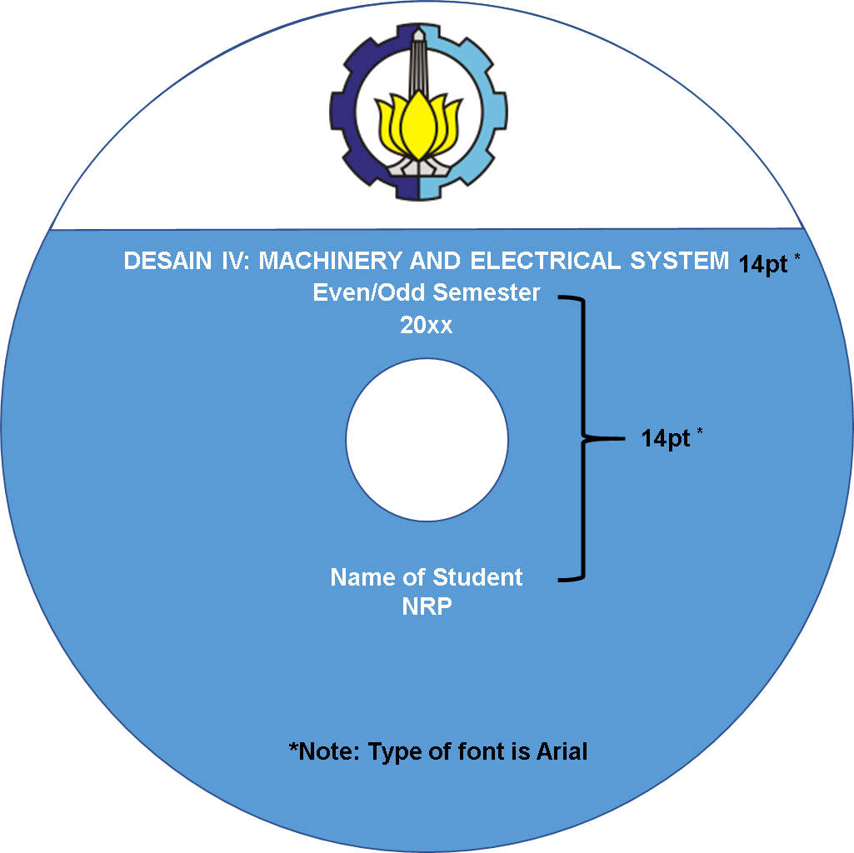

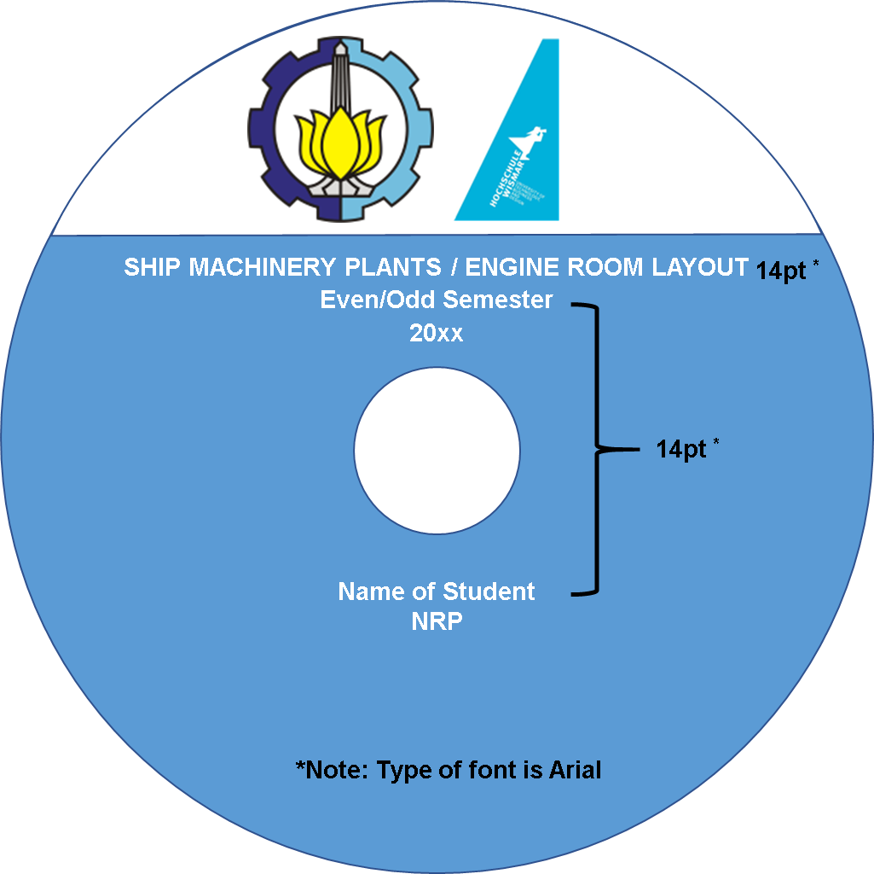
(for double degree program)

LAMPIRAN A – Format laporan
APPENDIX A – The Format of Report

Halaman ini sengaja dikosongkan
This page is intentionally left blank

Contoh Format Front Cover / Template of Front Cover
For Report of Machinery System
DEPARTMENT OF MARINE ENGINEERING
FACULTY OF MARINE TECHNOLOGY
INSTITUT TEKNOLOGI SEPULUH NOPEMBER (ITS)
SURABAYA
(Franklin Gothic Book 14pt for DeMARE & 12pt for FMT, ITS, Surabaya)

DESIGN IV – ME184730 (20pt)
MARINE MACHINERY AND ELECTRICAL SYSTEM (18pt)
EVEN/ODD SEMESTER 20XX (18pt)

BOOK 1 - REPORT OF MACHINERY (Franklin Gothic Book 16pt)

NAME OF THE VESSEL (Franklin Gothic Book 12pt)
CLASS NOTATION (Franklin Gothic Book 12pt)
Note:
- Background for the cover is white.
- Colour for the line under ITS logo is:
- Blue for the 1st attempt
- Yellow for the 2nd attempt
- Red for the 3th attempt
- Black for the 4th attempt

STUDENT: (Franklin Gothic Book 12pt)
NAME OF STUDENT (Franklin Gothic Book 12pt)
NRP. _____________ (Franklin Gothic Book 12pt)
3rd
4th
2nd
1st

SUPERVISOR MACHINERY: (Franklin Gothic Book 12pt)
NAME OF SUPERVISOR (Franklin Gothic Book 11pt)
NIP. _____________ (Franklin Gothic Book 11pt)

Contoh Format Front Cover / Template of Front Cover
For Report of Electrical System
DEPARTMENT OF MARINE ENGINEERING
FACULTY OF MARINE TECHNOLOGY
INSTITUT TEKNOLOGI SEPULUH NOPEMBER (ITS)
SURABAYA
(Franklin Gothic Book 14pt for DeMARE & 12pt for FMT, ITS, Surabaya)

DESIGN IV – ME184730 (20pt)
MARINE MACHINERY AND ELECTRICAL SYSTEM (18pt)
EVEN/ODD SEMESTER 20XX (18pt)

BOOK 2 - REPORT OF ELECTRICAL (Franklin Gothic Book 16pt)

NAME OF THE VESSEL (Franklin Gothic Book 12pt)
CLASS NOTATION (Franklin Gothic Book 12pt)
Note:
- Background for the cover is white.
- Colour for the line under ITS logo is:
- Blue for the 1st attempt
- Yellow for the 2nd attempt
- Red for the 3th attempt
- Black for the 4th attempt

STUDENT: (Franklin Gothic Book 12pt)
NAME OF STUDENT (Franklin Gothic Book 12pt)
NRP. _____________ (Franklin Gothic Book 12pt)
3rd
4th
2nd
1st

SUPERVISOR MACHINERY: (Franklin Gothic Book 12pt)
NAME OF SUPERVISOR (Franklin Gothic Book 11pt)
NIP. _____________ (Franklin Gothic Book 11pt)

Contoh Format Front Cover / Template of Front Cover
For Report of Engine Room Layout (machinery) (Double Degree Program)
DOUBLE DEGREE PROGRAM
DEPARTMENT OF MARINE ENGINEERING
INSTITUT TEKNOLOGI SEPULUH NOPEMBER (ITS)
HOCHSHULE WISMAR
(Franklin Gothic Book 14pt for DD, DeMARE & 12pt for ITS, Hochshule Wismar )

SHIP MACHINERY PLANTS /
ENGINE ROOM LAYOUT - ME184761 (20pt)
EVEN/ODD SEMESTER 20XX (18pt)

BOOK 1 - REPORT OF MACHINERY (Franklin Gothic Book 16pt)
Note:
- Background for the cover is white.
- Colour for the line under ITS logo is:
- Blue for the 1st attempt
- Yellow for the 2nd attempt
- Red for the 3th attempt
- Black for the 4th attempt

NAME OF THE VESSEL
CLASS NOTATION
(Franklin Gothic Book 12pt)

4th
3rd
2nd
1st
STUDENT: (12pt)
NAME OF STUDENT (12pt)
NRP. ____________(12pt)

SUPERVISOR MACHINERY: (Franklin Gothic Book 12pt)
NAME OF SUPERVISOR (Franklin Gothic Book 11pt)
NIP. _____________ (Franklin Gothic Book 11pt)

Contoh Format Front Cover / Template of Front Cover
For Report of Engine Room Layout (electrical) (Double Degree Program)
DOUBLE DEGREE PROGRAM
DEPARTMENT OF MARINE ENGINEERING
INSTITUT TEKNOLOGI SEPULUH NOPEMBER (ITS)
HOCHSHULE WISMAR
(Franklin Gothic Book 14pt for DD, DeMARE & 12pt for ITS, Hochshule Wismar )

SHIP MACHINERY PLANTS /
ENGINE ROOM LAYOUT - ME184761 (20pt)
EVEN/ODD SEMESTER 20XX (18pt)

BOOK 2 - REPORT OF ELECTRICAL (Franklin Gothic Book 16pt)
Note:
- Background for the cover is white.
- Colour for the line under ITS logo is:
- Blue for the 1st attempt
- Yellow for the 2nd attempt
- Red for the 3th attempt
- Black for the 4th attempt

NAME OF THE VESSEL
CLASS NOTATION
(Franklin Gothic Book 12pt)

4th
3rd
2nd
1st
STUDENT: (12pt)
NAME OF STUDENT (12pt)
NRP. ____________(12pt)

SUPERVISOR ELECTRICAL: (Franklin Gothic Book 12pt)
NAME OF SUPERVISOR (Franklin Gothic Book 11pt)
NIP. _____________ (Franklin Gothic Book 11pt)

Contoh Format Cover (Batas Setiap Dokumen) / Template of Cover In each Document
For Report of Machinery System
DESIGN IV MACHINERY SYSTEM
DEPARTMENT OF MARINE ENGINEERING
font : FRANKLIN GOTHIC BOOK 14pt)
JUDUL DOKUMEN / TITTLE OF DOCUMENT (e.g. BILGE SYSTEM)
(font : FRANKLIN GOTHIC BOOK 24pt BOLD)
Doc.No. 01 - 42 VV WWXX – LE
(font : FRANKLIN GOTHIC BOOK 12 pt)

(Font FRANKLIN GOTHIC BOOK 10 pt)
Rev. | Date | Remark | Prepared by | Approved by
 |  |  | Name of Student | Name of Supervisor
 |  |  | (signed) | (signed)

Contoh Format Cover (Batas Setiap Dokumen) / Template of Cover In each Document
For Report of Electrical System
DESIGN IV ELECTRICAL SYSTEM
DEPARTMENT OF MARINE ENGINEERING
font : FRANKLIN GOTHIC BOOK 14pt)
JUDUL DOKUMEN / TITTLE OF DOCUMENT (e.g. LIGHTINGS AND ELECTRIC TERMINALS)
(font : FRANKLIN GOTHIC BOOK 24pt BOLD)
Doc.No. 01 - 42 VV YYZZZ - EL
(font : FRANKLIN GOTHIC BOOK 12 pt)

(Font FRANKLIN GOTHIC BOOK 10 pt)
Rev. | Date | Remark | Prepared by | Approved by
 |  |  | Name of Student | Name of Supervisor
 |  |  | (signed) | (signed)

Contoh Format Cover (Batas Setiap Dokumen) / Template of Cover In each Document
For Report of Engine Room Layout (Machinery) (only for Double Degree Program)
ENGINE ROOM LAYOUT (MACHINERY SYSTEM)
DOUBLE DEGREE ON MARINE ENGINEERING
ITS – HOCHSCHULE WISMAR
font : FRANKLIN GOTHIC BOOK 14pt)
JUDUL DOKUMEN / TITTLE OF DOCUMENT (e.g. BILGE SYSTEM)
(font : FRANKLIN GOTHIC BOOK 24pt BOLD)
Doc.No. 02 - 42 VV WWXXX- BG
(font : FRANKLIN GOTHIC BOOK 12 pt)

(Font FRANKLIN GOTHIC BOOK 10 pt)
Rev. | Date | Remark | Prepared by | Approved by
 |  |  | Name of Student | Name of Supervisor
 |  |  | (signed) | (signed)

Contoh Format Cover (Batas Setiap Dokumen) / Template of Cover In each Document
For Report of Engine Room Layout (electrical) (only for Double Degree Program)
ENGINE ROOM LAYOUT (ELECTRICAL SYSTEM)
DOUBLE DEGREE ON MARINE ENGINEERING
ITS – HOCHSCHULE WISMAR
font : FRANKLIN GOTHIC BOOK 14pt)
JUDUL DOKUMEN / TITTLE OF DOCUMENT (e.g. LIGHTINGS AND ELECTRIC TERMINALS)
(font : FRANKLIN GOTHIC BOOK 24pt BOLD)
Doc.No. 01 - 42 VV YYZZZ - EL
(font : FRANKLIN GOTHIC BOOK 12 pt)

(Font FRANKLIN GOTHIC BOOK 10 pt)
Rev. | Date | Remark | Prepared by | Approved by
 |  |  | Name of Student | Name of Supervisor
 |  |  | (signed) | (signed)

Contoh Penulisan Laporan / Template of Writing Report
 | NAME OF SYSTEM  (14pt Franklin Gothic Book) | Doc. No. | Doc.No. 02 - 42 VV WWXXX- BG
 |  | Rev. No. | BB
 |  | Page | CC of DD
- INTRODUCTION (12pt Franklin Gothic Book)
Bilge system in ships or vessels helps to remove excess water from engine room, machinery spaces, cargo spaces, and other rooms below the main deck of the ship. Water accumulated trough leakage, condensation, and other means will go to the bilge well. Special case that water in the engine room or machinery spaces are mixed with oil. So, to suct the excess water, will be needed pumps to transfer the oily water from bilge well to the holding tank. Then, another small pump will be needed to transfer the oily water rom the holding tank through the OWS (Oil Water Separator). (11 Franklin Gothic Book)

- OBJECTIVES
The things that we must understand about Bilge System are:
- Understand the bilge system inside the ship.
- Calculate the diameter of the main bilge and the branch bilge in ship.
- Determining the capacity and head of bilge pump according BKI Rules Vol. III Section 11.
- Choosing the pipe and pump which match to the calculation above.
- Drawing the design of bilge system

- REFERENCES
- BKI Volume III for Machinery Installations 2016 Edition
- Pompa dan Kompresor Ir. Sularso dan Haruo Tahara, M MSE
- BKI Volume II for Hull 2014 Edition

- LIST OF ABBREVATIONS
HLs : Head loss mayor suction side (m)
Hld : Head loss discharge side (m)
Mls : Head loss minor at suction side (m)
Mld : Head loss minor at discharge side (m)
dH : Calculated inside diameter of main bilge pipe (mm)
B : Moulded breadth of the ship (m)
- SYSTEM DESCRIPTION
This bilge system made by the author are installed in every compartments that are not in use in ballast system including forepeak compartments, void spaces, and also in engine room. But, bilge system in engine room will be included to oily bilge water system and also use different type of pump. In every compartment will be placed a suction side, butterfly valve, and a strainer that has direct relation to the Bilge-Ballast Pump in Engine Room. After that, if the stucked water in bilge would like to be discharged, so it will be discharged through the overboard that has a height of 0.75 m + draught
.
- DESIGN REQUIREMENTS
No. | Key Equipment | Reference | Parameter Design
1. | Bilge Lines | BKI Vol.III 2016 Sec. 11-D.6.3.2 | Valves and control lines are to be located as far as possible from the bottom and sides of the ship
 |  | BKI Vol.III 2016 Sec.11-N.111 | Bilge line and bilge suction are to be so arranged that the bilges can be completely drained even under unfavourable trim conditions.
2. | Bilge Pipelines | BKI Vol.III 2016 Sec.11-D.9.7.1 | In bilge pipelines, a non-return valve is to be fitted either on the watertight bulkhead through which the pipe passes to the bilge suction or at the bilge suction itself.
 |  | BKI Vol.III 2016 Sec.11-N.1.2.1 | Bilge pipes may not be led through tanks for lubricating oil, thermal oil, and drinking water or feed water.
3 | etc | Etc | Etc.

- SUMMARY OF CALCULATION
- Calculated of Main Bilge Pipe
Main Pipe Diameter | (dH) | = |  | mm
 |  | = |  | inches
Spesification of pipe according to
Nominal Size |  | = |  | inches
 |  | = |  | mm
Inside Diameter | (dH) | = |  | inches
 |  | = |  | mm
Outside Diameter | (da) | = |  | inches
 |  | = |  | mm
Schedule Number |  | =
 |  | =
Thickness | (s) | = |  | inches
 |  | = |  | mm

- Calculated of Branch Bilge Pipe
Branch Pipe Diameter | (dH) | = |  | mm
 |  | = |  | inches
Spesification of pipe according to
Nominal Size |  | = |  | inches
 |  | = |  | mm
Inside Diameter | (dH) | = |  | inches
 |  | = |  | mm
Outside Diameter | (da) | = |  | inches
 |  | = |  | mm
Schedule Number |  | =
 |  | =
Thickness | (s) | = |  | inches
 |  | = |  | mm

- Calculated Capacity of Pump
Q = m³/h
= m³/s

- Calculated of Head Bilge Pump
Hs = m
Hp = m
Hv = m
HL1s = m
HL1d = m
MLs = m
MLd = m
Total = m

- Pump Specification
Maker:
Type of pump:
Pressure (bar):
NPSH (m):
Q (m³/h):
H (m):
Pump material:

Pump’s electric motor
Power (kW):
Voltage (volt):
Freq (Hz):
IP number:
- DETAIL OF CALCULATION
See attachment of Doc.No. 01 - 42 XX YYZZ – BG
- SPECIFICATION OF EQUIPMENTS
See attachment of Doc.No. 01 - 42 XX YYZZ – BG
- DRAWING OF SYSTEM
See attachment of Dwg.No. 01 - 42 XX YYZZ – BG

DESIGN IV ELECTRICAL SYSTEM
DEPARTMENT OF MARINE ENGINEERING
font : FRANKLIN GOTHIC BOOK 14pt)
JUDUL LAMPIRAN / TITTLE OF ATTACHMENT
(e.g. ATTACHMENT OF BILGE SYSTEM)
(font : FRANKLIN GOTHIC BOOK 24pt BOLD)
Attachment of Doc.No. 02 - 42 VV WWXXX- BG
(font : FRANKLIN GOTHIC BOOK 12 pt)

ENGINE ROOM LAYOUT
DOUBLE DEGREE ON MARINE ENGINEERING
ITS – HOCHSCHULE WISMAR
font : FRANKLIN GOTHIC BOOK 14pt)
JUDUL LAMPIRAN / TITTLE OF ATTACHMENT
(e.g. ATTACHMENT OF BILGE SYSTEM)
(font : FRANKLIN GOTHIC BOOK 24pt BOLD)
Attachment of Doc.No. 02 - 42 VV WWXXX- BG
(font : FRANKLIN GOTHIC BOOK 12 pt)

 | DETAIL CALCULATION OF BILGE SYSTEM  (14pt Franklin Gothic Book) |  | Doc. No. | Doc.No. 02 - 42 VV WWXXX- BG
 |  |  | Rev. No. | BB
 |  |  | Page | CC of DD
    - CALCULATION (12pt Franklin Gothic Book)
Content of calculation (11 Franklin Gothic Book)
Spreadsheet modeling for detail of calcuation in Ms.excel.

 | SPECIFICATION OF BILGE SYSTEM  (14pt Franklin Gothic Book) |  | Dwg. No. | Doc.No. 02 - 42 VV WWXXX- BG
 |  |  | Rev. No. | BB
 |  |  | Page | CC of DD
Registrasi Equipment
Equipment ID : 100.01
Name : FO Transfer Pump

Specification
Maker : Allweiller
Type : SNS 660 ER 40
Capacity : 31.2 m3/h
Pressure : 3 bar

Catalog of specification
attached

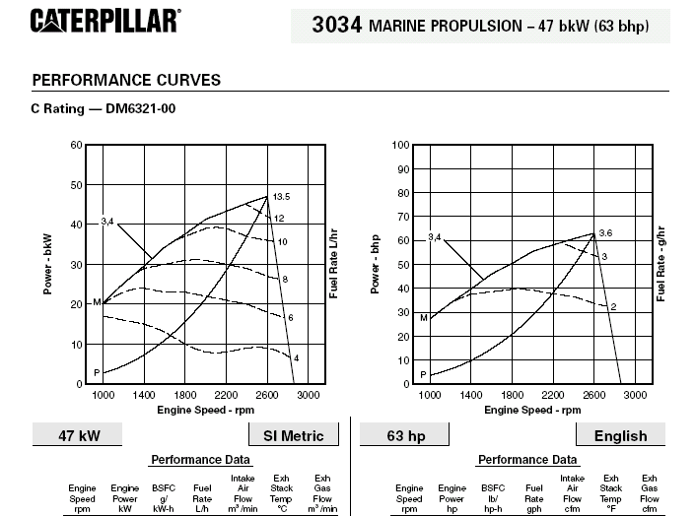

 | KEYPLAN OF BILGE SYSTEM  (14pt Franklin Gothic Book) |  | Dwg. No. | Dwg.No. 02 - 42 VV WWXXX- BG
 |  |  | Rev. No. | BB
 |  |  | Page | CC of DD
 | 3D DRAWING OF BILGE SYSTEM  (14pt Franklin Gothic Book) |  | Dwg. No. | Dwg.No. 04 - 42 VV WWXXX- 3D
 |  |  | Rev. No. | BB
 |  |  | Page | CC of DD
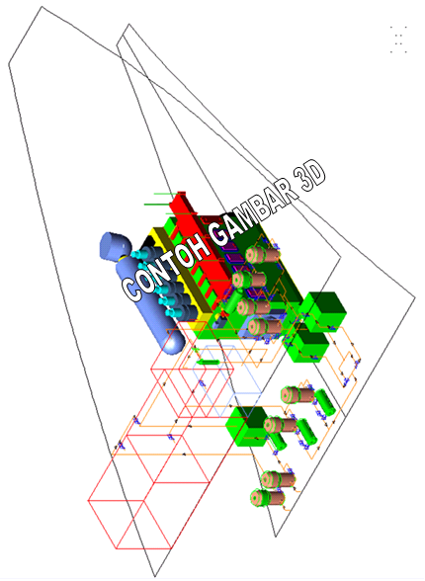
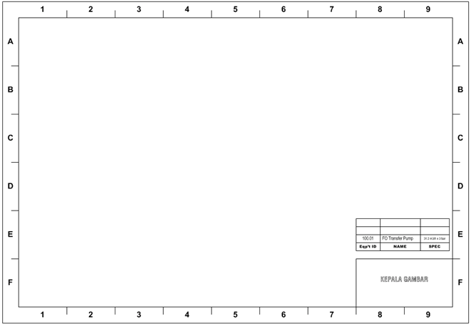
Contoh Standar Gambar / Template of Drawing Standar
STANDAR OF DRAWING

Contoh Standar Kepala Gambar / Template of Head of Drawing Standar
*(dimension in millimeters)

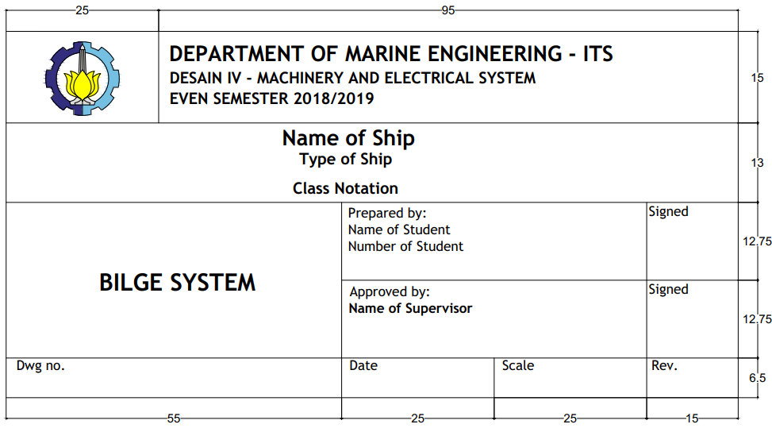

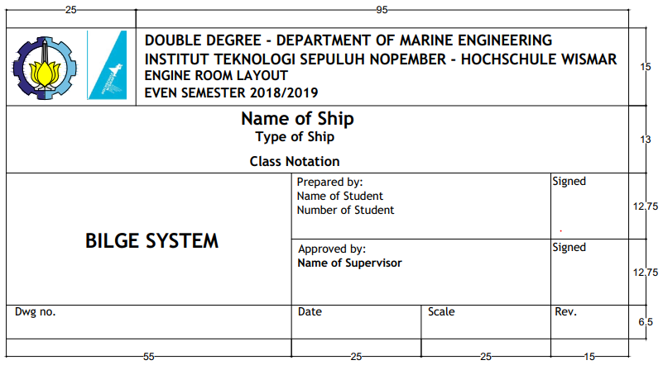

LAMPIRAN B – Business Process
APPENDIX B - Business Process

Halaman ini sengaja dikosongkan
This page is intentionally left blank

LAMPIRAN C-1 - Design IV Machinery and Electrical System Form
APPENDIX C1 - Design IV Machinery and Electrical System Form

Halaman ini sengaja dikosongkan
This page is intentionally left blank

LAMPIRAN C-2 – Engine Room Layout Form
APPENDIX C-2 - Engine Room Layout Form

Halaman ini sengaja dikosongkan
This page is intentionally left blank

