Template Manuscript for IPTEK Proceeding Series
First Author¹, Second Author², and Third Author*¹
¹Department, University Name, City, Country
²Company Name, City, Country
*Corresponding author’s e-mail: abcd.1234@hyoko.xxx
Abstract―This is a digest of the paper describing in brief the background, problems, methods, findings, and conclusion. Written in English with approximately 200 words.

Keywords―Not More Than 5 Words; Alphabetical Order; Should be Capitalized; Saparated by Semicolon; Used as the Operational Words in the Paper; It Would be Preferable Not to Use Words in the Title.

Introduction
This document shows the suggested format and appearance of a manuscript prepared for IPTEK Proceeding Series to assist Author in preparing a manuscript. The final layout of the typeset paper will not match this template layout.
This chapter suggests the basic rules: 1) Present the material simply and concisely; 2) Use single spacing on A4-sized paper; 3) Cross-check several times to eliminate errors, superfluous material and repetition; 4) Use figures and tables sparingly; plan their format to use page space economically; 5) Put figures and tables at the proper position in the text; 6) All pages should be numbered consecutively not less than 6 pages and not more that 10 pages; 7) The equality, the main body of the paper should be numbered in consecutive order a: Introduction; Methods; Results and Discussion; Conclusions; Acknowledgments; and References. All pages should be numbered consecutively not less than 6 pages and not more than 10 pages.
Please submit MS-Word file as completed manuscripts (camera-ready manuscripts) including the diagrams and photographs. The full paper should be written in English or Bahasa Indonesia.

Page Setup
All script should be typed on A4-sized (210mm x 297mm) white paper, single spaced. Keep proper margins such as left and top (2.5 cm), right and down (1.7 cm). Article must be typed justified formation. Greece symbol has to be original like β (beta), γ (gamma) and etc. Chemical notation has to go with standard rule, such as BaTiO₃ and Mg(OH)₂.

Font
Use the “Times New Roman” font with the size 24 for title, size 12 for authors name, 10 for author affiliation, coresponding author email, abstract, keywords, and the body text, size 8 for reference, table title, and figure caption.

The Title
Avoid titles that are too long (maximum 10 Word); the titles should be in capitals for all words except for conjuctive (see the example).

The Name(s) of The Author(s)
Write complete author’s name without academic degrees and professional positions (e.g.: Lecturer, Researcher, etc). Do not abbreviate your last/family name. Always give your First and Last names (should be at least 2 (two) words). If your name has only one word, you should repeat your name, e.g.: Sugiono Sugiono.

Affiliation
Add affiliation description for all authors and the affiliations are cited by superscripts as shown in the above example. Add an asterisk (*) in superscript to the corresponding author.

The Abstract
The abstract should present the outline and main points of the paper and give the principal conclusions. It should be a single paragraph of no more than 200 words. Abstract should be written using ”Times New Roman” font with the size of 10. Add Keywords not more 5 words after the abstract.

Paragraphs
Please put a single space line between paragraphs. Paragraphs that immediately follow a section heading are leading paragraphs and should not be indented, according to standard publishing style. The same goes for leading paragraphs of subsections and sub-subsections.

Section Formatting (Heading 1)
Three ranks of heading may be used section, subsection, and sub-subsection. Use the heading styles: 1. Section; 1.1 Subsection; and 1.1.1 Sub-subsection. Put a space line before each heading (see Table 1). Bullet and numbering within body text are not allowed. All sentence should be typed as descriptive paragraph format.

Subsection Headings (Heading 2)
Subsection headings should be numbered 1.1, 1.2, etc.

Sub-subsection headings (Heading 3)
Sub-subsection headings should be numbered 1.1.1, 1.1.2, etc

Numerals
Numerals of five or more digits are grouped in three-digit blocks by spaces, e.g. 12,345 (if written in English) or 12.345 (if written in Bahasa Indonesia). Pay attention a significant figure and avoid an unnecessary long digit number.

Units
Use SI unit or SI derived units.

Mathematics
Extreme care should be taken in preparing mathematical typescripts (MS Word Equation Editor or MathType), not in image format. All mathematics should be legible, precise and carefully aligned. The following shows an example of putting an equation in the text:
(1)
where Y and X are the output and input variables, respectively; A and B are constants.
Italic character should be used as variable. On the other hands, the “Times New Roman” character should be used as function e.g. sin, exp, log.
As in above, equations should be at the left-hand margin; while the equation number displayed expressions with Arabic numerals in parenthesis should be at the right-hand margin. Put space lines both before and after the equation(s).

Figures and Tables

Figures
Figure should be titled and numbered consecutively in Arabic numerals below the figure. Figure title should be followed by space line (see Table 1). All figure parts must be labeled (a), (b), etc. Each figure file should contain all parts of the figure. For example, Figure 2. contains two parts (a) and (b); therefore, all of the labeled parts should be combined in a single file for Figure 2 (see Figure 2). For references to them belonging to the paper, use, e.g. “Figure 2.”

Tables
Tables should be titled and numbered consecutively in Arabic numerals above the table and referred in the text by the table number without location (above, below, following, etc.). Table title should be followed by space line (see Table 1). For references to them belonging to the paper, use, e.g. “Table 4.”. Tables cannot be in the image format.

Table 1. Formatting Rules
Object | Font | Alignment | Space above | Space below
Title | 24pt | centered | 0pt | 18pt
Author(s) | 12pt | left | 10pt | 10pt
Affiliation | 10pt | left | 0pt | 0pt
Coresponding Author | 10pt | left | 12pt | 18pt
Abstract & Keywords | 10pt | justified | 0pt | 0pt
Heading1 | 10pt | left | 12pt | 4pt
Heading2 | 10pt | left | 4pt | 4pt
Heading3 | 10pt | left | 2pt | 2pt
Body | 10pt | justified | 0pt | 0pt
Table title | 8pt | centered | 6pt | 0pt
Figure title | 8pt | centered | 0pt | 6pt
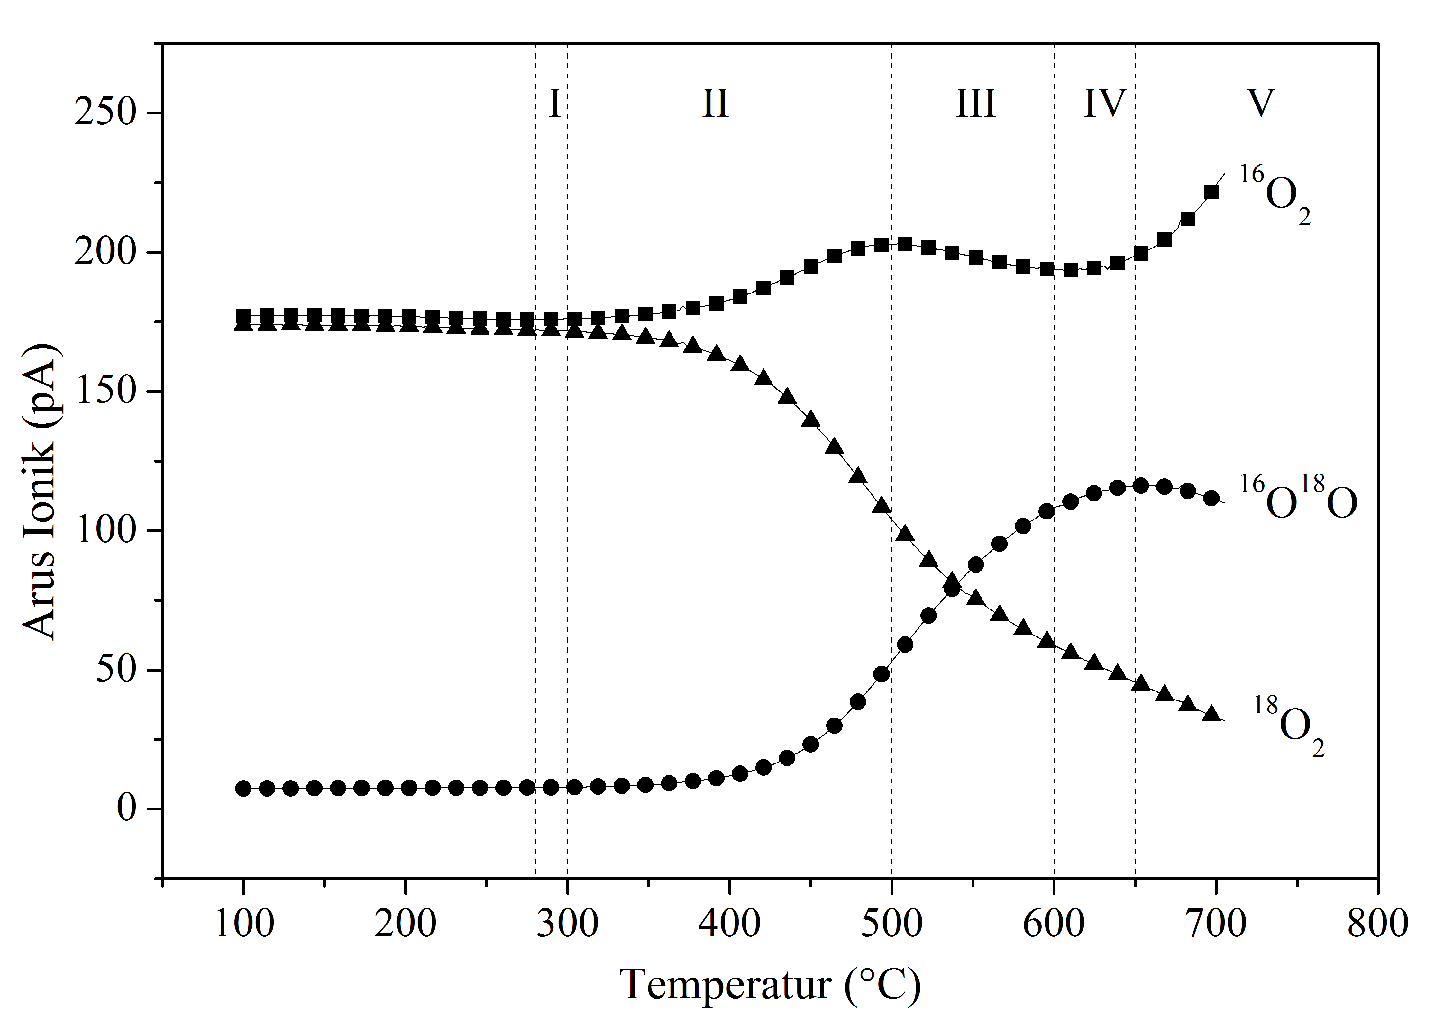
Figure 1. Put the caption for figure 1 here. Use an appropriate and as clear as possible caption for the figure
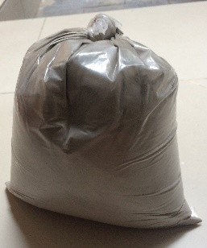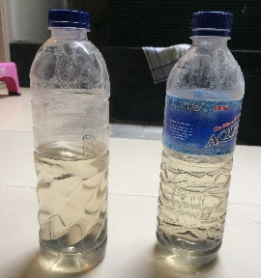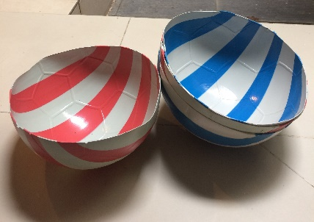
(a) (b) (c)
Figure 2. (a) mold; (b) fly ash; (c) aktivator

References
References should be cited in square brackets [ ], and placed before the punctuation; for example [1], [1–3] or [1,3]. References must be numbered in order of appearance in the text (including citations in tables and legends) and listed individually at the end of the manuscript. We urge authors to prepare the references with a bibliography software package, i.e. Mendeley, to avoid typing mistakes and duplicated references. Include the digital object identifier (DOI) for all references where available.
Check each reference against the original source (authors name, volume, issue, year, DOI Number). Please ensure that every reference cited in the text is also present in the reference list (and vice versa).
Every text citation must be listed under the heading “References” centered at the end of the text. IEEE format is selected as the reference to write the citations used in the paper. Referencing is written using Times New Roman 8.The following is the example of how to wrote the references.
Sample Quotations from Section Books:
- J. Jokar Arsanjani, A. Zipf, P. Mooney, and M. Helbich, “An Introduction to OpenStreetMap in Geographic Information Science: Experiences, Research, and Applications,” in OpenStreetMap in GIScience: Experiences, Research, and Applications, J. Jokar Arsanjani, A. Zipf, P. Mooney, and M. Helbich, Eds. Cham: Springer International Publishing, 2015, pp. 1–15.
- M. W. Dobson, “VGI as a Compilation Tool for Navigation Map Databases,” in Crowdsourcing Geographic Knowledge, Dordrecht: Springer Netherlands, 2013, pp. 307–327.

Sample Quotations from Books:
- J. Han and M. Kamber, Data Mining: Concepts and Techniques, 3rd ed. Burlington, MA: Elsevier, 2011
- D. J. Bowersox, D. J. Closs, and M. B. Cooper, Supply Chain Logistics Management, 4th ed. New York: McGraw-Hill, 2013.

Sample Quotations from Periodicals:
- C.-L. Huang, M.-C. Chen, and C.-J. Wang, “Credit scoring with a data mining approach based on support vector machines,” Expert Syst. Appl., vol. 33, no. 4, pp. 847–856, Nov. 2007.
- J. Olhager and D. I. Prajogo, “The impact of manufacturing and supply chain improvement initiatives: A survey comparing make-to-order and make-to-stock firms,” Omega, vol. 40, no. 2, pp. 159–165, Apr. 2012.

Sample Quotations from Conference Proceeding:
- L. Palen, R. Soden, T. J. Anderson, and M. Barrenechea, “Success & Scale in a Data-Producing Organization,” in Proceedings of the 33rd Annual ACM Conference on Human Factors in Computing Systems - CHI ’15, 2015, pp. 4113–4122.
- M. Cardos, E. Babiloni, M. E. Palmer, and J. M. Albarracin, “Effects on undershoots and lost sales on the cycle service level for periodic and continuous review policies,” in 2009 International Conference on Computers & Industrial Engineering, 2009, pp. 819–824.

Sample Quotations from Website:
- Prosci, “Definition of Change Management,” Prosci. [Online]. Available: https://www.prosci.com/resources/articles/change-management-definition?utm_source=tutorial-definition-2009&utm_medium=redirect&utm_campaign=cm. [Accessed: 23-Sep-2009]

Sample Quotations from Thesis/Dissertation:
- Al Fattah, “Analisa Perubahan Pola Beban Kerja Berdasarkan Value Added, Non-Value Added, Necessary Added Aktivitas Overhaul dan Dampaknya Terhadap Aspek Kualitas, Biaya, dan Waktu,” Institut Teknologi Sepuluh Nopember, 2018.
- H. Asmuni, “Fuzzy Methodologies for Automated University Timetabling Solution Construction and Evaluation,” University of Nottingham, 2008

Sample Quotations from Papers Presented at Conferences (unpublished):
- D. Ebehard and E. Voges, “Digital single sideband detection for interferometric sensors,” presented at the 2nd Int.Conf. Optical Fiber Sensors, Stuttgart, Germany, 1984.

Sample Quotations from Standards/Patents:
- G. Brandli and M. Dick, “Alternating current fed power supply,” U.S. Patent 4 084 217, Nov. 4, 1978.

