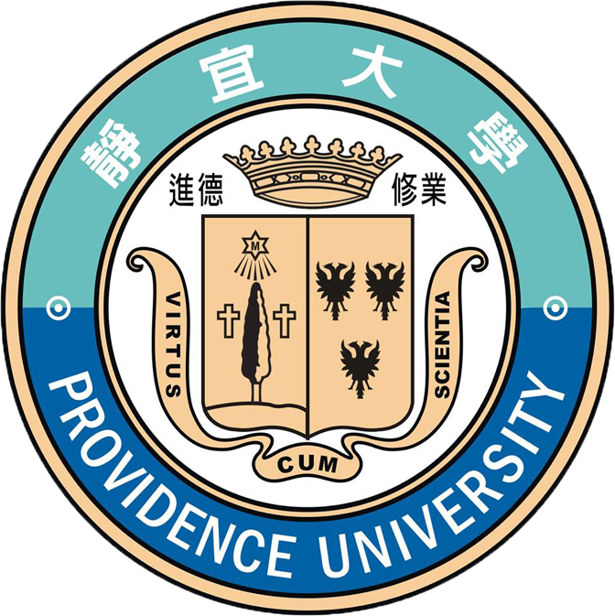

"Scientific Explorations of Chemistry,
Food and Cosmetics"
A FREE Immersion Program for
Indonesia Students, 2023

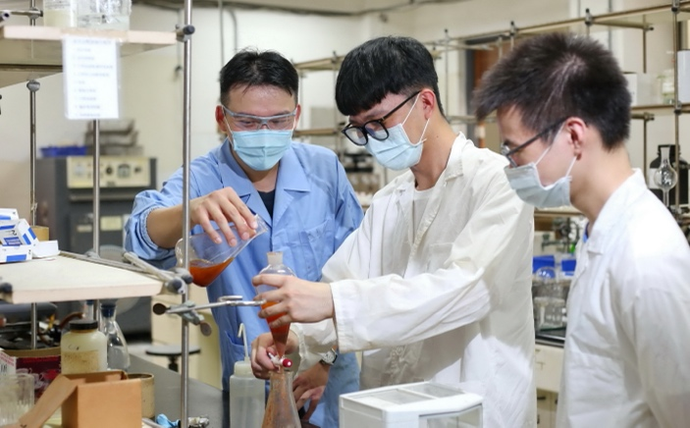
Our Motivation
In line with Taiwan's National Southbound Policy, which aims to promote regional exchanges and collaboration between Indonesia and Taiwan, Providence University welcomes reputed institutions in Indonesia for collaboration.
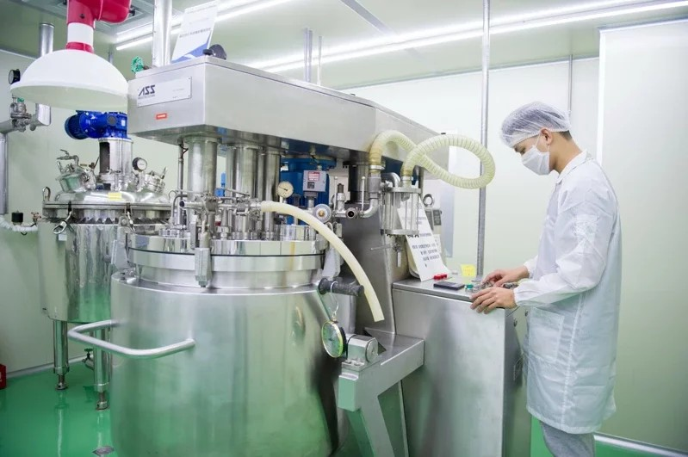
The object of the program is to provide some introductory courses regarding these professions. In addition, the procedures are all executed by companioning with the laboratory for practice learning. Therefore, we firmly believe that the knowledge from this workshop will help teachers and students in their career advancements.

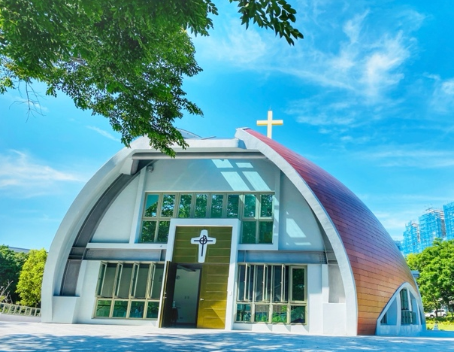
About Providence University
Providence University in Taiwan was founded by the Sisters of Providence of Saint Mary's of the Woods, Indiana, USA, in 1956.
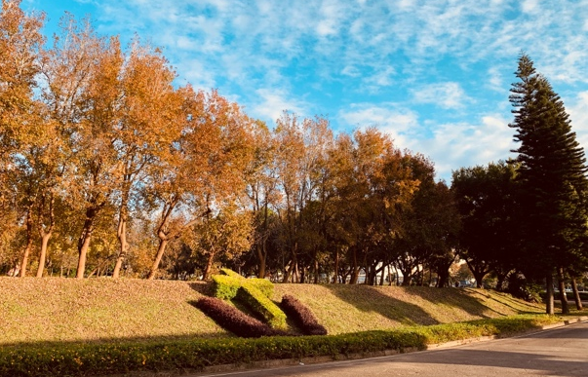
Since then, Providence University has been recognized for its international campus atmosphere, and international collaboration has also been one of the most critical strategies for its development.
Please visit http://www.pu.edu.tw/english/ for more info.

Scientific Explorations of Chemistry, Food and Cosmetics-Indonesia-2023 (Based on Taiwan Time)
TIME | 1/4(Wed.) | 1/5(Thu.) | 1/6(Fri.) | 1/9(Mon.)
9:00 am  |  11:30am | 9:00-9:30  Opening  Campus tour  Prof. Yun-Chin Chung (PUFN)  Assoc. Prof.  Gen-Hung Chen  (PUCS) | Renewable energy  Prof. Ren-Jan Wu (PUAC) | Colorful tapioca pearls  Asst. Prof. Po-Hsieh Li  (PUFN) | How to Utilize Solar Energy  Asst. Prof. Hsien-Hsin Chou  (PUAC)
13:30pm  |  16:00pm | Little Giants–Nanomaterials  Assoc. Prof.  Grace S. Chen  (PUAC) | Decomposable Plastics PLA & PCL  Assoc. Prof. Ming-Tsz Chen  (PUAC) | Healthy eating every day  Asst. Prof. Yaolin Weng  (PUFN) | Palladium is the King of Transition-Metal Catalysts  Asst. Prof.  Yu-Chang Chang (PUAC)
TIME | 1/10(Tue.) | 1/11(Wed.) | 1/12(Thu.) | 1/13(Fri.)
9:00 am  |  11:30am | An Introduction to Cosmetic Industry I  Asst. Prof.  Clive Yen  (PUCS) | An Introduction to Cosmetic Industry II  Asst. Prof.  Clive Yen  (PUCS) | Must be sugar  Assoc. Prof  Yan-Jiun Huang  (PUFN) | From food to energy: a perspective in nutrition  Assoc. Prof.  Chih-Chung Wu  (PUFN)
13:30pm  |  16:00pm | Mechanistic Study of Triazole Based Aminodiol Derivatives in Leukemic Cells-Crosstalk between Mitochondrial Stress-Involved Apoptosis and Autophagy. | An integrated approach to elucidate signaling pathways of dioscin-induced apoptosis, energy metabolism and differentiation in acute myeloid leukemia  Assoc. Prof. | Taro and it’s products, staple food or desserts ?  Prof. Chiun-Chuang Wang  (PUFN) | Campus tour  Assoc. Prof.  Grace S. Chen (PUAC)
14:30—16:00
Closing ceremony

*Note: PU reserves all rights for applicant selection and making changes in the schedule.

