Engaging Our Future: Innovation Challenge for Sustainable Society
Application Form
Please refer to the application guidelines carefully before filling in below.

Section A: Team Details
Project Title:
Team Details
Name of Team Members | Date of Birth  ^{(DD/MM/YYYY)} | Gender | Faculty/School | Level of Degree ^{(B/M/PhD)} | University/Country
1)
2)
3)
4)
5)
Primary Contact Details (All communications will be directed via the given contact details)
Email:
Contact Number: Alternative Contact Number:
Address:
Facebook:
Which channel(s) do you prefer to use for the group communication? Tick up to two channels and provide the information as necessary.
□ Email □ Facebook □WhatsApp □ Google Meet □ Other (please specify):

Section B: About Your Project
Stage of the Project (Please tick one)
□ Idea | □ Idea with Prototype
Video of Your Project (Not more than 3 minutes). Please indicate its YouTube link below.

SDGs Aligned with Your Project (Please tick all that may apply.)
□ 1. No Poverty |  | □ 2. Zero Hunger |  | □ 3. Good Health and Well-Being
□ 4. Quality Education |  | □ 5. Gender Equality |  | □ 6. Clean Water and Sanitation
□ 7. Affordable and Clean Energy |  | □ 8. Decent Work and Economic Growth |  | □ 9. Industry, Innovation and Infrastructure
□ 10. Reduced Inequalities |  | □ 11. Sustainable Cities and Communities |  | □ 12. Responsible Consumption and Production
□ 13. Climate Action |  | □ 14. Life Below Water |  | □ 15. Life on Land
□ 16. Peace and Justice Strong Institutions |  | □ 17. Partnerships for the Goals
To learn more about SDGs: https://www.un.org/sustainabledevelopment/sustainable-development-goals/
Business Model
□ Profit | □ Non-profit | □ Hybrid
Have you ever submitted or are you in the process of submitting this project to any other competitions?
□ Yes |  |  |  | □ No
If you answer YES to the above, please specify the details to the best of your knowledge. This includes but is not limited to, 1) name(s) of the competition(s), 2) result/phase of your entr(ies)/application(s) to the competition(s), 3) value of competition(s) (e.g. monetary award).

Other Details
How did you learn about this competition? (please tick all that may apply)
□ Competition Website
□ Social Media [Facebook, LINE, etc.]
□ Chulalongkorn University Official Website
□ APRU Official Website
□ Friends & Family
□ Other (please specify): __________________________________

Executive Summary
Provide an executive summary of your project (not more than 600 words).

University Enrolment Confirmation

Name of Team Members | University ID card  (insert image file for each team member)
1) | 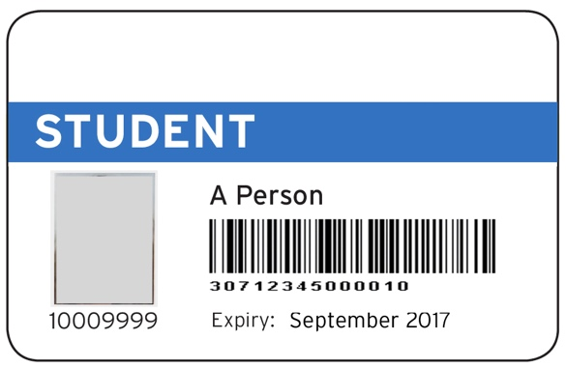
2)
3)
4)
5)

With the signature below, I certify that all the information contained in this form is true and accurate. I attest that the idea is original to my team. Any use or modification of ideas by the competition organizers and partners will not give rise to any third party claims for infringement or violation of copyright, trademark or any other right of any third party, or to any third party claims including libel, defamation, and violation of privacy or contract breach. I release the competition organizers and partners from any liability in connection with my participation in this competition.

Date:
Name of the team leader:
Signature:

