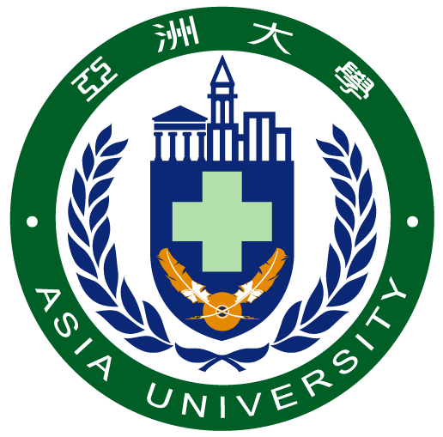 ASIA UNIVERSITY | Please attach 1 2-by-2  inches photo taken within 3 months.
2020 SUMMER PROGRAMS
APPLICATION FORM
FOR INTERNATIONAL STUDENTS
*Please write neatly or type on computer!!!
PERSONAL INFORMATION
NAME (in Chinese) ˍˍˍˍˍˍˍˍˍˍˍˍˍˍˍˍˍˍˍˍˍˍˍˍˍˍˍˍˍˍˍˍˍ
NAME (in English) ˍˍˍˍˍˍˍˍˍˍˍˍˍˍˍˍˍˍˍˍˍˍˍˍˍˍˍˍˍˍˍˍˍ First Middle Last
DATE OF BIRTH (YYYY/MM/DD)  ˍˍˍˍˍˍˍˍˍˍˍˍˍˍ | PLACE OF BIRTH  ˍˍˍˍˍˍˍˍˍˍˍˍˍˍ | NATIONALITY  ˍˍˍˍˍˍˍˍˍˍˍˍˍˍ
GENDER  Male Female | MARITAL STATUS  Single Married | PASSPORT NO.  ˍˍˍˍˍˍˍˍˍˍˍˍˍˍ
PHONE  ( ) ˍˍˍˍˍˍˍˍˍˍˍˍ | CELL PHONE  ( ) ˍˍˍˍˍˍˍˍˍˍˍˍ | EMAIL  ˍˍˍˍˍˍˍˍˍˍˍˍˍˍ
PERMANENT ADDRESS
ˍˍˍˍˍˍˍˍˍˍˍˍˍˍˍˍˍˍˍˍˍˍˍˍˍˍˍˍˍˍˍˍˍˍˍˍˍˍˍˍˍˍˍˍ
Home University____________________________________________________________________________
Major ____________________________________________________________________________________
LEVEL Bachelor Master

INFORMATION OF LEGAL GUARDIAN
NAME (in English/other) ˍˍˍˍˍˍˍˍˍˍˍˍˍˍˍˍˍˍˍˍˍˍˍˍˍˍˍˍˍˍˍˍˍ
First Middle Last
PERMANENT ADDRESS
ˍˍˍˍˍˍˍˍˍˍˍˍˍˍˍˍˍˍˍˍˍˍˍˍˍˍˍˍˍˍˍˍˍˍˍˍˍˍˍˍˍˍˍˍ
PHONE  ( ) ˍˍˍˍˍˍˍˍˍˍˍ | OCCUPATION  ˍˍˍˍˍˍˍˍˍˍˍˍˍˍ | RELATIONSHIP  ˍˍˍˍˍˍˍˍˍˍˍˍˍˍ
INTENDED PROGRAMS OF STUDY
(*Please specify the summer programs you wish to attend and choose from between 1 and 3 programs from the list below. Most of our international students will just attend one program.)
OPTION | SUMMER PROGRAM TITLE
1 | ˍˍˍˍˍˍˍˍˍˍˍˍˍˍˍˍˍˍˍˍˍˍˍˍˍˍˍˍˍˍˍˍˍˍˍˍˍˍˍˍ
2 | ˍˍˍˍˍˍˍˍˍˍˍˍˍˍˍˍˍˍˍˍˍˍˍˍˍˍˍˍˍˍˍˍˍˍˍˍˍˍˍˍ
3 | ˍˍˍˍˍˍˍˍˍˍˍˍˍˍˍˍˍˍˍˍˍˍˍˍˍˍˍˍˍˍˍˍˍˍˍˍˍˍˍˍ
YOUR ENGLISH PROFICIENCY (TOEFL, IELTS, TOEIC, or other test score) ˍˍˍˍˍˍˍˍˍˍˍˍˍˍ
YOUR CHINESE PROFICIENCY (TOCFL, HSK, or other test level) ˍˍˍˍˍˍˍˍˍˍˍˍˍˍ

ASIA UNIVERSITY 2020 SUMMER PROGRAMS
NO. | Program Title | Dates
College of Medical and Health Sciences
1 | Healthy Aging & Anti-Aging | 7/13 - 7/24
2 | Medical Speech, Language & Hearing | 7/13 - 7/24
College of Information and Electrical Engineering
3 | Artificial Intelligence: Deep Learning | 8/10 - 8/21
4 | Artificial Intelligence: Data Science | 8/10 - 8/21
5 | Artificial Intelligence: Azure AI Engineer Associate | 8/10 - 8/21
6 | Web Design | 7/6 - 7/24
College of Management
7 | Innovation & Entrepreneurship | 8/10 - 8/21
8 | Taiwan Economy and Culture | 7/10 - 7/27
9 | FinTech | 7/13 - 7/24
10 | Leisure & Recreation Management | 7/13 - 7/24
College of Humanities and Social Sciences
11 | Community Care Practice in Taiwan | 7/6 - 7/17
12 | Language & Culture | 8/3 - 8/21
College of Creative Design
13 | Creative and Cultural Industry | 7/6 - 7/17

ˍˍˍˍˍˍˍˍˍˍˍˍˍˍˍˍˍ ˍˍˍˍˍˍˍˍˍˍˍˍˍˍSignature of Applicant Date

