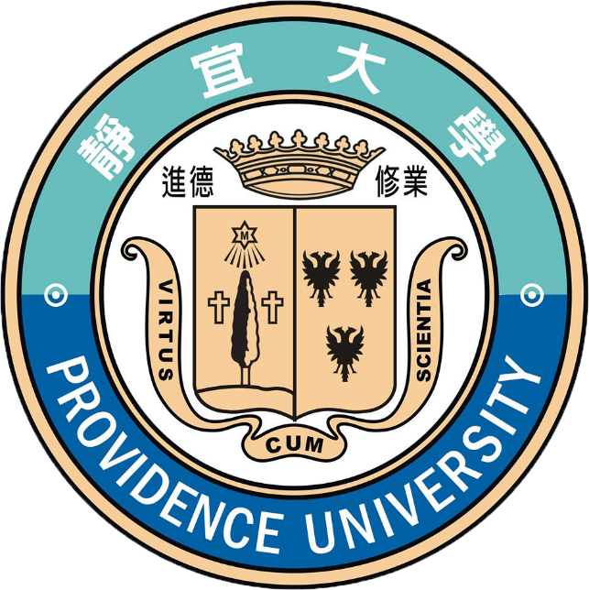

***“Scientific Explorations of Chemistry,***

***Food and Cosmetics”***

***A FREE Immersion Program for  
Indonesia Students and Teachers, 2020***

**Sponsored by: Providence University (PU), Taiwan**

### Invitation

Providence University’s “2020 Cultural Immersion Program” is a FREE 10-day workshop, which is specially designed for Indonesia students, and teachers, who want to learn fundamentals of ***Scientific Explorations of Chemistry, Food and Cosmetics***, and are interested to improve their knowledge about Taiwan. We are inviting your applications on or before **Dec. 8th, 2020**. Key program guidelines are as follows:

1. **Program title**: Scientific Explorations of Chemistry, Food and Cosmetics
2. **Program duration**: **Jan 7th, 2020** to **Jan 16th, 2020**
3. **Program location**: Providence University, Taichung, Taiwan (<http://www.pu.edu.tw/english/>)
4. **Program schedule: Please see last page; Language of instruction**: English
5. **Facilities offered**: **FREE** to use premier laboratories and digital classrooms (24x7)
6. **Program fees**: **FREE**; **Accommodation**: **FREE**
7. **Breakfast**: **FREE**; **Trips**: **FREE**; **Airport pick-up and drop-off**: **FREE**
8. **Air-tickets, Visa and Travel insurance to Taiwan**: **SELF-SPONSORED**
9. **Key contact**:：Ms. Maya & Ms. Yvone
10. **Students from same school please make sure to book the same flight and please kindly find the flight itinerary attached below for your reference. Pick up time : 16:40**

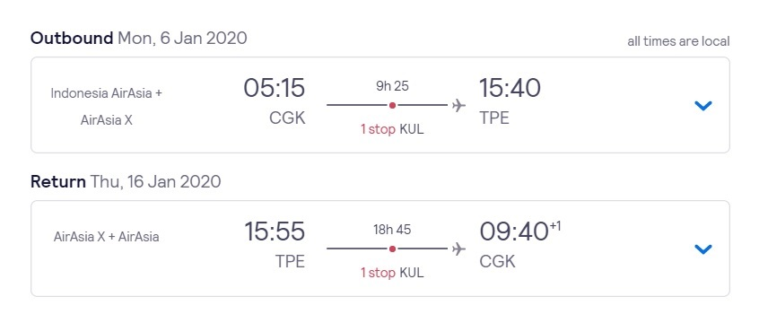**■ Jakarta ⇄ Taipei**

**■ Surabaya ⇄ Taipei**

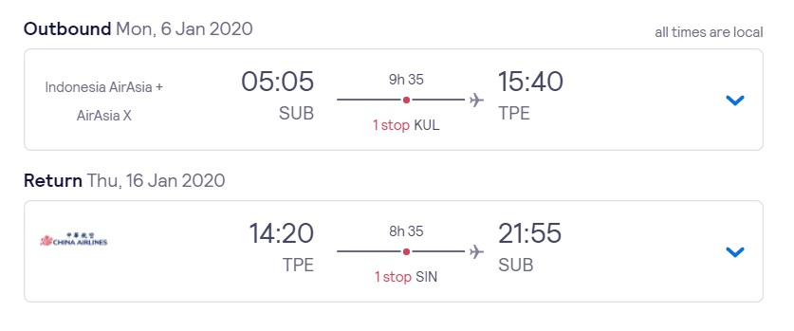

### Applicant Eligibility

1. Must be an Indonesia teacher or student and must hold Indonesia passport.
2. Have interested in Chemistry, Food and Cosmetics or relevant background
3. Must complete registration before the deadline, Dec 6th, 2019.

**Note: Active participation is required in the class.**

### Registration

1. Please email completed **Registration Form** (see last page) along with other documents to studyabroad@its.ac.id in PDF format with subject: Apply_PU_Immersion Program2020_Name_NRP

### Results

Result of your application will be sent to you by email and final decision will made by Providence University before **Dec. 20th, 2019.**

### Desserts

1. Orientation and University Campus tour will be arranged to familiarize participants of this program with the campus and university culture.
2. A Free city tour will be provided, covering key interesting places nearby, including Sun-Moon Lake.
3. A FREE field trip covering key tourist places will be provided.

### The Motivation

In line with, Taiwan’s National Southbound Policy, which aims to promotes regional exchanges and collaboration between Indonesia and Taiwan, we, Providence University, Taiwan, are welcoming reputed institutions in Indonesia for collaboration. This FREE program is part of our collaboration initiatives toward Indonesia institutions.

Object of the program is to provide some basic courses regarding to these professions. In additions, the courses are all executed by companioning with laboratory for the practice learning. Therefore, we strongly believe that the learning from this workshop will help teachers/students for their career advancements.

### About Providence University

Providence University was found in 1956 by an American Congregation, “The Sisters of Providence of Saint Mary-of-the-Woods”, Indiana, USA. Having more than 12,000 undergraduate students, 1,200 postgraduate students and 400 full-time faculties as well as several 100% English taught programs such as Bachelor’s in International Business Administration (BIBA), Global Master of Business Administration (MBA).

Please visit <http://www.pu.edu.tw/english/> for more info.



|  |  |  |  |  |
| --- | --- | --- | --- | --- |
| **Registration Form** | | | | |
| Family Name |  | First Name |  | Recent Color Passport Photo  （2’ size） |
| Nationality and Passport No. |  | Gender |  |
| Date of Birth |  | Occupation |  |
| Food Preference (Veg/Non-Veg) |  | | |
| Tel: | School office/Lab: *Mobile Phone:  *Home: Others: | | | |
| E-mail | (1)  (2) | | | |
| Permanent Address | □□□-□□ | | | |
| Emergency Contact at Home/ School | Name: ____________________ Tel:_____________________________  Position: __________________ Mobile Phone:____________________  Institution: ___________________________________________________  Email:_______________________________________________________  Contact Address: _______________________________________________  _____________________________________________________________ | | | |
| Declaration | I confirm that the abovementioned information is true, correct, and complete. Providence University has my permission to use this information during my stay in Taiwan in case of emergency.  Applicant's Signature:_______________________ Date:______________ | | | |
| Note | ⬥ All fields in the above form are mandatory. Incomplete forms will be rejected.  ⬥ Be sure your traveling insurance covers all the days in Taiwan. | | | |

Paste your Passport copy below:

|  |
| --- |
|  |

**Immersion Program**

【**Scientific Explorations of Chemistry, Food and Cosmetics**】

|  |  |  |  |  |  |
| --- | --- | --- | --- | --- | --- |
| TIME | 1/7 TUE. | 1/8 WED. | 1/9 THR. | 1/10 FRI. | 1/11 SAT. |
| **9:10am**  **|**  **12:00am** | Arrival & Check In | Orientation  Campus Tour | Wheat flour practice  (Food and Nutrition) | Health matters: blood pressure measurement  (Food and Nutrition) | Cultural Tour |
| **13:30pm**  **|**  **16:30pm** | Beverage-from raw materials to production  (Food and Nutrition | Introduction and shopping fun for healthy balanced diet  (Food and Nutrition) | Soda can Battery  (Applied Chemistry) |
| TIME | **1/12 SUN.** | **1/13 MON.** | **1/14 TUE.** | **1/15 WED.** | **1/16 THU.** |
| **9:10am**  **|**  **12:00am** | Cultural Tour | Etching Chemistry  (Applied Chemistry) | Cosmetic Industry  (Cosmetic Science) | Skin Science and Skin Care Practice  (Cosmetic Science) | Departure |
| **13:30pm**  **|**  **16:30pm** | Hufflepuff’s Chemical Experiments  (Applied Chemistry) | Cosmetic Design and Manufacture  (Cosmetic Science) | Basic Makeup  (Cosmetic Science) |

Note: PU reserves all rights for applicant selection and making changes in the schedule