DIRECTORATE OF RESEARCH AND COMMUNITY SERVICE
INSTITUT TEKNOLOGI SEPULUH NOPEMBER
SURABAYA
2026
TM/DRPM-ITS/PM.02.014
COMMUNITY SERVICE PROGRESS REPOST
INTERNATIONAL COMMUNITY SERVICE TYPE …
ITS FUNDING
YEAR 2026



(TITLE ……….)
Location : (Village, District/Sub-district, Regency, Province, Country)

Community Service Team :
Team Leader : Name / Department / Faculty / Institution
Team Members :
1. Name / Department / Faculty / Institution
2. Name / Department / Faculty / Institution
3. Name / Department / Faculty / Institution
etc.

Partner Team:
International Partner : Name / Department / Institution / Country

COMMUNITY SERVICE ACTIVITY IDENTIFICATION
INTERNATIONAL COMMUNITY SERVICE TYPE .......
ITS FUNDING
YEAR 2026

- Community Service Title :
- Pusdi Field :
- Pusdi Topic :
- SDGs Topic :
- Principal Investigator
  - Principal Investigator :
  - NIP/NIDN :
  - Scopus ID :
  - Scopus H-Index :
  - Faculty/Department :
  - Email Address :
- Proposed Funding : Rp.
- Expected Outcomes:
No | Outcomes | Remarks
1
2
etc.
- Research Team Members:
No | Member Name | Department | Institution
1
2
etc.

ABSTRACT

The abstract (maximum 500 words) should describe the problem addressed, the proposed product-based solution, and the expected outputs to be achieved in accordance with the characteristics of the research center. The abstract should also briefly and clearly explain the proposed activity plan. The abstract must be written using one-and-a-half line spacing.

Keywords :
SDGs Topic :

TABLE OF CONTENTS

ABSTRACT iii
TABLE OF CONTENTS iv
List of Tables v
List of Figures vi
List of Appendices vii
CHAPTER 1. INTRODUCTION 2
CHAPTER 2. PROBLEMS AND SOLUTIONS 3
2.1 Priority Problems 3
2.2 Solutions 3
CHAPTER 3. METHODOLOGY FOR THE PROGRAM 4
CHAPTER 4. OUTPUTS AND TARGET ACHIEVEMENTS 5
CHAPTER 4. NEXT PHASE PLAN 12
CHAPTER 5. CONCLUSION AND RECOMMENDATIONS 13
CHAPTER 6. ACTIVITY LOGBOOK 14
REFERENCES 15
APPENDIX 3. OUTPUTS 18

List of Tables

List of Figures

List of Appendices

CHAPTER 1. INTRODUCTION

This introduction contains the following descriptions:
- Situation Analysis and Partner Problems to be Addressed The situation analysis should be written comprehensively to provide a complete overview of the target partner’s condition in terms of potential, existing problems, and regional characteristics. The analysis must be based on the current condition of the partner/community to be empowered and supported by an informative partner profile, including relevant data and images. The existing condition of the target partner should be described thoroughly from upstream to downstream, preferably in quantified data where possible.
- Detailed Description of the Target Partner’s Condition Provide a detailed explanation of the target partner’s condition, including but not limited to: business processes such as raw materials, production, processing activities, products/services (type, quantity, specifications, quality), distribution, management, marketing (marketing techniques, product pricing, target consumers), facilities and infrastructure, socio-economic conditions of the community, and accessibility.
- Objectives of the Activity and Its Relevance to the Research Center’s Priority Areas
Describe the objectives of the proposed activity and its relevance to the twelve (12) priority fields of the Research Centers, referring to the research center’s roadmap and the specific problems being addressed.
- Other Relevant Information Include any additional information considered necessary to support the proposal.

CHAPTER 2. PROBLEMS AND SOLUTIONS

2.1 Priority Problems
The priority problems should be described using Times New Roman font, size 12, single spacing, on A4 paper. This section contains a description of the issues to be addressed, covering at least one aspect of activities related to the target partner. The priority problems should be explained based on an agreement with the target partner and are expected to include sub-problems for which solutions will be provided.
This section should also explain the impact and benefits of the program in addressing the problems faced by the partner and the broader community. The expected impacts should also be correlated with the achievement of the Sustainable Development Goals (SDGs).

2.2 Solutions
The solutions should be described using Times New Roman font, size 12, single spacing, on A4 paper. This section contains a description of all proposed solutions to address the problems faced by the target partner. A complete description of the proposed solutions should include the following:
- List all solutions offered to address the partner’s problems systematically according to the priority of the identified problems. The solutions must be directly related to the partner’s priority problems.
- Specify the targeted impacts expected from each proposed solution, both qualitatively and quantitatively (as measurable as possible and preferably presented in table form).
The proposed solutions may take the form of products, technologies, or innovations that have been or will be developed by the proposing team. These solutions must be directly related to the activities to be implemented and should provide added value

CHAPTER 3. METHODOLOGY FOR THE PROGRAM

The method of activities should be written using Times New Roman font size 12 with single spacing on A4 paper and should include the following descriptions:
- Explain the stages of community service implementation, which should at least include the following:
- Socialization
- Training
- Implementation of products, technology, or innovations
- Mentoring and evaluationProgram sustainability
- Describe the methodological approach and the application of products, technologies, and innovations proposed to address the agreed problems of the partner. The explanation should include the suitability of the work volume, prioritization of activities, partner participation in the implementation of the program, evaluation of program implementation, program sustainability in the field, and the roles and responsibilities of each team member according to their expertise, including student involvement. Also explain the potential academic credit recognition (SKS) for the students involved.
- Describe how the partner participates in the implementation of the program.
- Describe the evaluation of program implementation and the sustainability of the program in the field after the community service activities have been completed. Explain the roles and responsibilities of each team member according to their expertise, including student assignments.
- Describe the potential recognition of academic credits (SKS) for the students involved in the activities.

CHAPTER 4. OUTPUTS AND TARGET ACHIEVEMENTS

Community Service Program
International Community Service Type ...
ITS Funding
Year 2026

Community Service Title :
Team Leader :
NIP :
Departement :

- COMMUNITY SERVICE SCIENTIFIC JOURNAL PUBLICATION | Remarks
Target Journal Name
Article Title
Manuscript Status (please check )
- Article Draft
- Submitted
- Under Reviewed
- Accepted
- Published | (URL)
- MEDIA PUBLICATION | Remarks
Article Title
Article URL
Media Outlet Name
Registered with the Indonesian Press Council? https://www.dewanpers.or.id/data/perusahaanpers | Yes/No
Manuscript Status (please check )
- Article Draft
- Submitted
- Published
- ACTIVITY VIDEO PUBLICATION ON YOUTUBE (youtube.com/drpmits) | Remarks
Video title
Article URL
Video Status (please check )
- Video Draft
- Copyright Registration
- Online
- PRODUCTS GENERATED | Remarks
Type of Recognition (please check )
- Patent / Simple Patent / Industrial Design
- Halal Certificate / Indonesian National Standard (SNI)
- Distribution Permit (PIRT / BPOM / NIB)
- Start-up Company / Teaching Industry
- Policy / Policy Brief / Academic Paper / Official Feedback and Recommendations on Draft Government Regulations (RPP) submitted to the government, industry, or other partners

If the planned outputs have not been achieved, please explain the reasons: ……………………………………………………………………………………………………………………………………………………………………………………………………………………………………………………………………………………………………………………….

Surabaya,
Team Leader,

Signature

(Full Name)
NIP.

Community Service Output Achievement Indicators :
No. | Achievement Indicator | Options / Entries
- Partner Profile
1. | Target Partner | ⇨ Productive Economic Community  ⇨ Non-Productive Economic Community
1. | Partner Name
1. | Partner Phone Number
1. | Partner Address
2. | Partner Social Status
2. | Productive Economic Community | ⇨ Micro-Entrepreneur / MSME  ⇨ Cooperative Member  ⇨ Farmer / Fishermen / Livestock Farmer Group  ⇨ Home Industry Group
2. | Non-Productive Economic Community | ⇨ Educational Institution Group (Preschool, Elementary School, Junior High School, Senior High School/Vocational School/Islamic Boarding School)  ⇨ Family Welfare Program (PKK) / Youth Organization Group  ⇨ Community Health Center (Puskesmas) / Integrated Health Service Post (Posyandu)
3. | Number of Partners | ……. Persons
4. | Educational Background of Partners | ⇨ Doctoral Degree (Ph.D.)  ⇨ Master's Degree  ⇨ Bachelor's Degree  ⇨ Diploma  ⇨ Senior High School  ⇨ Junior High School  ⇨ Elementary School  ⇨ No Formal Education
5. | Partner Problem Areas | ⇨ Technology  ⇨ Management  ⇨ Socio-Economic Issues  ⇨ Legal Issues  ⇨ Security Issues
6. | Distance to Partner | ⇨ < 50 km  ⇨ 50 - 100 km  ⇨ 101 - 200 km  ⇨ < 200 km (different province)
7. | Activity Implementation Method | ⇨ Counseling / Outreach  ⇨ Mentoring  ⇨ Education  ⇨ Demonstration Plot / Pilot Project  ⇨ Design and Development  ⇨ Training
8. | Entrepreneurship Learning Method | ⇨ Product Development Training  ⇨ Business Management Training  ⇨ Industrial Internship  ⇨ Business Forum / Discussion Session  ⇨ Visits and Consultation
9. | Investment and Business Development Method | ⇨ Production Planning  ⇨ Procurement and Infrastructure Development Planning  ⇨ Human Resource Development Planning  ⇨ Marketing Planning  ⇨ Investment Planning
10. | Marketing Model | ⇨ Consignment  ⇨ Through Collectors/Middlemen  ⇨ Direct Sales  ⇨ Through Distribution Agents  ⇨ Direct Purchase by Buyers  ⇨ Others
11. | Quality Assurance | ⇨ Quality Control Stage Implemented  ⇨ Quality Assurance System Available  ⇨ No Quality Assurance System
 | Issues Addressed Through Community Service | ⇨ Technology  ⇨ Management  ⇨ Human Resources  ⇨ Others
12. | Effective Implementation Period | ……. Months
13. | Program Sustainability | ⇨ Continued  ⇨ Discontinued
14. | Production Capacity Before the Program | ……. (ton/kg/etc.)
15. | Production Capacity After the Program | ……. (ton/kg/etc.)
16. | Revenue Before the Program | ……. IDR
17. | Revenue After the Program | ……. IDR
18. | Customers | ⇨ Domestic Community  ⇨ International Community  ⇨ Other Industries  ⇨ Government Institutions  ⇨ Others
19. | Facilities and Infrastructure | ⇨ Available and Complete  ⇨ Available but Incomplete  ⇨ Not Available
- Partner Contribution
1. | Partner's Role in the Activities | ⇨ Object of the Activities  ⇨ Subject of the Activities
2. | Partner's Participation in the Activities
2. | Active (describe activities carried out): | …………………………
2. | Passive (explain reasons for passive participation): | …………………………
3. | Role of Local Government | ⇨ Financial Support  ⇨ Policy Support  ⇨ Activity Implementation Support
4. | Financial Contribution | ……. IDR
- Partner Improvement
1. | Improvement in Competitiveness
1. | Improved (Explain) | …….
1. | Not Improved (Explain) | …….
2. | Improvement in Science and Technology Adoption
2. | Improved (Explain) | …….
2. | Not Improved (Explain) | …….
3. | Improvement in Community Values (Explain) | …….
4. | Improvement in Partner Governance (Management, IT Utilization, Management Procedures) | …….
5. | Increase in Income | …….
6. | Improvement in Regional/Village Development Governance Quality (Quality and completeness of formal and informal organizations/groups, level of IT utilization, completeness of management procedures) | …….
7. | Improvement in Natural Resource Management (Policy, Governance, Exploration, and Conservation) | …….
8. | Products (Goods or Services)
8. | Goods (Specify) | …….
8. | Services (Specify) | …….
5. | Knowledge Transfer to Partners | …….
9. | Technology Provided | …….
10. | Problem-Solving Solutions Implemented | …….
11. | Changes in Mindset Achieved | ⇨ Community Members Participated  ⇨ Community Members Benefited from Changes in Mindset, Attitudes, and Outcomes
11. | Explanation | …….
- Activity Management
1. | Role of the Research Center | ⇨ Lead the Preparation Process  ⇨ Determine Technical Implementation Procedures  ⇨ Adjust Field Approach Strategies  ⇨ Manage Finances  ⇨ Establish Activity Schedules
2. | Role of Provincial/District/City Government | ⇨ Lead the Preparation Process  ⇨ Determine Technical Implementation Procedures  ⇨ Adjust Field Approach Strategies  ⇨ Manage Finances  ⇨ Establish Activity Schedules
3. | Role of CSR (Corporate Social Responsibility) | ⇨ Lead the Preparation Process  ⇨ Determine Technical Implementation Procedures  ⇨ Adjust Field Approach Strategies  ⇨ Manage Finances  ⇨ Establish Activity Schedules
4. | Role of the Community | ⇨ Lead the Preparation Process  ⇨ Determine Technical Implementation Procedures  ⇨ Adjust Field Approach Strategies  ⇨ Manage Finances  ⇨ Establish Activity Schedules

CHAPTER 4. NEXT PHASE PLAN

CHAPTER 5. CONCLUSION AND RECOMMENDATIONS

CHAPTER 6. ACTIVITY LOGBOOK
No. | Date | Activity | Activity Completion Percentage
 |  |  | 100%

REFERENCES
References should be compiled and written using a numerical citation system based on the order in which sources are cited in the document. Only references cited in the community service proposal should be included in the References section. The use of citation management software such as Mendeley and IEEE citation style is highly recommended for consistency and ease of formatting (see the example below).

[1] T. Blaschke, “ISPRS Journal of Photogrammetry and Remote Sensing Object based image analysis for remote sensing,” ISPRS J. Photogramm. Remote Sens., vol. 65, pp. 2–16, 2010, doi: 10.1016/j.isprsjprs.2009.06.004.
[2] L. G. Denaro et al., “Pseudo-Invariant Feature Selection for Crosssensor Optical Satellite Images,” J. Remote Sens. GIS, vol. 07, no. 04, p. 1, Oct. 2018, doi: 10.4172/2469-4134.1000239.
APPENDIX 1. OVERVIEW OF SCIENCE, TECHNOLOGY, AND INNOVATION

This section provides an overview of the science, technology, and innovation (STI) activities to be implemented for the partner.
APPENDIX 2. LOCATION MAP

This section contains a map showing the partner’s location, including information on the distance between the partner’s location and the address of the team leader.

Partner Institution Name :
Partner Address :
Distance from ITS to Partner Location : …km

The use of google map is recommended for ease of preparation and presentation (see the example below).

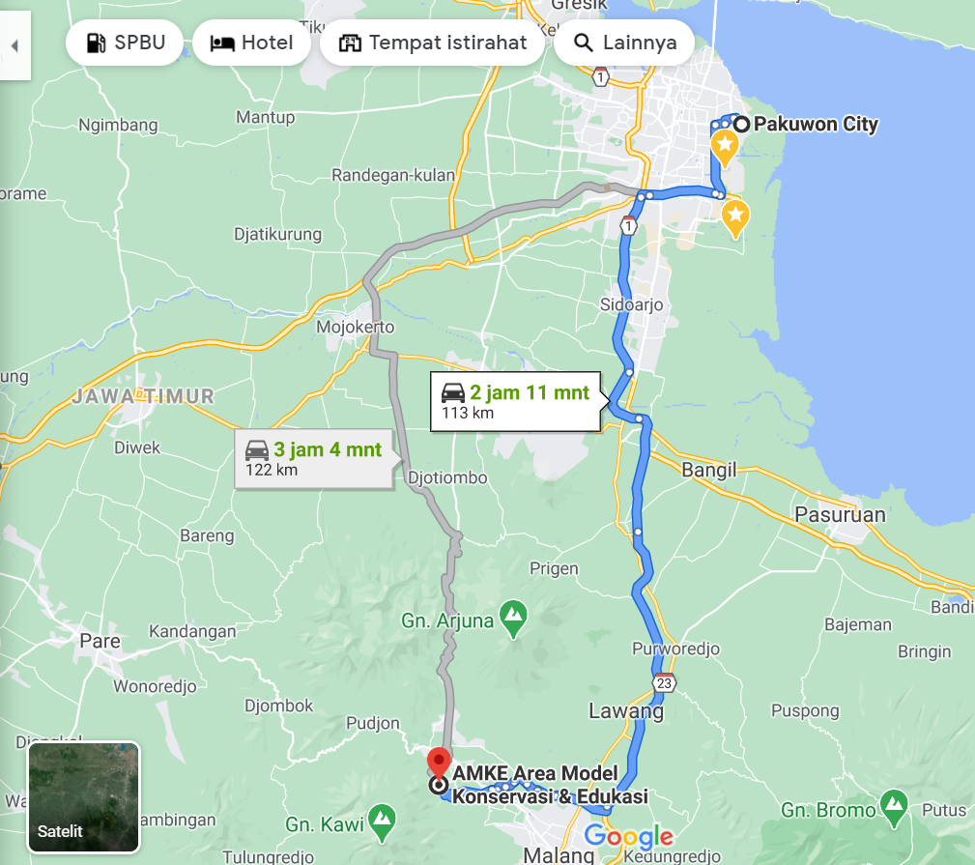

APPENDIX 3. OUTPUTS
.

