TM/DRPM-ITS/PM.01.014
COMMUNITY SERVICE PROPOSAL
INTERNATIONAL COMMUNITY SERVICE SCHEME
ITS FUNDING



(TITLE ……….)
Location: (Village, District/Sub-district, Regency, Province)

Community Service Team :
Team Leader : Name / Departemen/ Fakultas / Instansi
Team Members :
- Name / Department / Faculty / Institution
- Name / Department / Faculty / Institution
- Name / Department / Faculty / Institution
Etc.

DIREKTORAT RISET DAN PENGABDIAN KEPADA MASYARAKAT
INSTITUT TEKNOLOGI SEPULUH NOPEMBER
SURABAYA
YEAR 2026

APPROVAL PAGE
COMMUNITY SERVICE PROPOSAL
INTERNATIONAL COMMUNITY SERVICE SCHEME
YEAR 2026
1 | Title | :
2 | Team Leader | :
 | - Full Name | :
 | - Gender | :
 | - Employee Identification Number (NIP) | :
 | - Academic Rank / Functional Position | :
 | - Rank / Grade | :
 | - Field of Expertise | :
 | - Department / Faculty | :
 | - Team Members | :
3 | Partner | :
 | Partner Institution | :
 | Partner Address | :

No | Full Name | Employee Identification Number (NIP) | Faculty / Department / Unit | Institution / University
1
2
3
4
5

 | Surabaya,
Acknowledged by,
Head of Research Center | Team Leader
Full Name | Full Name
NIP | NIP
Approved by
Direktur Riset dan Pengabdian kepada Masyarakat
Fadlilatul Taufany, S.T., Ph.D
NIP 198107132005011001

ABSTRACT
The abstract (maximum 500 words) should describe the problem addressed, the proposed product-based solution, and the expected outputs to be achieved in accordance with the characteristics of the research center. The abstract should also briefly and clearly explain the proposed activity plan. The abstract must be written using one-and-a-half line spacing.
Keywords :
SDGs Topic :

TABLE OF CONTENTS

APPROVAL PAGE ii
ABSTRACT iii
TABLE OF CONTENTS iv
List of Tables v
List of Figures vi
List of Appendices vii
Chapter I. Introduction 1
Chapter II. Problems and Solutions 2
II.1 Priority Problems 2
II.2 Solutions 2
Chapter III. Methodology for the Program 3
Chapter IV. Overview of Technology and Innovation 4
Chapter V. Implementation Schedule 5
Chapter VI. Summary of the Budget Plan 6
Chapter VII. Outputs and Target Achievements 1
Chapter VIII. References 2
Appendix 1. Format Of Letter Of Commitment As International Partner 3
Appendix 2. Overview Of Science And Technology 4
Appendix 3. Location Map 5

List of Tables

List of Figures

List of Appendices

Chapter I. Introduction

This introduction contains the following descriptions:
- Situation Analysis and Partner Problems to be Addressed The situation analysis should be written comprehensively to provide a complete overview of the target partner’s condition in terms of potential, existing problems, and regional characteristics. The analysis must be based on the current condition of the partner/community to be empowered and supported by an informative partner profile, including relevant data and images. The existing condition of the target partner should be described thoroughly from upstream to downstream, preferably in quantified data where possible.
- Detailed Description of the Target Partner’s Condition Provide a detailed explanation of the target partner’s condition, including but not limited to: business processes such as raw materials, production, processing activities, products/services (type, quantity, specifications, quality), distribution, management, marketing (marketing techniques, product pricing, target consumers), facilities and infrastructure, socio-economic conditions of the community, and accessibility.
- Objectives of the Activity and Its Relevance to the Research Center’s Priority Areas
Describe the objectives of the proposed activity and its relevance to the twelve (12) priority fields of the Research Centers, referring to the research center’s roadmap and the specific problems being addressed.
- Other Relevant Information Include any additional information considered necessary to support the proposal.

Chapter II. Problems and Solutions

II.1 Priority Problems
The priority problems should be described using Times New Roman font, size 12, single spacing, on A4 paper. This section contains a description of the issues to be addressed, covering at least one aspect of activities related to the target partner. The priority problems should be explained based on an agreement with the target partner and are expected to include sub-problems for which solutions will be provided.
This section should also explain the impact and benefits of the program in addressing the problems faced by the partner and the broader community. The expected impacts should also be correlated with the achievement of the Sustainable Development Goals (SDGs).

II.2 Solutions
The solutions should be described using Times New Roman font, size 12, single spacing, on A4 paper. This section contains a description of all proposed solutions to address the problems faced by the target partner. A complete description of the proposed solutions should include the following:
- List all solutions offered to address the partner’s problems systematically according to the priority of the identified problems. The solutions must be directly related to the partner’s priority problems.
- Specify the targeted impacts expected from each proposed solution, both qualitatively and quantitatively (as measurable as possible and preferably presented in table form).
The proposed solutions may take the form of products, technologies, or innovations that have been or will be developed by the proposing team. These solutions must be directly related to the activities to be implemented and should provide added value.

Chapter III. Methodology for the Program
The method of activities should be written using Times New Roman font size 12 with single spacing on A4 paper and should include the following descriptions:
- Explain the stages of community service implementation, which should at least include the following:
- Socialization
- Training
- Implementation of products, technology, or innovations
- Mentoring and evaluationProgram sustainability
- Describe the methodological approach and the application of products, technologies, and innovations proposed to address the agreed problems of the partner. The explanation should include the suitability of the work volume, prioritization of activities, partner participation in the implementation of the program, evaluation of program implementation, program sustainability in the field, and the roles and responsibilities of each team member according to their expertise, including student involvement. Also explain the potential academic credit recognition (SKS) for the students involved.
- Describe how the partner participates in the implementation of the program.
- Describe the evaluation of program implementation and the sustainability of the program in the field after the community service activities have been completed. Explain the roles and responsibilities of each team member according to their expertise, including student assignments.
- Describe the potential recognition of academic credits (SKS) for the students involved in the activities.

Chapter IV. Outputs and Target Achievements
In this section, the proposer must clearly and thoroughly describe the mandatory outputs that are committed to be achieved. The mandatory outputs must comply with the ITS Community Service Guidelines (Abmas) 2026 https://www.its.ac.id/drpm/id/kumpulan-file-unduhan .

Chapter V. Overview of Technology and Innovation

The overview of Technology and Innovation should be written using Times New Roman font, size 12, single spacing, on A4 paper. This section describes the technology and innovation that will be implemented for the target partner, including its form, size, specifications, functions, and utilization capacity.

The description should be presented schematically and narratively, and should be supported by the following information:
- Images or photographs of the technology and innovation
- Technical specifications
- Dimensions or size
- Expected benefits
- Functions or uses

Chapter VI. Implementation Schedule

Activity Implementation Plan
No | Activity Name | Month
No | Activity Name | 1 | 2 | 3 | 4 | 5 | 6 | 7 | 8
1
2
3
* For the scope of the PMP program, the implementation period is 8 (eight) months at most within the same fiscal year as the proposal submission, starting from the signing of the contract, with a minimum of 8 site visits.

Chapter VII. Summary of the Budget Plan

List of Budget Plan Fill-in Groups
RAB Group | RAB Component | Units | Description
Non-Personnel Costs - Goods (Non-PKP) | Stationery | Paket | Preparation of reports, proposals, questionnaires, and other stationery for research purposes
Non-Personnel Costs - Goods (Non-PKP) | Research Materials (Consumables) | Unit | Laboratory research materials, field research materials, souvenirs for respondents, etc.
Non-Personnel Costs - Goods (Non-PKP) | Consumption costs | OH | Meeting expenses for coordination, focus group discussions, data collection, data analysis, and report and/or output preparation
Non-Personnel Costs - Goods (Non-PKP) | Inventory/Assets | Unit | Research support equipment with a certain value and recorded as inventory items
Non-Personnel Costs - Postdoctoral Fellow Scholarship | Lumsum | OB | Covering the basic needs of postdoctoral fellows, including living expenses, accommodation, meals, local transportation, and other needs relevant to research activities (specifically for postdoctoral schemes).
Non-Personnel Costs - Services (Non-PKP) | Sample analysis costs | Unit | Costs for sample analysis, including product testing costs
Non-Personnel Costs - Services (Non-PKP) | Maintenance Costs | Unit | Care, maintenance, or minor repairs to facilities and infrastructure supporting research and community service activities to ensure they continue to function optimally during the implementation of activities.
Non-Personnel Costs - Services (Non-PKP) | Research equipment | Unit | Research equipment not owned by the research institution
Non-Personnel Costs - Services (Non-PKP) | Research transport | OK (Kali) | Transport for data retrieval, data collection, and data analysis purposes
Non-Personnel Costs - Services (Non-PKP) | Sample analysis costs | Unit | Costs for sample analysis, including product testing costs
Non-Personnel Costs - Services (Non-PKP) | Maintenance Costs | Unit | Care, maintenance, or minor repairs to facilities and infrastructure supporting research and community service activities to ensure they continue to function optimally during the implementation of activities.
Non-Personnel Costs - Services (Non-PKP) | Research equipment | Unit | Research equipment not owned by the research institution
Non-Personnel Costs - Services (Non-PKP) | Research transport | OK (Kali) | Local transport for research purposes
Non-Personnel Costs - Land/Building Rental Services (Non-PKP) | Experimental Garden | Unit | Experimental gardens not owned by research institutions
Non-Personnel Costs - Land/Building Rental Services (Non-PKP) | Research subject | Unit | Experimental objects not owned by the research institution
Non-Personnel Costs - Land/Building Rental Services (Non-PKP) | Research support room | Unit | Space for research purposes not owned by the research institution
Non-Personnel Costs - Land/Building Rental Services (Non-PKP) | Experimental Garden | Unit | Experimental gardens not owned by research institutions
Non-Personnel Costs - Land/Building Rental Services (Non-PKP) | Research subject | Unit | Experimental objects not owned by the research institution
Non-Personnel Costs - Land/Building Rental Services (Non-PKP) | Research support room | Unit | Space for research purposes not owned by the research institution
Non-Personnel Costs - Travel | Accommodation | OH | Accommodation during data collection and data analysis
Non-Personnel Costs - Travel | Ticket | OK (Kali) | Land, sea and air transport tickets
Non-Personnel Costs - Travel | Transport | OK (Kali) | Local transport for data collection and data analysis purposes
Non-Personnel Costs - Travel | Daily Allowance | OH | Daily allowance for data collection, data gathering, and coordination of data analysis
Personnel Costs | HR Resource Person | OJ | Informants needed for data processing
Personnel Costs | Field Assistant HR | OH | Field officers who assist in data collection
Personnel Costs | HR Research Assistant | OJ | Research assistants, laboratory assistants, technicians and the like
Personnel Costs | Data Processing HR | Penelitian | Officials who assist in processing research data
Personnel Costs | HR Survey Officer | OH/OR | Data collector/gatherer
Personnel Costs | HR Secretariat/Administration | OB | Officials who administer the implementation of activities
Mandatory/Additional Reporting/Outputs | Other science and technology output costs (prototypes, TTG, etc.) | Paket | Costs for design services, assembly, equipment design and construction, production and product documentation (specifications, designs, usage procedures and other descriptions), registration, substantive examination, claim fees, application fees, certificate fees.
Mandatory/Additional Reporting/Outputs | KI Output Costs (patents, copyrights, etc.) | Paket | Costs for design services, assembly, equipment design and construction, registration, substantive examination, claim fees, application fees, certificate fees
Mandatory/Additional Reporting/Outputs | Video Output Costs | Paket | Video production service fees
Mandatory/Additional Reporting/Outputs | Product Testing Document Preparation Costs | Paket | Testing costs and product documentation (specifications, design, usage procedures and other descriptions)
Mandatory/Additional Reporting/Outputs | Cost of Book Compilation Including Book Chapter | Paket | Drafting, proofreading, editing, publishing, ISBN
Mandatory/Additional Reporting/Outputs | Cost of Publishing Articles in International Journals | Paket | Translation fees, proofreading fees, publication fees
Mandatory/Additional Reporting/Outputs | Cost of Publishing Articles in National Journals | Paket | Publication fees
Mandatory/Additional Reporting/Outputs | Mass Media Publication Costs | Paket | Publication fees
Mandatory/Additional Reporting/Outputs | International seminar fees | Paket | Registration, local transport, tickets, accommodation, daily allowance.
Description :
1. PKP (Taxable Entrepreneur): Expenditure for the procurement of goods from suppliers with Taxable Entrepreneur (PKP) status. This transaction is subject to VAT in accordance with applicable tax regulations.
2. NON PKP (Taxable Entrepreneur): Expenditure for the procurement of goods from suppliers who are not registered as Taxable Entrepreneurs (PKP). This transaction is not subject to Value Added Tax (VAT).
3. UNITS :
OJ = Persons per Hour
OH = Persons per Day
OB = Persons per Month
OK (Kali) = Persons per Activity

Chapter VII. Outputs and Target Achievements
In this section, the proposer must clearly and thoroughly describe the mandatory outputs that are committed to be achieved. The mandatory outputs must comply with the ITS Community Service Guidelines (Abmas) 2026 https://www.its.ac.id/drpm/id/kumpulan-file-unduhan .

Chapter VIII. References
The references must be compiled and written using the numbering system (Vancouver style) according to the order of citation. Only references cited in the community service proposal should be included in the Reference List.

Guidelines for writing citations using the Vancouver style can be found in the research and community service management guidelines or through the YouTube page.

Appendix 1. Format Of Letter Of Commitment As International Partner

LETTER OF COMMITMENT AS INTERNATIONAL PARTNER

The undersigned below us:
Name | : | ........................................................................
Position | : | ........................................................................
Institution | : | ........................................................................
Institution Address | : | ........................................................................

Hereby declares the willingness of our institution to cooperate as a partner in a community enggagement activities with the team from Institut Teknologi Sepuluh Nopember (ITS), as detailed below:
Title of Community Service Activity | : | .......................................................................
Head of the Community Service Team | : | .......................................................................
Partner Contribution (in-kind / in-cash) | : | IDR .......... (Following the patners currency)
Duration of Cooperation | : | .......................................................................

Furthermore, our institution agrees to fulfill the roles, duties, and contributions as a partner as follows:
…………………………………………………………………………………………..
…………………………………………………………………………………………..
…………………………………………………………………………………………..

This statement is made truthfully to be used as required.
.........................., month 2026
Declared by,

(Signed)

Full Name

Appendix 2. Overview Of Science And Technology
This section describes the overview of the science and technology that will be implemented with the partner.

Appendix 3. Location Map
This section contains the map of the partner's location along with the distance data from the partner location to the team leader's address.

Partner Institution Name :
Partner Address :
Distance from ITS to Partner Locationa : …km

Use google map to make it easier (as shown in the example below).

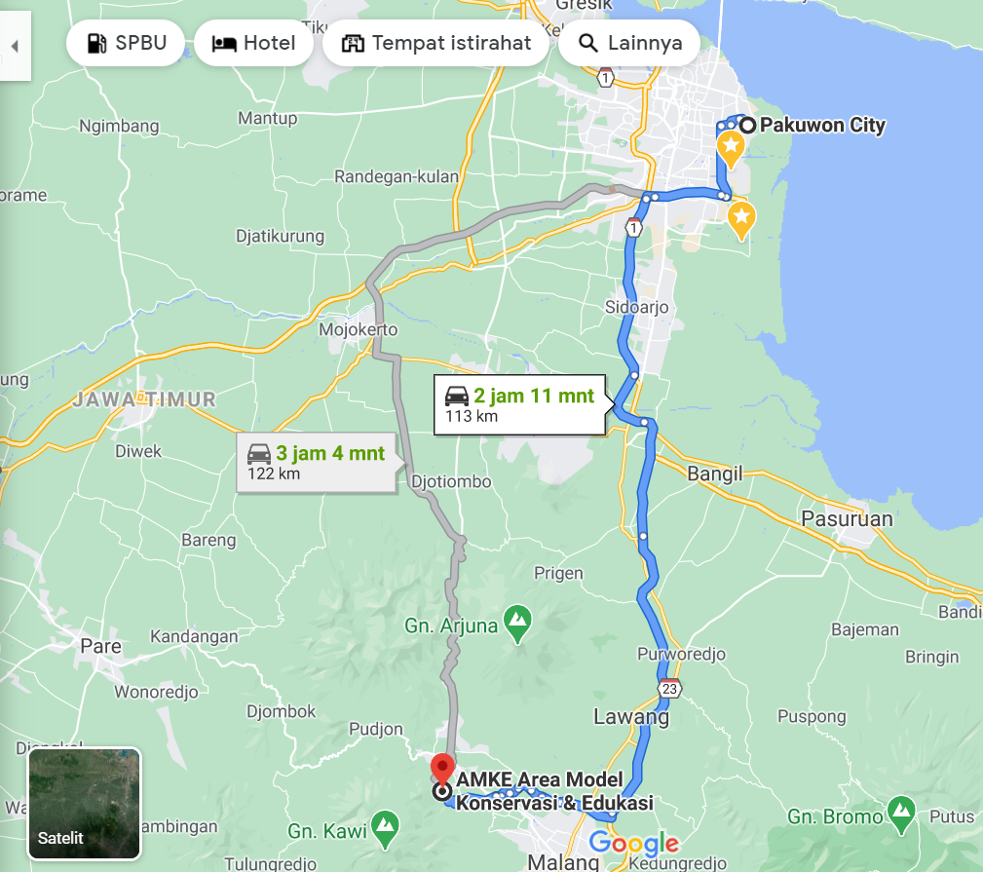

Appendix 4. Biodata Of The Service Team

1. Ketua
a. | Full Name | :
b. | Gender | :
c. | NIP (Employee ID) | :
d. | Functional Position/Rank/Grade | :
e. | Field of Expertise | :
f. | Department/Faculty | :
g. | University | :
 | Home Address and Phone Number | :

Community Service History (2 most recent funded by ITS or national institutions, specify as Chairperson or Member)
No | Community Service Title | Funding Source | Year
1
2

Scientific Publications (2 most recent in the form of papers or books)
No | Intellectual Property Title | URL Article
1
2

HKI (2 terakhir)
No | Judul Hak Kekayaan Intelektual | Jenis HKI | No. HKI
1
2

Jenis HKI = HC, Paten, Paten Sederhana, Desain Industri, atau Merk Dagang

2. Anggota I
(format sama dengan Ketua)

3. Anggota II
(format sama dengan Ketua)

dan seterusnya

