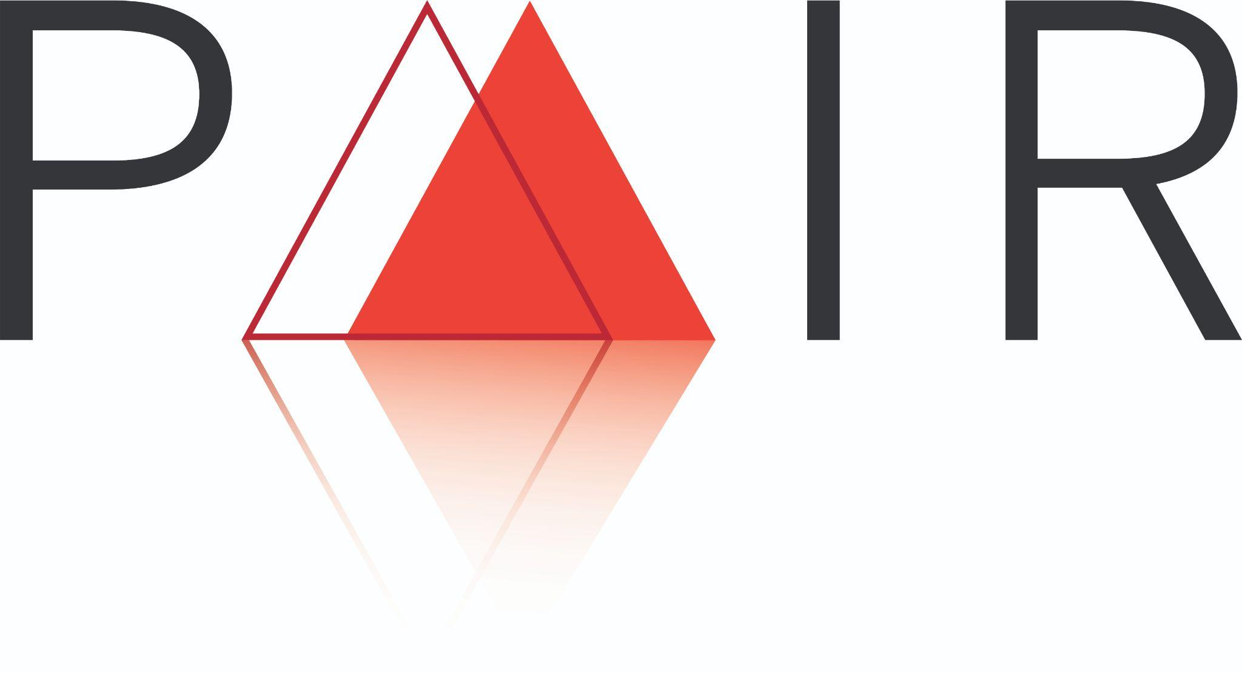

PAIR Sulawesi

Researcher application template
Note: Please submit this application in word format to the PAIR portal at https://pair.unhas.ac.id/ by the deadline Thursday 19 September 2024 5pm WIB/8pm AEST.

Please save your application in word using the following convention: Number of research area, number of project topic, your full name, your university. For example, Hasnawati Saleh from Unhas applying for the farming project in the circular economy research area would save their application as: 1.1 Hasnawati Saleh, Unhas.

A: Researcher application

Application reference ID (to be filled by PAIR PMT)
Title: (e.g. Professor, Associate Professor, Doctor)
Name:
Academic level (Dropdown) | Indonesians: Choose an item.
Academic level (Dropdown) | Australians: Choose an item.
Institution:
Faculty and/or Centre:
Email address:
WhatsApp number:
Research area: (Please select one research area that best fits your expertise and interest from the Topic Map) | Choose an item.
Project topic this proposal responds to (Within your selected research area, please specify the project topic you are most interested in contributing to. Refer to the Topic Map for a list of project topics under each research area.) | 1. Circular economy: Choose an item.
 | 2. Net zero: Choose an item.
 | 3. Climate change and health: Choose an item.
1a. Understanding of the research area and project topic (150 words)
Briefly describe your understanding of the broader research area you have selected and its significance in the context of climate change and coastal communities in Sulawesi.
1b. Understanding of the topic issue: (max 400 words).
Focusing on your chosen project topic within this area, provide a more detailed explanation of: a) the key issues and challenges related to this specific topic, b) how this topic connects to or impacts other aspects within the broader research area, c) potential approaches or methodologies you would consider in addressing this topic.
2. Research expertise and track record:
Please address the following points in your response (max 400 words).
Describe your specific research expertise relevant to your chosen project topic.
Highlight 2-3 key research projects or publications that demonstrate your track record in this or related areas.
Explain how your expertise and experience will contribute to addressing the challenges outlined in the topic map for your chosen area.
Describe how you successfully applied your research skills in an interdisciplinary or collaborative context.
3. International Research Experience:
(max 300 words)
Describe your most significant international experience(s), including the project(s), your role, and the countries involved.
Discuss specific skills or insights you have gained from your international experience that will be valuable for this project in Sulawesi.
4. H-Index:
Please provide your current H-Index score. The H-Index metric measures the productivity and impact of a researcher's published work.
Optional: If you feel the H-Index does not adequately represent your research impact, please briefly explain why and provide alternative evidence of your research influence. (max 50 words).
5. Stakeholder engagement and policy impact:
(max 400 words)
Describe your experience conducting applied research that has informed policy or practice. Include details about the project, the stakeholders involved (e.g. government bodies, industry partners or local communities) and your specific role.
How did you ensure your research was relevant to their needs?
Describe what measures you took to ensure it could be effectively translated into policy or practice.
What was the concrete impact of your work? Provide specific examples.
6. (Optional) Propose research partners
Note a max three potential research collaborators from other PAIR Sulawesi partner institutions you have previously worked with. These researchers also need to apply. Not guarantee that this will become your team.

B: Curriculum Vitae (CV)
Please attach your CV to this document—maximum of four pages in plain English. Your CV should be tailored to highlight information relevant to this project. Please include the following sections:
- Personal Information:
  - Full name, current position and affiliation and contact details (email, phone number)
- Education:
  - Degrees, institutions, years of completion
- Research Experience:
  - Key research positions held (last 10 years)
  - Brief descriptions of major research projects (emphasise those relevant to this application)
- Publications:
  - List up to 5 most significant publications relevant to this project
  - Include full citations and brief (1-2 sentence) explanations of each publication's relevance or impact
- Grants and Funding:
  - Major grants received (last 5 years) and your role in each grant (PI, Co-PI, etc.)
- International Collaboration:
  - Key international research partnerships or workshops organised
- Stakeholder Engagement:
  - Experience working with policymakers, industry, or communities and/or any advisory roles or board memberships.
***
C: Additional information
Do not include this information section when uploading your application to the PAIR Portal at https://pair.unhas.ac.id/ as it might compromise the file size.**
Thank you for your interest in the PAIR program focusing on Climate Change and Coastal Communities in Sulawesi.
Purpose of the application:
This application aims to assess your expertise, experience, and understanding of the research area and specific project topics. We seek researchers who can contribute effectively to applied, policy-relevant research in an international, collaborative context.
Selection Process:
- Partner university Research Offices will score eligible applications using a standardised matrix that assesses understanding of the research area, expertise, international experience, and stakeholder engagement capabilities.
- Shortlisted applicants will be submitted to the PAIR Panel that will conduct an in-depth review of top-scoring applications and select researchers to form balanced, interdisciplinary teams.
- Selected researchers will be notified and invited to join project teams.
We appreciate the time and effort you invest in this application. Your thorough and thoughtful responses will help us assemble the most effective teams to address the complex challenges facing coastal communities in Sulawesi.
Deadline for submission:
Please complete this application in Australian English and submit to the PAIR portal by 5pm WIB/ 8pm AEST on Thursday 19 September 2024. The application must be uploaded as a Word document.
Write clearly and in plain English. Avoid the use of technical terms, acronyms and quotation marks.
Contact pair@australiaindonesiacentre.org for any technical issues.
Expectations regarding time commitment and project duration:
Projects will be 24 months in total duration, including an ongoing advocacy for the research findings yielded in the first year. Successful applicants will be expected to commit sufficient time on a weekly basis for the duration of the project to deliver against the project objectives.
Application Checklist:
Before submitting your application, please ensure you have completed all sections and met all requirements:
Personal Information:
- Title, Name, Institution, Faculty/Centre
- Email address and WhatsApp number provided
Research Focus:
- Research area and topics selected from dropdown menu
- 1. Understanding of the research area and project topic (150 words)
- 2. Research expertise and track record (400 words)
- 3. International Research Experience (300 words)
- 4. H-Index score provided
- 5. Stakeholder engagement and policy impact (400 words)
- Curriculum Vitae (CV) (maximum four pages, in plain English)
- Application is saved as a Word document, ready for upload to the PAIR portal.
Please review this checklist carefully before submitting your application. Ensuring all items are complete will help us process your application efficiently.

PAIR Matrix for assessing researcher applications
(For evaluators use)
Overview:
The PAIR rubric assessment tool standardises the evaluation process across all applications. The Rubric seeks to ensure fair and thorough consideration of each candidate's application. It covers five main aspect of the researcher’s profile:
- Understanding of the research area and project topic
- Research expertise and track record
- International Research Experience
- H-Index (not scored in the rubric but provided for reference)
- Stakeholder engagement and policy impact
Each section contains specific criteria to be scored on a scale of 1 to 4, where:
1 - Does not meet requirements
2 - Partially meets requirements
3 - Meets requirements
4 - Exceeds requirements
How to Use the Rubric:
- Read each application carefully, paying attention to how the applicant addresses each criterion.
- For each criterion, assign a score based on the provided guidelines.
- Use the "Comments" sections to note specific strengths, weaknesses, or standout aspects of the application.
- Calculate the total score for each section and the overall application.
Your thorough and thoughtful evaluations will play a crucial role in assembling strong, diverse research teams capable of addressing the complex challenges facing coastal communities in Sulawesi.

1. Understanding of the research area and project topic
Criteria | Score (0-4)
Topic understanding - How well does the applicant demonstrate a comprehensive understanding of both the broader research area and the specific project topic?
1. Basic understanding of either the research area or project topic, but not both
2. Adequate understanding of both, but lacks depth in one or the other
3. Good understanding of both the research area and project topic, with clear connections between them
4. Excellent, nuanced understanding of both, demonstrating insight into their interconnections and broader implications
Comments:

Issues identification and interdisciplinary awareness - How effectively does the applicant identify and explain key issues and challenges specific to their chosen project topic?
1. Limited identification of issues, with no interdisciplinary awareness
2. Identifies some key issues, but explanation lacks depth or interdisciplinary perspective
3. Effectively identifies and explains key issues, showing some interdisciplinary awareness
4. Comprehensively identifies and explains key issues, demonstrating strong interdisciplinary awareness and insights
Comments:

Methodological approach - How appropriate and innovative are the potential approaches or methodologies proposed by the applicant in addressing their chosen topic?
1. Proposed approaches are vague or inappropriate for the topic
2. Appropriate but conventional approaches proposed, lacking innovation
3. Appropriate and somewhat innovative approaches proposed, well-suited to the topic 4. Highly appropriate and innovative approaches proposed, demonstrating deep understanding of methodological implications
Comments:

Total score (out of 12)

2. Research expertise and track record (focused on the applicant’s overall research expertise and track record)
Criteria | Score (0-4)
Relevance of expertise - How relevant and substantial is the applicant’s research expertise to the specific project topic they have chosen?
1. Minimal expertise relevant to the chosen project topic
2. Some relevant expertise, but lacks depth or direct applicability
3. Relevant and substantial expertise that aligns well with the chosen project topic
4. Highly relevant, extensive expertise that perfectly matches the chosen project topic
Comments:

Track record quality - To what extent do the highlighted projects/publications demonstrate a strong and relevant track record in the chosen area?
1. Highlighted projects/publications show limited relevance or impact
2. Some relevant projects/publications, but limited in number or significance
3. Strong track record with relevant, impactful projects/publications
4. Exceptional track record with highly relevant, influential projects/publications in the chosen area
Comments:

Team contribution - To what extent will the applicant’s expertise and experience contribute to an effective interdisciplinary, collaborative project team?
1. Limited evidence of interdisciplinary or collaborative work
2. Some evidence of interdisciplinary work, but role in collaboration not clear
3. Clear evidence of effective interdisciplinary collaboration and potential team contribution
4. Exceptional track record of leading or significantly contributing to interdisciplinary, collaborative projects
Comments:

Total score (out of 12)

3. International Research Experience (specifically targets experience in international research context and how it can contribute to a project)
Criteria | Score (0-4)
Relevance of international experience - How relevant and substantial is the applicant’s international experience to the project?
1. No international research experience, or experience entirely unrelated to the project)
2. Has some international experience, but not in areas or context closely related to the project)
3. Has international experience in areas related to the project)
4. Has substantial international experience highly relevant to the project - climate change coastal communities)
Comments:

Skills and contribution - To what extent are the specific skills or insights gained from their international experience directly applicable to this project?
1. Fails to connect international experience to the current project (no specific examples or skills or insights mentioned)
2. Provide general statements about skills gained, but lack specificity)
3. Identifies 1-2 specific skills or insights from international experience)
4. Articulate multiple specific, highly relevant skills or insights)
Comments:

Total score (out of 8)

4. Stakeholder engagement and policy impact - (examines to what extent the applicant demonstrates experience in conducting applied research that has informed policy or practice)
Criteria | Score (0-4)
Applied research experience - How relevant and substantial is the applicant's experience in conducting applied research that has informed policy or practice?
1. No relevant applied research experience
2. Limited experience or experience not clearly related to policy/practice
3. Clear, relevant experience in applied research informing policy/practice
4. Extensive, highly relevant experience with significant projects
Comments:

Stakeholder engagement and research relevance - How effectively did the applicant engage stakeholders and ensure research relevance to their needs?
1. No clear stakeholder engagement strategy described
2. Basic engagement described, but limited evidence of ensuring relevance
3. Clear engagement strategy with evidence of ensuring research relevance
4. Comprehensive, innovative engagement approach with strong focus on relevance
Comments:

Research translation and impact - To what extent did the applicant effectively translate their research into policy or practice, and what concrete impacts resulted?
1. No clear examples of research translation or impact
2. Vague or limited examples of translation or impact
3. Clear examples of research being translated with definite impacts
4. Exceptional examples of translation leading to significant, wide-reaching impacts
Comments:

Total score (out of 12)

