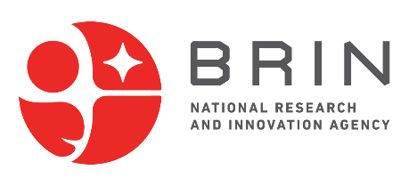


APPROVAL SHEET
Call for Proposals – SATREPS FY 2026
Science and Technology Research Partnership for Sustainable Development

This form is to be completed and signed by the Indonesian Principal Investigator and their affiliated institution.
It serves as an official endorsement of the proposal submission to BRIN under the Joint Call for Proposals 2025.

1. Research Project Title:
[Insert full title]
2. Principal Investigator (Indonesia):
a. Full Name (with academic title):
b. Affiliated Institution:
c. Faculty / Department / Research Center & Research Organization:
d. Institutional Address:
e. Phone Number:
f. Email:
3. Research Team Members (Indonesia):
No | Name | Institution

4. Project Duration: From: [Month/Year] To: [Month/Year] (Duration: [xx] months)
5. Research Area:
(Please indicate the selected theme by bold, underline, and blue font)
A. Environment and Energy
B. Bioresources
C. Disaster Prevention and Mitigation
D. Infectious Diseases Control
6. Partner Information (Japan Side):
Name of Principal Investigator (Japan): [Full Name and Title]
Affiliated Institution: [University / Research Institute]
7. Authorized Signatures – Indonesia Side:
Role | Signature & Stamp | Name & Title
Principal Investigator (Indonesia)
Authorized Official / Head of Institution
Note: This form may be signed electronically or with wet signatures. In case of mixed formats, both parties must ensure authenticity and consistency of the content.
8. Acknowledgement by Japanese Partner PI:
This proposal has been jointly developed, and I confirm my awareness of its content and submission to BRIN.
Role | Signature & Stamp | Name & Title
Principal Investigator (Japan)
Note: This signature confirms awareness of the proposal submission

